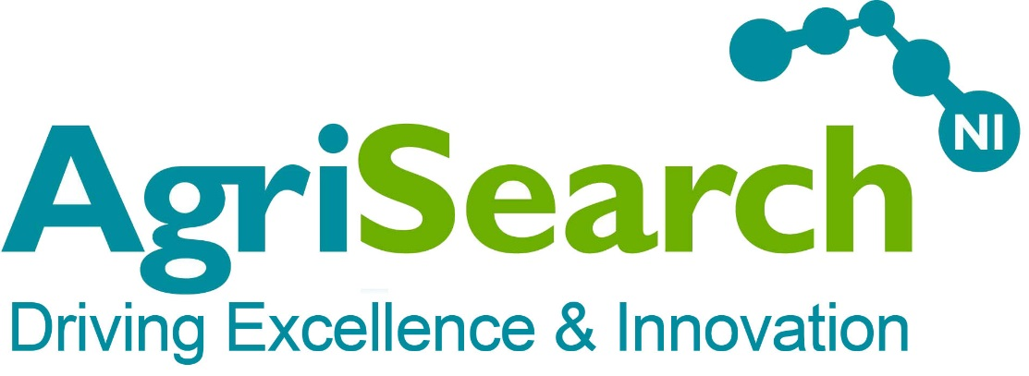
97 Moy Road
Dungannon
County Tyrone
BT71 7DX

T: 028 8778 8206
F; 028 8778 8200
E: info@agrisearch.org

Project Manager

Information Pack and Application Form

Dear Applicant,

Thank you for your interest in the position of Project Manager at AgriSearch.

The information pack includes the following documents which you should refer to when completing your application:

- Job description
- Person specification
- Application form.

Completed forms should be submitted by 5pm Monday 21st December 2015.

Interviews will be held on Friday 8th January 2015.

May I take this opportunity to thank you for your interest. We look forward to receiving your application.

Yours faithfully,

Jason Rankin
Company Secretary

Job Description

The Company and Role

The Northern Ireland Agricultural Research and Development Council (T/A AgriSearch), is a charitable organisation whose mission is to drive innovation and excellence in ruminant livestock farming, as a trusted, valued conduit of knowledge and innovation based on sound science, and widely applied research.

We are now seeking to appoint a Project Manager to work with key delivery partners and stakeholders in executing the recommendations of the AbacusBio report commissioned by Agri-Food Strategy Board regarding the creation of a Northern Ireland Livestock Industries Data Hub.

The role is for a fixed period of 12 months, commencing Feb 2016, or as soon as possible thereafter.

Purpose of Role

Reporting directly to the Agri-Food Strategy Board Livestock Genetics Steering Group the person appointed will have full responsibility for commencing the implementation of the recommendations contained within the AbacusBio report:

- Build business relationships and the IT infrastructure required to bring together data from different parts of the dairy, beef and sheep value chain;
- Source comprehensive external genetic evaluations to increase the rate of genetic gain within the dairy, beef and sheep sectors; and
- Develop a comprehensive suite of farm livestock evaluation tools to help local farmers bring about real change in their business performance.

The role will be based in the greater Belfast area, but the person appointed will spend much of their time meeting with industry across Northern Ireland. They must be willing to travel elsewhere in Ireland and the UK when necessary.

Salary and Hours

The salary is circa £45,000.

Whilst the role is based on a notional 37.5 hour week it is anticipated that the role will require commitment and dedication beyond this with flexibility of approach including early mornings and evenings as projects demand.

Main duties and responsibilities

Working with key industry partners and stakeholders in government, the Agri-Food sector, and with scientific and academic organisations, the Project Manager will be responsible for:

- Compilation of information to support the business case for government and industry funding
- Communicating and disseminating the potential opportunities and benefits of the NI Livestock Industries data hub to industry and primary producers.
- Liaising with stakeholder organisations
- Leading negotiations with government for the required capital investment
- Leading negotiations with processors, livestock marts and representatives of primary producers to develop a framework for levy collection to fund the ongoing running costs of the data hub.
- Leading negotiations with holders of data (milk recording organisations, AI companies, breed societies, farm software providers and processors) regarding the protocols for the exchange of data between their IT systems and the data hub.
- Liaising with providers of genetic evaluations
- Building linkages with existing and planned Knowledge Exchange initiatives to promote the benefits of genetic improvement across the industry.
- Developing potential new initiatives to enable and accelerate the rate of adoption at farm level.
- Other tasks and duties as determined by the Livestock Genetics Steering Group or the Board of AgriSearch, commensurate with the role

Person Specification

Essential knowledge, experience, skills and qualifications

- Educated to degree level or equivalent, in an animal science, agricultural or related subject.

- Demonstrable track record of effective project management

- Experience in the development of business cases

- Demonstrable experience of building effective relationships with industry, government and research / scientific bodies in the delivery of a project.

- Demonstrable experience of assisting with benefits realisation, research / technology application, and knowledge transfer to beneficiaries and other parties with a vested interest in the project outcomes

- Excellent IT ability, including Microsoft Office

- Excellent communication, influencing, interpersonal and negotiating skills.

- As travel throughout Northern Ireland is essential the successful candidate must have a full valid driving licence and access to a form of transport that will permit them to meet the requirements of the post in full.

Desirable knowledge, experience, skills and qualification

- Post-graduate degree in an animal science, agricultural or related subject

APPLICATION FORM

Personal Details
Full name (underline preferred name, if appropriate)
Address including post code

Previous address

Home tel no
Mobile tel no
Email address

CAREER HISTORY

Please enter detail of your career history, beginning with your present or most recent position and indicating time period that each position has been held.

Company | Job title | Salary / benefits package | Achievements and duties; reason for leaving

ESSENTIAL CRITERIA

In no more than 300 words for each of the criteria, please demonstrate how you meet the essential criteria through recent (within the last 5 years) experience. Please provide specific examples.

1. Educated to degree level or equivalent, in an animal science, agricultural or related subject.

2. Demonstrable track record of effective project management. (Please provide specific examples clearly setting out the role you played, the contribution you made, and the outcome achieved)

3. Experience in the development of business cases (Please provide specific examples clearly setting out the role you played, the contribution you made, and the outcome achieved)

4. Demonstrable experience of building effective relationships with industry, government and research / scientific bodies in the delivery of a project. (Please provide specific examples clearly setting out the role you played, the contribution you made, and the outcome achieved)

5. Demonstrable experience of assisting with benefits realisation, research / technology application, and knowledge transfer to beneficiaries and other parties with a vested interest in the project outcomes (Please provide specific examples clearly setting out the role you played, the contribution you made, and the outcome achieved)

6. Excellent communication, influencing, interpersonal and negotiating skills.

7. Excellent IT ability, including Microsoft Office

8. Full valid driving licence and access to a form of transport that will permit them to meet the requirements of the post in full.

DESIRABLE CRITERIA
1. Post-graduate degree in an animal science, agricultural or related subject.

Referees

Please provide details of 2 referees (excluding family members) who are well acquainted with you and willing to answer questions about your character, experience and qualifications for the appointment . It is preferable that one referee is your present or most recent employer. Referees will not be contacted until after interviews are completed..

Name, company and position | Address | Contact details  (e-mail and phone / mobile)

Thank you for completing this application. By completing and submitting this Application Form, you consent to AgriSearch using and keeping information about you, provided by you or third parties, such as referees relating to your application for future employment.

Please return either by email to:

jason.rankin@agrisearch.org or by post to:

Jason Rankin
Company Secretary
AgriSearch
97 Moy Road
Dungannon
County Tyrone BT71 7DX
Completed application forms must be received no later than 5pm Monday 21st December 2015.

