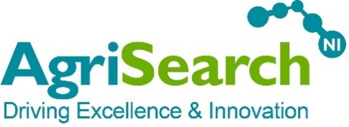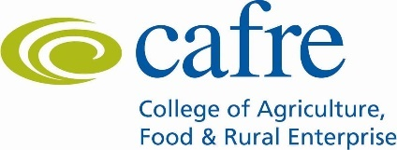

**INFORMATION FOR BEEF FARMERS INTERESTED IN**

**“BEEF FROM GRASS”**

**Background**

In Northern Ireland grazed or ensiled grass remains the dominant forage source, occupying an estimated 93% of the total farmed area and with a natural climatic advantage for grass production it is important that we maximise the use of high quality pasture in our beef and sheep production systems. However, the current performance of managed grasslands remains sub-optimal with an estimated 4.1 tonnes of grass dry matter utilised per hectare on beef and sheep farms, significantly behind achievable levels.

The Sustainable Agricultural Land Management Strategy for Northern Ireland has called for an increase in the uptake of sward assessment and grass utilisation measurement on grassland farms as one measure by which improvements in grassland utilisation can be achieved. A recent study carried out by AFBI demonstrated that improving grassland utilisation by one tonne per hectare on a beef and sheep farm is worth an additional profit of £204/ha/year.

The past 12 months has highlighted the wide variability in grass growing conditions present across Northern Ireland and it is important that this variation is monitored and understood. The ‘‘Beef from Grass” project jointly funded by DAERA and AgriSearch will began in 2017. As part of this project AgriSearch is looking to recruit new beef farms from across Northern Ireland to join the existing beef farms in the project to measure grass growth and quality across a range of production systems and land types in 2018. This project aims to provide high quality grass growth and grass quality information from regions across Northern Ireland to assist farmers in making grass management decisions.

**What we are looking for?**

AgriSearch (in partnership with AFBI) are seeking to recruit new beef farmers from across Northern Ireland to participate in the study.

Farmers will be expected to measure their grazing platform on a weekly basis throughout the grazing season. Grass measurements will be fed into an online management platform (AgriNet) along with stock numbers and details of meal and silage fed to cattle.

Every fortnight each farm will submit grass samples to AFBI for analysis. This will be done on a rotating basis with half the farms submitting samples one week and the other half submitting on the following week.

Each farm will be equipped with a max/min thermometer and a rain gauge and asked to record these figures daily.

Each farm will be featured in the local press one or two times per year. Pilot farmers will be encouraged to use social media to promote their involvement in the study and their experiences measuring and managing grass. Following 2018, there may also be an opportunity for the pilot farms to engage further with new grassland research projects.

We will give preference to farmers who are in a CAFRE Business Development Group and would encourage pilot farms to host a meeting of their BDG during the year. Some of the pilot farmers may be asked to host a larger farm walk during the year.

Applications are particularly welcome from Armagh, North West Londonderry and South Antrim areas.

**Next Steps**

If you wish to apply, download an application form from the AgriSearch website and return via email to [elizabeth@agrisearch.org](mailto:elizabeth@agrisearch.org) or by post to:

AgriSearch

Innovation Centre

Large Park

Hillsborough

County Down

BT26 6DR

**Deadline**

Applications forms must arrive no later than noon on Monday the 19th of February 2018.

**Further Information**

If you have any specific queries then contact either Elizabeth Earle (AgriSearch) on 028 9268 1514 or Francis Lively (AFBI) on 028 9268 1552.

Project supported by:

