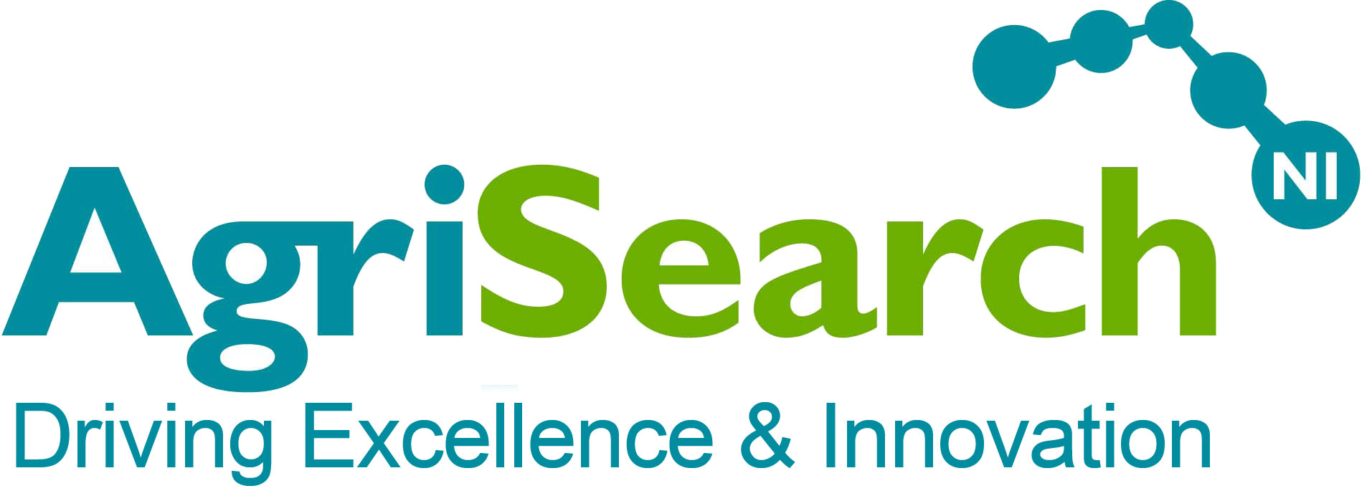

The Northern Ireland Agricultural Research & Development Council

Job Title: Independent Trustee

Remuneration: The role of Trustee is not accompanied by any financial remuneration, although expenses for travel may be claimed.

Time Commitment: 5 Trustees’ meetings per year (+ possible further sub- committee meetings)

Term: Trustees are elected for a three year term and may serve no more than three consecutive terms (four in the case of the Chair / Vice Chair of the Board of Trustees)

About the organisation
AgriSearch (The Northern Ireland Agricultural Research and Development Council) is an independent charity incorporated as a company limited by guarantee.

AgriSearch was formed in 1997 to help dairy, beef and sheep farmers become directly involved with production-oriented research. The funds contributed by farmers to AgriSearch (through a voluntary levy collected by Dairy and Red Meat Processors) are used to commission research that will improve and develop beef, sheep and dairy farming in Northern Ireland. The guiding principle behind all of AgriSearch-funded projects is to provide research that will be of practical benefit to farmers and provide them with tools to help reduce costs, increase performance, drive innovation and improve welfare.

In recent years AgriSearch's role has grown from merely being a co-funder of research to taking a much more active role in leading projects and acting as a liaison between researchers, advisors and the industry, as well as articulating the research and innovation needs of the sector. It now has a pivotal role within the research and knowledge transfer functions for Northern Ireland's ruminant livestock sector.

AgriSearch has recently completed a review of its strategy and published a five year strategic statement:

Vison – Driving Farm Profitability and sustainability through science, research and innovation.
Purpose – Equip farmers through the application of science, research and innovation to make a difference for the rural economy, environment and society.

Strategy – Applying our knowledge, network and capabilities and working with others to turn scientific possibilities into sound farm practice.

Our three main priorities for 2025-2030 are:
- Placing the farmers needs at the heart of research and innovation in Northern Ireland.
- Grow our long-term research and innovation platforms.
- The last mile – research into practice.

The full strategic statement can be found here: https://www.agrisearch.org/publications/corporate-publications/agrisearch-strategic-doc-2025-2030/viewdocument/717

Introduction
The Trustees are responsible for ensuring that the organisation runs according to its constitution and that the financial management of the organization is sound. The Trustee has considerable influence over the strategy of an organisation and is an important component of its effectiveness.

Currently AgriSearch’s Board has an under-representation of women, so applications are particularly welcomed from this group.

The Role & What is Expected
Contribution to the Board
Your role on the Trustee Board is important and you will be expected to have good attendance at Trustee Meetings.

You will be expected to undertake the following
- Review of financial statements
- Review of strategy documents
- Preparation of strategy documents
- Interpretation of research projects

Meetings
Most meetings will include the following:
- Review of financial position
- Assessment against defined strategy.
- Discussion of future activity and strategy
- Assessment of spending decisions

Person specification
The Board of Trustees are jointly and severally responsible for the overall governance and strategic direction of the charity, its financial health, the probity of its activities and developing the organisation’s aims, objectives and goals in accordance with the governing document, legal and regulatory guidelines.
All trustees should also be aware of, and understand, their individual and collective responsibilities, and should not be overly reliant on one or more individual trustees in any particular aspect of the governance of the charity.

Desirable Qualities
Having recently conducted a skills gap analysis we are particularly keen to recruit Trustees who have one or more of the following skills sets:
- A contemporary knowledge of the agri-food sector including the direction of government policy (international, national & regional)
- Science / Research and Development / Knowledge Exchange
- Senior management / CEO commercial experience
- Animal Health / One Health & Welfare / Veterinary Science & Policy

Experience
- Knowledge of and interest in the Northern Ireland Agri-Food sector.
- Successful experience of operating within a board in a charitable, public sector or commercial organisation
- Demonstrable experience of building and sustaining relationships with colleagues and key stakeholders at every level in industry and government to achieve organisational objectives
- A proven track record of sound judgement and effective decision making
- A history of impartiality, fairness and the ability to respect confidences

Knowledge, skills and understanding:
- Commitment to the organisation and a willingness to devote the necessary time and effort to their duties as Trustee and if called upon as Chair / Vice-Chair
- Preparedness to make unpopular recommendations to the board, and a willingness to speak their mind as well as listening to the views of others
- Willingness to be available to staff for advice and enquiries on an ad hoc basis
- Good, independent judgement and strategic vision
- An understanding and acceptance of the legal duties, responsibilities and liabilities of trusteeship
- An ability to work effectively as a member of a team
- Leadership ability (as may be called on to take the role of Chair / Vice-Chair)
- Tact and diplomacy
- Good communication skills
- Ability to take decisions for the good of the organisation
- An understanding of the respective roles of the Chair, Trustees and Chief Executive

Possible future role as Chair / Vice-Chair
We are also looking to recruit Trustees that would be willing and able to assume the role of Chair or Vice Chair of the Board of Trustees. Please indicate if you would be willing to take on this responsibility. Details of the role of the Chair are included in the appendix.

Role Summary
The role of the Chair is to provide leadership and direction to the board of Trustees. The Chair’s aim is to enable the board to fulfil their responsibilities for the overall governance and strategic direction of the organisation.

The Chair will ensure that the organisation complies with its governing document, charity law, company law and any other relevant legislation or regulations and to make sure that the organisation pursues its objects as defined in its governing document.

The Chair's role is also to work in partnership with the Senior Management and support the employees, helping them achieve the aims of the organisation; and to optimise the relationship between the board of Trustees and the staff.

In addition to the general responsibilities of a Trustee, the Chair has a number of tasks specific to their role.

Main Responsibilities of the Chair
- providing leadership for the board of trustees in their role of setting the strategy and policy of the organisation
- planning the annual cycle of board meetings and set the agendas
- chairing and facilitating the board meetings
- giving directions to board policy making
- monitoring that decisions taken at board meetings are implemented
- representing the organisation at appropriate events, meetings or functions
- acting as a spokesperson for the organisation where appropriate
- liaising with Senior to keep an overview of the organisation’s affairs and to provide support as appropriate
- reviewing and appraising the performance of the Senior Management
- sitting on appointment panels as required
- attending and being a member of other committees or working groups when appropriate in role as Chair

Application Procedure
Application forms can be downloaded from the AgriSearch website:
Completed applications may be sent by any of the following methods:

Email: sean@agrisearch.org

Post: Sean Kane
Company Secretary
AgriSearch
Innovation Centre
Large Park
Hillsborough
County Down
BT26 6DR

