[](https://www.google.co.uk/url?sa=i&rct=j&q=&esrc=s&source=images&cd=&cad=rja&uact=8&ved=0ahUKEwie64GsnKfVAhWOZFAKHSClD6gQjRwIBw&url=https://www.ufuni.org/app-forms/view.php?id%3D11991&psig=AFQjCNECAAe1qP10n6vud5jfrnaDl2LsgA&ust=1501167869965854)  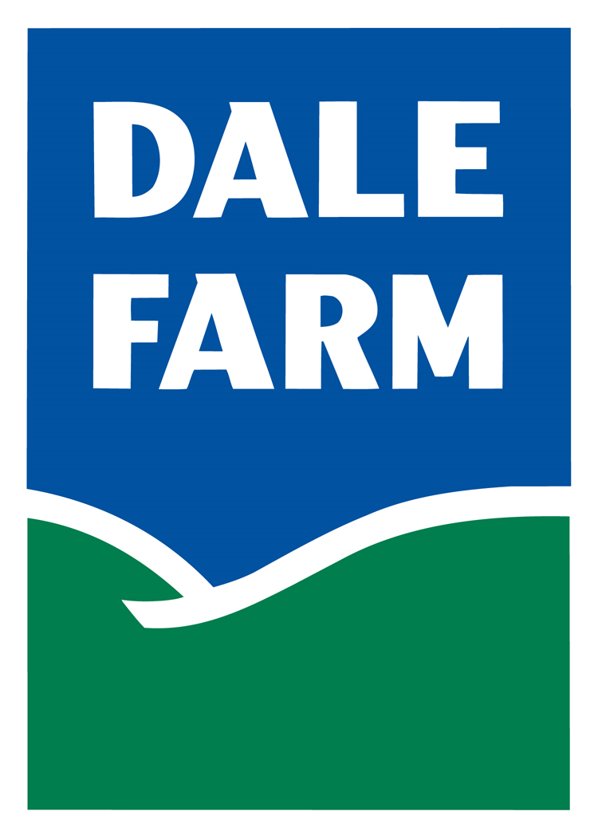

 



AFQCC Dairy Colostrum Project 2017 FARMER APPLICATION

|  |  |  |  |
| --- | --- | --- | --- |
| Name |  | | |
| Address |  | | |
| County | Choose an item. | Postcode: |  |
| Mobile No. |  | | |

|  |  |
| --- | --- |
| **Farm Profile** | |
| Farm size (ha) |  |
| Number of cows |  |
| Production system |  |
| Grazing platform (ha) |  |
| Feeding system (self feed, easy feed, TMR) |  |
| Milk sold / year (litres) |  |

|  |  |
| --- | --- |
| **Herd Structure** | |
| Cow breed type (% Holstein, Jersey, etc in herd) |  |
| Calving pattern (Autumn, Spring, Autumn through Spring, Year-round) |  |
| Number of cows calving  (October – Mid-December) |  |
| Number of cows calving  (January – February) |  |
| Percentage of cows bred to AI / natural service |  |
| Total concentrate fed to herd (tonnes) |  |

**Additional Questions:**

1. How many cows in the herd will calving down for their second and third lactation in autumn of 2017 and Spring of 2018?

1st October to 15th December 2017

1st January to 28th February 2018

1. Do you milk record? (Please circle accordingly) Yes No

If yes, Do you record on a monthly, six weeks or eight weeks basis (Please circle accordingly)

1. Are you currently in a Business Development Group? (Please circle accordingly)
2. Yes
3. No
4. Not currently but have applied
5. Do you currently benchmark with CAFRE? (Please circle accordingly)
6. Yes
7. No
8. Not yet but plan too
9. Do you have freezer storage facilities available on-site to store colostrum samples? (Please circle accordingly)
10. Yes
11. No