

**Project D-33-06**

**Increasing dairy cow intakes by optimising feeding system design**

**Final Report for AgriSearch**

March 2012

**Research team: Conrad Ferris, Niamh O’Connell,   
Desmond Patterson, Sinclair Mayne, David Kilpatrick**

**Report prepared by Conrad Ferris and Niamh O’Connell**

**Agri-Food and Biosciences Institute, Agriculture Branch, Hillsborough, County Down, Northern Ireland BT26 6DR**



# STRUCTURE OF REPORT

This project was established to examine the impact of non-nutritional factors on food intake, milk production performance and behaviour of lactating dairy cows. A total of six experiments were undertaken within this project.

This report begins with an ‘Executive summary’ which highlights key aspects of the project. This is followed by three separate chapters: Chapter 1 presents the findings of two experiments which were conducted to examine the impact of feed space allowance and a period of access to food, on milk production and cow behaviour. Chapter 2 presents the findings of a study designed to examine interactions between feed barrier design and feed space allowance on cow performance and cow behaviour. The results of this paper have already been published in the scientific journal, Applied Animal Behaviour Science. Chapter three presents the findings of three small scale experiments which examined a number of diverse non-nutritional strategies. These ‘novel’ studies were undertaken to provide possible direction for future larger scale research areas. The report concludes with a summary of scientific outputs arising from the project.

**LIST OF CONTENTS**

|  |  |
| --- | --- |
|  | Page No |
| **Executive summary** | 1 |
| **Chapter 1:**  The effect of feed space allowance and period of access to food on dairy cow performance and behaviour (Experiments 1 and 2) | 11 |
| **Chapter 2:**  Effect of feed barrier design and feed space allowance on performance and behavioural parameters in dairy cows (Experiment 3) | 41 |
| **Chapter 3:**  Effect of feed delivery time on the performance of mid/late lactation dairy cows (Experiment 4)  The effect of roughness of the feeding area surface on the short term intakes of dairy cattle (Experiment 5)  The effect of altering the floor surface, on the intake and behaviour of housed dairy cows (Experiment 6) | 69  73  77 |
| **Technology transfer associated with the project** | 81 |

**EXECUTIVE SUMMARY**

**Background**

Meeting the higher nutrient requirements of high yielding dairy cows remains a key challenge. While many studies have examined nutritional approaches to achieve increased food intakes, for example increasing the nutrient density of the diet, ‘non nutritional strategies’ may also have an important role in achieving higher intakes. Feed space allowance and period of food access are often suggested as two important non-nutritional strategies.

While a number of dairy cow studies have examined the impact of feed space allowance and period of access to food, the primary objective of most of these studies was to examine cow behaviour rather than animal performance. Indeed, the majority of studies where information on cow performance has been presented involved short-term measurement periods. In addition, a number of studies examining the impact of competition at feeding have involved increasing the number of cows sharing each ‘feed box’, while most studies examining the impact of access time to food have involved cows confined in individual tie stall. Neither of these scenarios would appear to be directly applicable to group housed cows accessing food from an ‘open’ feed barrier.

Within the scientific literature, remarkably few studies have examined the impact of feed space allowance or period of access to food on cow performance over a reasonable time scale using commercial feeding systems. Thus Experiments 1-3 were designed to examine the impact of feed space allowance, period of access to food and feed barrier design, on cow performance.

Experiments 4-6 were smaller scale experiments which examined a number of diverse non-nutritional strategies. These ‘novel’ small scale studies were undertaken to provide direction for possible future larger scale research projects.

**Experiment 1**

As most food consumed by housed cows is consumed at a feed barrier, ensuring that cows have adequate feed space has often been suggested as a key factor controlling intake. This is particularly important at present in view of the ongoing trend towards increasing herd size on many farms. While 0.6 m of horizontal feed space per cow is commonly recommended, there appears to be little science behind this value, with recommendations ranging from 0.2 to 1.0 m per cow. To address this issue, an experiment was undertaken to examine the effect of feed space allowance on the performance of dairy cows offered grass silage-based diets.

Forty-two Holstein-Friesian dairy cows were allocated to one of three treatment groups (nine multiparous and five primiparous cows per group) at calving. Within each pen cows accessed food via a ‘post and rail’ type feed barrier. Treatments examined comprised three horizontal feed space allowances, namely 20, 40 and 60 cm/cow.

The experiment commenced with 14 late lactation non-experimental cows occupying each pen. Experimental cows were then transferred into the appropriate experimental pen within 36 hours of calving, and non-experimental cows removed, with the process repeated until each pen contained 14 experimental cows. Cows remained in their experimental groups for a mean of 127 days post-calving, with the period from the last cow calved until the end of the experiment being 88 days.

# Throughout the experiment cows had *ad libitum* access to a diet comprising grass silage and concentrates (65:35 DM ratio).

Mean DM intakes with the 20, 40 and 60 cm/cow treatments were 19.0, 18.7 and 19.3 kg/cow/day, with differences between treatments being numerically small. Feed space allowance had no significant effect on milk yield per cow, milk composition, milk somatic cell count, or on cow live weight or body condition score at the end of the experiment (P>0.05).

Restricting feed space allowance resulted in a change in time budget, with the number of animals feeding during the periods immediately after access to fresh food decreasing as space allowance decreased. This was associated with an increase in frequency of aggressive behaviours with the lower space allowance treatments during the period after fresh food was offered and during the period after cows returned following pm milking. However, these periods of ‘increased’ aggression had no effect on any aspect of cow performance.

The results of this experiment provides no evidence that the feed space allowances examined had a detrimental effect on any of the cow performance parameters measured. When examined purely from an animal production point of view, a space allowance of 20 cm/cow would appear to have been adequate for the cows within this experiment.

However, at a feed space allowance of 20 cm per cow there were practical difficulties in being able to place the full allowance of food for a 24-hour period in front of the space available at the barrier, with cows more likely to pull food into the pen resulting in food wastage.

**Experiment 2**

While it is normally considered prudent to ensure that dairy cows have access to food at all times, management practices on farms may on occasions result in cows running out of food for a period of time before fresh food is offered. In addition, it might be expected that the impact of not having access to food would be more dramatic under a restricted feed space allowance. Indeed, it has been suggested that the critical amount of manger space below which competition occurs depends on the time that feed is in the manger. To address these issues, an experiment was undertaken to examine the relationship between feed space allowance per cow, and period of access to food, on the performance of dairy cows.

Forty-eight Holstein-Friesian dairy cows were used in a continuous 2 x 2 factorial design experiment (10 weeks duration). Thirty-two cows were multiparous, while the remaining were primiparous. Eight multiparous and four primiparous cows were allocated to each treatment, with cows a mean of 141 days calved when the study commenced.

Throughout the experiment cows were kept in four adjacent but visually isolated pens (12 cows per pen) of equal size and similar layout, and accessed food via a ‘post and rail’ type feed barrier. Treatments examined comprised two horizontal feed space allowances (15 and 40 cm/cow), and two periods of access to food (unrestricted and restricted). With the former, uneaten feed was removed at 08.00 hours, while feeding took place at 09.00 hours. With the latter, uneaten feed was removed at 06.00 hours, while feeding was delayed until 12.00 hours.

Fresh food was offered *ad libitum* with all treatments. Food was offered daily in the form of a complete diet comprising forage and concentrates (60:40 DM basis).

Total DM intakes were 18.1 and 18.2 kg/day with the ‘restricted feeding time’ treatments (15 and 40 cm respectively) and 17.8 and 18.1 kg/day with the ‘unrestricted feeding time’ treatments (15 and 40 cm respectively). These differences in food intake were numerically very small. Treatment had no significant effect on milk yield, milk composition, or end of study live weight and body condition score (P>0.05).

A restricted feed space allowance and a reduced period of access to food resulted in a change in time budget, with the number of animals feeding during the periods immediately after access to fresh food decreasing as space allowance decreased. The restricted space allowance was associated with an increase in the frequency of butting (P=0.048) after fresh food was offered, and a trend towards an increase in pushing during the 30 minute period following pm milking (P=0.065). Period of access to food had no significant effect on any of the behaviours observed.

Feed space allowance had no significant effect on any of the performance parameters examined within this experiment. Thus from a cow performance point of view, it would appear that a feed space allowance of 15 cm per cow may be adequate for mid lactation cows. In addition, restricting the period of time during which cows had access to food had no effect on cow performance, even at a space allowance of 15 cm/cow.

However, within the current study the feeding time restriction was applied continuously throughout the experiment, and cows appeared to become accustomed to this scenario. It is possible that not having access to food on random occasions (i.e. occasionally running out of food) may actually be more stressful for cows than a regular period without access to food.

**Experiment 3**

Sixty mid-lactation Holstein-Friesian dairy cows (40 mature cows and 20 first lactation heifers) were allocated to one of four treatments in a 2 x 2 factorial design arrangement. The treatments involved two feed barrier space allowances (56 cm/cow (“high”) or 20 cm/cow (“low”)) and two feed barrier designs (‘open’ or ‘individual head spaces’). The ‘open’ barrier was a standard post and rail design, whereas ‘individual head spaces’ were created using vertical bars.

Cows were housed in groups of 15 animals (10 cows and 5 heifers). A completely balanced changeover design was applied over four 5-week periods.

There was no significant effect of treatment on dry matter intake, or on average daily milk yield (average values: 21.7 kg/day and 32.0 kg/day respectively). However, there was a significant interaction between feed barrier design and space allowance on milk protein levels. The milk protein content of milk produced by animals in the ‘open’ barrier treatment was higher when a high space allowance was provided rather than a low space allowance (Individual head spaces: ‘high’ 35.7, ‘low’ 35.5; Open barrier: ‘high’ 36.0, ‘low’ 35.2; (g/kg); P<0.05). Milk fat and protein yield was similarly affected. The reason for these effects is unclear.

The average number of animals at the feed barrier increased as feed barrier space allowance increased (P<0.001), but was not significantly affected by barrier design. The proportion of animals at the feed barrier or in the feed passage that were heifers, and the total number of animals in the feed passage, was not significantly affected by treatment (average values: 0.34, 0.31, 0.55 animals, respectively).

There was no significant interaction between feed barrier treatment and time period during the day on the number of animals at the feed barrier, suggesting that feeding patterns were similar between treatments.

Reducing feed barrier space allowance led to a significant increase in aggressive behaviour when individual head spaces were used, but not when open barriers were used. It is suggested that it may be more difficult to displace animals when individual head spaces are used, and that this exacerbates aggression in competitive situations.

It is concluded that reducing feed barrier space allowance from 56 to 20 cm/animal does not adversely affect feed intake or milk yield levels in mid-lactation dairy cows when using either open barrier or individual head space barriers. In addition, the effects of using individual head spaces in the feed barrier on levels of aggression differ depending on the feed space allocation provided.

**Experiment 4**

Within a grazing context cows are known to have one of their main grazing bouts during the evening, and as such it has been suggested that synchronising feeding with this grazing bout may encourage cows to consume more. In one Canadian study total daily dry matter intake was 2.0 kg higher with evening fed cows than with morning fed cows. As this research does not appear to have been replicated elsewhere, a study was conducted to examine the impact of feed delivery time on cow performance under UK conditions.

Twenty-four late lactation multiparous Holstein-Friesian dairy cattle were used in a two-period (each of five weeks duration) completely balanced change-over design experiment involving two treatments. Treatments examined the effect of either morning (AM feeding) or evening (PM feeding) feed delivery time. With the AM feeding treatment cows were given access to fresh food at approximately 09.30 hours, while with the PM feeding treatment cows were given access to fresh food at approximately 18.00 hours.

Total DM intakes were 20.5 and 20.1 kg/cow/day with the AM and PM feeding treatments, respectively. In addition, feed delivery time had no effect on milk yield, milk composition or fat + protein yield, reflecting the similar intakes observed with both treatments.

This study provided no evidence that either food intake or cow performance can be improved by feeding dairy cows in the evening, rather than the morning.

**Experiment 5**

In many livestock houses concrete feed passages have become corroded by long term exposure to silage acids, often exposing sharp aggregates within the concrete, and leaving the feeding surface rough. However, there is anecdotal evidence that rough feed passage surfaces may have a negative effect on the intake of dairy cattle. To address this issue, an experiment was conducted to examine the effect of roughness of the surface of the feeding area on the short term intake of dairy cattle.

Fourteen late lactation Jersey **×** Holstein crossbred cows were used in a two-treatment completely balanced change over design experiment, with cows paired on the basis of milk yield. Treatments comprised cows consuming food from either a Rough (concrete feed passage with aggregate exposed) or Smooth (recycled plastic) feeding surface.

The experiment was initially conducted using a forage mix as the test diet, and then repeated using a pelleted concentrate as the test diet. With each test diet, intakes were measured during two consecutive days. On Day 1, one cow from each pair was assigned to the Rough treatment, and the second cow to the Smooth treatment, with treatments reversed on Day 2.

Each cow was brought into the pen individually and offered 1.5 kg of the forage mix (fresh basis), with the quantity of food remaining uneaten recorded after 180 seconds. This process was repeated approximately one week later, with cows given access to 1.0 kg of pelleted concentrate for 90 seconds.

When offered the forage mixture, DM intake was unaffected by roughness of the feeding surface (P>0.05). However, when offered the concentrate pellets, intakes were significantly lower for cows feeding from the rough compared to the smooth surface (P<0.05).

This experiment provided clear evidence that during short term measurement periods cows consumed concentrates at a slower rate from a rough surface than from a smooth surface. That forage intakes were unaffected by the feeding surface may be due to the cows being able to consume the bulky forage while making minimal contact with the surface with their tongues.

Feeding from a smooth feed surface is likely to minimise the risk of damage to the cows tongue, with subsequent risk of infection. In addition, it is much easier to keep smooth feed surfaces clean. Longer term studies are required to identify if food intake and cow performance are influenced by the roughness of the feeding surface.

**Experiment 6**

Housed dairy cows spend approximately 4-5 hours per day eating, and normally stand on a concrete surface during this time. However, concrete surfaces are known to contribute to hoof lesions, and subsequent lameness problems. It has been suggested that improving cow comfort at the feeding area, for example, by providing a more ‘comfortable’ standing surface, may promote total dry matter (DM) intake, and improve hoof health and cow welfare. This study was designed to examine food intake and cow behaviour as a result of placing matting along the standing area behind a feed barrier.

Eighteen late lactation (mean, 398 days in milk) Holstein-Friesian dairy cows (mean milk yield, 14.3 kg) were used in a two-treatment (9 cows per treatment), four period (period length, 10 days), changeover design experiment. Cows were divided into two groups, each of nine cows, with groups balanced for lactation number, days calved, milk yield, live weight and condition score. The two groups were housed separately, side by side, in cubicle accommodation.

A 28 mm thick compression moulded mat made from expanded polymers was attached to the floor behind the feed barrier in one pen. The two groups of cows rotated between pens, so that each group was on each treatment (Mat or Concrete) twice. Grass silage was offered *ad libitum* once daily. Feed intakes were measured during days 6-10 of each experimental period.

Total DM intakes were 15.4 and 15.8 kg/day with the Concrete and Mat treatments respectively (P>0.05). Treatment had no significant effect on the number of animals observed at different locations within each pen, and the number of animals eating, or standing at the feeding area over the 12-hour observation period.

Placing a compression moulded mat behind a feed barrier had no significant effect on either intake or cow behaviour, compared to cows standing on concrete.

**CHAPTER 1**

**The effect of feed space allowance and period of access to food on dairy cow performance and behaviour (Experiments 1 and 2)**

**Effect of feed space allowance per cow and period of access to feed, on dairy cow performance and behaviour**

**INTRODUCTION**

Achieving high nutrient intakes is generally recognised as a key management strategy for dairy cows of high yield potential. While dietary strategies such as improving forage quality or increasing concentrate feed levels can promote food intake (Ferris *et al*., 2001), non-nutritional strategies such as optimising the cow-food interface may also have a role in promoting intake. In particular, ensuring that cows have an adequate feed space allowance and adequate access times to food are often highlighted as important non-nutritional strategies to maximise intake. With regards feed space, Grant and Albright (2001) have mentioned a ‘traditional recommendation’ of 0.6 m/cow, while an allowance of 0.65-0.67 m for a 600 kg cow has been made by Defra (2006). The rational for these recommendations appears to be that this is the space occupied by one cow when feeding, and that all cows should be able to feed at any one time. However, feed space allowances of more that 0.6 m/cow have recently been suggested as a means of reducing the frequency of aggressive behaviours (DeVries and von Keyserlingk, 2006). In relation to food access time, it is normally suggested that the period during which cows do not have access to food should be minimised. Indeed, the relationship between feed space available and food access time was highlighted by Albright (1993) who suggested that the critical length of manger space below which competition occurs depends on the time that food is in the manger.

While a number of dairy cow studies have examined different feed space allowances and feed access times, the primary objective of most of these studies was to examine cow behaviour rather than animal performance. Indeed, a number of studies examining different feed space allowances make no mention of cow performance (DeVries *et al.*, 2004; DeVries and von Keyserlingk, 2006). However, in the majority of studies where information on cow performance has been presented, measurement periods were normally short, typically one week (Friend *et al.*, 1976: Collis *et al*., 1980). In addition, a number of studies examining the impact of competition at feeding have involved increasing the number of cows sharing each ‘feed space’ (Olofsson, 1999; Elizalde and Mayne, 2009), while most studies examining the impact of food access time have involved cows confined in individual tie stall (Collings *et al.*, 2011). Unfortunately, neither of these scenarios would appear to be directly applicable to group housed cows accessing food from an ‘open’ feed barrier. Indeed, remarkably few studies have examined the impact of feed space allowance or period of access to food on cow performance over a reasonable time scale using typical commercial feeding systems.

With this in mind, DeVries and von Keyserlingk (2006) concluded that work is required to understand the long term implications of increasing food access and reducing competition at the feed bunk on dry matter intake, milk production and health of lactating dairy cows, particularly those in early lactation.Thus the experiments presented within this paper were conducted with the primary objective of examining the impact of feed space allowance and period of access to food on cow performance.

**MATERIALS AND METHODS**

Two experiments were conducted to examine the effect of feed space allowance per cow (Experiment 1), and the interaction between feed space allowance per cow and period of access to food (Experiment 2), on dairy cow performance and behaviour.

**Experiment 1**

This three treatment continuous design experiment involved forty-two Holstein-Friesian dairy cows (mean Predicted Transmitting Ability [PTA2005] for fat plus protein yield, 18.2 [s.d., 12.46] kg), comprising 15 primiparous cows (five per treatment) and 27 multiparous cows (nine per treatment). Cows calved between 20 November and 10 February, and had a mean calving date of 1 January (s.d. 25.5 days). Cows were allocated to one of three treatment groups, with groups balanced (primiparous and multiparous cows within each group balanced separately) for PTA2005 fat + protein yield, and for live weight, condition score, expected calving date, cow height and cow girth diameter (measured approximately two weeks pre-calving). In addition, multiparous cows were balanced for lactation number and previous lactation milk composition.

Throughout the experiment cows were housed in a cow shed, in one of three adjacent pens, with the layout of pens 1 and 3 being identical, while pen 2 was a mirror image of pens 1 and 3. Each pen (dimensions: 855 cm x 1306 cm) was fitted with sixteen cubicles configured in three rows. The layout of each pen (from the front to the back of the pen) was as follows: a feed barrier (with a potential feed space allowance of 845 cm), a standing passage (375 cm wide), two rows each of five cubicles (cubicle dimension: 220 x 122 cm) arranged ‘head to head’, a second standing passage (246 cm wide), and a row of six cubicles (cubicle dimension: 246 x 122 cm) facing the back wall of the pen. Cows moved between the front and back of the pen via a 244 cm wide ‘cow pass’, and exited the pen via a cow pass located in the back wall. Each pen was fitted with a drinker and an out-of-parlour feeder (not in use), while each standing passage was scraped by an automatic scraper which operated six times daily. A plan of the pen layout has already been presented by O’Connell *et al.* (2010). Cubicles were fitted with rubber filled cow mats, approximately 6.0 cm deep. The divisions between pens were solid from 60 cm to 185 cm above floor level, thus visually isolating cows from those in adjacent pens. Feed barriers in all pens were ‘post and rail’ design and comprised a 10 cm wide concrete wall (inside pen height of 45 cm, outside pen height 40 cm), with the vertical feeding space defined by an upper and lower horizontal bar (6 cm diameter).

Treatments examined comprised three horizontal feed space allowances, namely 20, 40 and 60 cm/cow, the total feed space available for each treatment pen being 280, 560 and 845 cm, respectively. Within each of the latter two treatments, the feed space was ‘interrupted’ by either one or two steel vertical bars (10 x 10 cm), respectively. The space occupied by these bars was included within the ‘available’ feed space described. With the 20 and 40 cm/cow treatments, the boundary of the feed space on the inside of the pen was defined by a ‘divider’ at 90° to the pen, and which extended 95 cm into the pen. This divider restricted access to the feed barrier so that only cows standing directly behind the barrier were able to gain access to feed. On the outside of the pens, food was prevented from ‘spilling’ beyond the end of each barrier by a wooden wall.

The experiment commenced with each treatment pen occupied by 14 late lactation non-experimental cows, with each group of non-experimental cows balanced for milk yield and live weight. Experimental cows were transferred into their treatment group within 24 hours of calving, and a non-experimental cow removed, with the process repeated until each group comprised 14 experimental cows. By adopting this approach, experimental cows were subject to the designated feed space allowance (20, 40 and 60 cm per cow) from the point of calving, including the time prior to the full experimental group being established. Experimental cows remained on the treatment regimes until 9 May, a mean of 127 days, with the period from the last cow calved, until the end of the study being 88 days.

Cows were offered fresh feed at approximately 09.45 hours, with the ration offered comprising grass silage and concentrates (65:35 DM ratio). The silage offered was produced from a perennial ryegrass-based sward (primary re-growth) which was harvested on 8 August after a period of field wilting of approximately 36 hours. The concentrate component of the diet was in the form of a meal, and had an ingredient composition (on a kg/t air dry basis) as follows: barley 140; wheat 140; unmolassed sugar-beet pulp 95; citrus pulp 95; maize gluten feed 100; maize distillers grains 100; soya bean meal 165; rape meal 100; megalac 12; minerals 23; molasses 30. Sufficient silage for all three treatments was placed in a complete diet mixer wagon and mixed for 3-4 minutes. Sufficient concentrates for all three treatments was then added, and mixing continued for a further 7-8 minutes. This mix was then offered to cows within each of the three treatment groups, with food being offered to each group at proportionally 1.05 of the previous day’s intake. The order in which food was offered to each of the three groups was changed daily. Uneaten food was ‘pushed up’ to the barrier by hand on four occasions during each 24-hour period, at approximately 12.00 hours, 15.30 hours (after cows were removed for evening milking), 21.00 hours, and at 06.30 hours (after cows were removed for morning milking. Uneaten food was removed at approximately 09.00 hours the following day and the weight of uneaten food recorded for each pen. In addition, 1.0 kg of a commercial concentrate was offered in the parlour during milking (0.5 kg at each milking) to all cows. Artificial lighting was maintained in the cow house throughout the duration of the experiment.

**Experiment 2**

Forty-eight Holstein-Friesian dairy cows (mean PTA2005 fat + protein yield, 19.0 [s.d., 11.94] kg) were used in a continuous 2 x 2 factorial design experiment of 10 weeks duration. Thirty-two cows were multiparous (mean lactation number, 3.5), while the remaining cows were primiparous. Cows were a mean of 141 (s.d., 31.1) days calved when the study commenced, with cows having a mean pre-experimental milk yield of 31.1 (s.d., 6.86) kg/day. Cows were allocated to one of four treatment regimes during the week prior to the start of the study, with treatments balanced for calving date, lactation number, current milk yield, milk fat and protein content, cow live weight, condition score and height and girth measurements. Eight multiparous cows and four primiparous cows were allocated to each treatment.

Throughout the experiment cows were kept in four adjacent pens (as described in Experiment 1), with pens 1 and 3 a mirror image of pens 2 and 4. Treatments examined comprised two horizontal feed space allowances (15 and 40 cm per cow) and two periods of access to feed (Restricted and Unrestricted). The feed barriers were as described in Experiment 1, with total available feed space within the 40 and 15 cm/cow treatment pens of 480 cm and 180 cm. With the 40 cm/cow treatments, the feed space was interrupted by a vertical steel bar (10 cm x 10 cm), with the space occupied by this bar included within the space allowance. With all treatments, the boundary of the feed space on the inside of the pen was defined by a ‘divider’ which extended 95 cm into the pen, as described in Experiment 1. On the outside of the pens food was prevented from spilling beyond the end of each feeding space by a wooden retainer.

Cows were offered the experimental ration for a two week period prior to the start of the experiment. The experimental ration comprised forage and concentrates (60:40 DM basis), with the forage component of the diet comprising grass silage and maize silage (60:40 DM basis). The grass silage component of the diet was produced from secondary re-growth herbage (harvested on 4-6 October from predominantly perennial ryegrass based swards), while the maize silage offered was harvested on 1 November. The ingredient composition of the concentrate feed stuff was as described in Experiment 1, while 1.0 kg/day of a commercial concentrate was offered to each cow during milking (0.5 kg at each milking).

With the Restricted access time treatment, uneaten food was removed from the feed barriers when cows were removed for morning milking (at approximately 05.30 hours). With the Unrestricted access time treatment, uneaten food was removed from the feed barriers between 08.00 and 08.30 hours. The weight of uneaten food removed from each pen was recorded daily. Cows on the unrestricted and restricted access time treatments were offered fresh feed at 09.00 and 12.00 (+ 10 minutes). Rations were prepared as follows: sufficient grass silage for all four treatments was added to the mixer wagon and mixed for approximately 5 minutes, with sufficient silage for the restricted access time treatment then deposited on a clean floor in a roofed silo. The required quantities of maize silage and concentrates for the unrestricted access time treatments were then added to the wagon, and mixing continued for a further 7-8 minutes, with this food being offered to the non-restricted feeding treatment. After 11.00 hours, the remainder of the silage was placed back in the wagon, and the appropriate quantity of silage and concentrate added, and mixed as above, and subsequently fed. Maize silage blocks for the restricted and non restricted feeding were removed from adjacent positions in the silo to ensure similar composition. Food was offered to each treatment group at proportionally 1.1 of the previous days intake. The order in which food was offered to the two space allowance treatments within the Restricted and Unrestricted access time treatments was alternated daily. Uneaten food was pushed up to the barrier at 12.00 hours (Unrestricted access time only), 15.30 hours (after cows were removed for evening milking), at 21.00 hours, and at 06.30 hours (after cows were removed for morning milking: Unrestricted access time only). During the first few days of the experiment it was discovered that cows with the 15 cm space allowance tended to push food out during the night (between 21.00 hours and 06.30 hours, so that a significant proportion of food was placed beyond the reach of cows. To overcome this problem, a wood shield was placed along the front of the feed barriers with these treatments at 21.00 hours to maintain food within the reach of the cows. This problem did not arise with the 40 cm feed space allowance treatments.

***Measurements***

Cows were milked twice daily, between 05:30 and 06.30 hours and between 14:30 and 16:30 hours, with milk yields recorded automatically at each milking. The order in which each group of cows were removed for milking, milked, and returned to their pen post milking was maintained throughout the study, thus ensuring that each treatment group was away from food for a similar period of time. Throughout the experiments, milk samples were collected from each individual cow during two consecutive milkings each week, with each sample analysed for fat, protein and lactose concentrations using a Milkoscan FT120 (Foss Electric, Hillerød, Denmark). A weighted mean milk composition for each animal was subsequently calculated. Cow live weights were recorded weekly throughout each experiment. Food intakes were recorded daily throughout each experiment, as the difference between food offered and refused, with the calculation assuming no preferential selection of individual feed ingredients from the mixture offered. The oven dry matter (ODM) of the silages offered was determined daily throughout, while a fresh sample of each of the silages offered was analysed weekly throughout the study for nitrogen, pH, ammonia N, lactic acid, volatile components. In addition, dried silage samples were bulked over each two week period and analysed for neutral detergent fibre (NDF), acid detergent fibre (ADF) and ash concentrations, and in the case of maize silage, for starch. A bulked sample of the concentrate offered during each four week period was analysed for ODM, with the dried sample subsequently milled and analysed for nitrogen, NDF, ADF and ash concentrations.

Within each experiment each pen was video recorded (in 24-hour time lapse mode) continuously for one 24-hour period during each week. Tapes were scanned at 30 minute intervals to determine the total number of animals, and the number of heifers (identified by paint marks on their backs) at the feed barrier, standing in the passageway behind the feed barrier, and lying (Experiment 1), and the total number of animals at the feed barrier and standing in the passageway behind the feed barrier in Experiment 2. An animal was defined as being at the feed barrier if its head was through, or in contact with the barrier, or if the cow was part of a row of animals feeding at the barrier. The mean number of animals at each ‘position’ was averaged over the two observation periods each hour, and used to plot diurnal feeding patterns. The observations where animals were not present in the pen due to milking were not included in the analysis. In addition, mean number of animals at each position during the 24-hour period and during two 12-hour periods were subsequently determined (09.00 – 21.00, 21.00 – 09.00).

On one day each week during each of Experiments 1 and 2, all treatment groups were video recorded in real time for 30 minutes immediately after fresh food was offered in the morning and for 30 minutes after animals accessed fresh food after returning from evening milking. The frequency of butting and pushing per animal (per 5-minute period) was subsequently determined during each of these 30 minute observation periods, and the mean frequency during the six observation periods (during each 30-minute period) subsequently determined.

***Statistical analysis***

As food intakes were recorded on a group intake basis, it was not possible to undertake a statistical analysis of intake data in either experiment. Milk production and ‘end of study’ body tissue reserves were analysed using the individual cow data as the experimental unit. Mean performance data in Experiment 1 were analysed using ANOVA according to the three treatment design, while mean performance data in Experiment 2 were analysed according the 2 (feed space allowances) x 2 (periods of access to food) factorial design nature of the experiment.

**RESULTS**

The grass silages offered in Experiments 1 and 2 (Table 1) were both well fermented, with ammonia N concentrations of 52 and 79 g/kg total N, respectively, and crude protein concentrations of 166 and 171 g/kg DM, respectively. While the maize silage offered in Experiment 2 had a high DM content (343 g/kg), its starch content was low (216 g/kg DM).

A statistical comparison of treatment effects on food intake was not possible as group intakes were recorded in each of Experiments 1 and 2. Nevertheless, in Experiment 1 total daily DM intake with the 20 cm treatment was numerically 0.3 kg higher than for the 40 cm treatment, and 0.3 kg lower than for the 60 cm treatment (Table 2). In Experiment 2, total daily DM intakes with the 15 cm treatments were on average 0.2 kg lower than with the 40 cm treatments, while intakes with the restricted and unrestricted feeding time treatments both averaged 18.2 kg DM/cow/day. Feed space allowance (20, 40 or 60 cm/cow) had no effect on daily milk yield, or milk composition throughout the experimental period in Experiment 1 (Table 2), or on end of study body condition score or live weight. Similarly, neither feed space per cow or period of access to food had a significant effect on daily milk yield or milk composition during Experiment 2 (Table 3), or on the end of study live weight or body condition score.

**Photos demonstrating differing feed space allowances in Experiment 1**

**20 cm/cow**

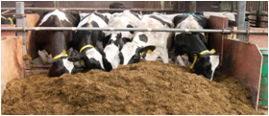

**40 cm/cow**



**60 cm/cow**

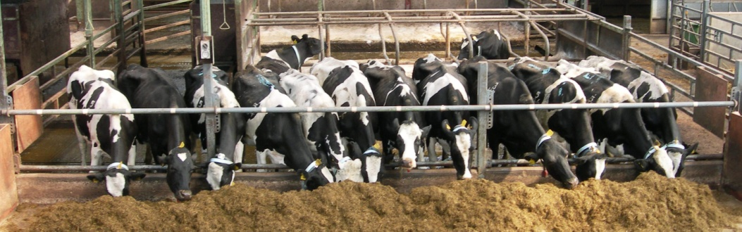

**Table 1** Chemical composition of feedstuffs offered in Experiment 1 and 2

|  |  |  |  |  |  |  |  |  |  |  |
| --- | --- | --- | --- | --- | --- | --- | --- | --- | --- | --- |
|  | Experiment 1 | |  | Experiment 2 | | | |  | Experiments 1 and 2 | |
|  | Grass silage | s.d. |  | Grass silage | s.d. | Maize silage | s.d. |  | Concentrate | s.d. |
| Oven dry matter (g/kg) | 377 | 62.4 |  | 264 | 23.9 | 329 | 23.5 |  | 880 | 7.7 |
| Corrected dry matter (g/kg) | 387 | 61.5 |  | 280 | 26.4 | 343 | 22.9 |  |  |  |
| Ammonia N (g/kg total N) | 52 | 10.0 |  | 79 | 8.0 | 104 | 9.1 |  |  |  |
| pH | 4.05 | 0.164 |  | 3.80 | 0.126 | 3.65 | 0.038 |  |  |  |
| Gross Energy (MJ/kg DM) | 19.2 | 1.44 |  | 18.9 | 0.82 | 18.7 | 0.79 |  |  |  |
| Crude protein | 166 | 20.3 |  | 171 | 21.5 | 77 | 4.4 |  | 211 | 14.6 |
| Lactic Acid | 74 | 35.6 |  | 170 | 36.0 | 61 | 13.4 |  |  |  |
| Acetic Acid | 7.2 | 2.08 |  | 14.5 | 1.68 | 16.1 | 4.72 |  |  |  |
| Propionic Acid | 0.1 | 0.12 |  | 0.2 | 0.18 | 0.3 | 0.61 |  |  |  |
| Ash | 110 | 7.1 |  | 107 | 9.8 | 38 | 13.8 |  | 77 | 4.0 |
| Acid Detergent Fibre | 303 | 13.5 |  | 305 | 9.3 | 286 | 18.7 |  | 114 | 10.8 |
| Neutral Detergent Fibre | 506 | 19.8 |  | 518 | 21.2 | 525 | 30.4 |  | 262 | 16.4 |
| Starch |  |  |  |  |  | 216 | 28.8 |  |  |  |

**Table 2** Effect of feed space allowance per cow on the performance of dairy cows (Experiment 1)

|  |  |  |  |  |  |
| --- | --- | --- | --- | --- | --- |
|  | Feed space per cow | | |  |  |
|  | 20 cm | 40 cm | 60 cm | SEM | Signif-icance |
| Total DM intake (kg/day) | 19.0 | 18.7 | 19.3 |  |  |
| Total milk output (kg/day) | 3820 | 3823 | 3705 | 164.4 | NS |
| Milk yield (kg/day) | 32.2 | 31.5 | 31.0 | 1.89 | NS |
| Milk fat (g/kg) | 42.4 | 42.1 | 42.2 | 0.86 | NS |
| Milk protein (g/kg) | 31.3 | 31.2 | 32.3 | 0.457 | NS |
| Milk lactose (g/kg) | 48.6 | 48.2 | 48.8 | 0.39 | NS |
| End of study condition score | 2.6 | 2.6 | 2.6 | 0.05 | NS |
| End of study live weight (kg) | 585 | 595 | 608 | 8.9 | NS |

The mean number of cows at the feed barrier (Figure 1), standing behind the barrier (Figure 2) and lying (Figure 3) are presented at hourly intervals over a 24-hour period within Experiment 1. During the one-hour period after fresh food was offered, approximately 9, 7 and 4 cows were observed at the feed barrier with treatments 20, 40 and 60 cm, respectively. While numbers feeding decreased over the seven-hour period after fresh food was offered with treatments 40 and 60 cm, the number of cows feeding with treatment 20 cm remained relatively constant during this period. A similar trend, although of a shorter duration (approximately 2 hours) was observed after cows returned following evening milking. During the rest of the 24-hour period the number of cows feeding appeared to be relatively similar with all three treatments. Over this 24-hour period, there were on average 2.9, 3.6 and 3.8 cows at the feed barrier with treatments 20 cm, 40 cm and 60 cm, respectively (SEM, 0.046; P<0.001), while the respective values for the mean number of heifers at the feed barrier and the proportion of heifers at the feed barrier was 1.1, 1.3 and 1.4 (SEM, 0.039; P<0.001) and 0.34, 0.34 and 0.39 (SEM, 0.013; P<0.05), respectively. Over the full observation period, neither the number of animals standing or the number of animals lying was affected by treatment. The frequency of butting and pushing decreased in a linear manner during the 30 minutes after fresh food was offered in the morning and during the 30-minute period after cows had access to food following evening milking (combined), from the 20 cm treatment through to the 60 cm treatment. The frequency of butting and pushing was lower during the 30-minute period following evening milking than during the period following access to fresh food in the morning. With the exception of butting, there were no treatment x time interactions for any of the other aggressions measured.

Figures 4 and 5 summarise the effect of treatment (on an hourly basis) on the mean number of cows at the feed barrier and the mean number of cows standing in the passage over a 24-hour period. With the unrestricted treatments, a maximum of six animals were observed feeding with the 40 cm treatment immediately after cows were given access to fresh food, with this number declining to approximately four cows at five hours post feeding. With the 15 cm treatment, 2-3 cows were observed to be feeding during the five-hour period following access to fresh food. Following evening milking the number of cows feeding tended to remain higher with the 40 cm treatment, compared to the 15 cm treatment, until approximately 22.00 hours, with only relatively small differences observed thereafter. During the 30-minute period post access to fresh food in the morning, the frequency of butts was higher with the 15 cm/cow treatment than with the 40 cm/cow treatment (P<0.05), although the frequency of pushes was unaffected by treatment. The frequency of none of these behaviours was affected by access time to food. Following the 30-minute period following evening milking neither feed space allowance or period of access to food had an effect on the frequency of any of these behaviours (P<0.05).

**Table 3** Effect of feed space allowance per cow and period of access to food on dairy cow performance (Experiment 2)

|  |  |  |  |  |  |  |  |  |  |  |  |
| --- | --- | --- | --- | --- | --- | --- | --- | --- | --- | --- | --- |
|  | Restricted access time | |  | | Unrestricted access time | |  | | Significance | | |
|  | 15 cm | 40 cm | |  | 15 cm | 40 cm | SEM | Feed space | | Access time | Interaction |
| Total DM intake (kg/day) | 18.1 | 18.2 | |  | 17.8 | 18.1 |  |  | |  |  |
| Milk yield (kg/day) | 29.8 | 30.7 | |  | 29.2 | 29.5 | 0.61 | NS | | NS | NS |
| Milk fat (g/kg) | 39.4 | 41.0 | |  | 40.5 | 41.2 | 0.68 | NS | | NS | NS |
| Milk protein (g/kg) | 32.9 | 32.6 | |  | 32.5 | 33.6 | 0.42 | NS | | NS | NS |
| Milk lactose (g/kg) | 47.3 | 47.7 | |  | 46.6 | 46.9 | 0.59 | NS | | NS | NS |
| End of study condition score | 2.5 | 2.5 | |  | 2.6 | 2.5 | 0.06 | NS | | NS | NS |
| End of study live weight (kg) | 620 | 618 | |  | 636 | 628 | 9.2 | NS | | NS | NS |

**Table 4** Effect of feed space allowance (20, 40 and 60 cm/cow) on the average frequency of aggressive behaviours per animal (per 5 minute period) recorded during the 30-minute period after fresh feed was offered in the morning (AM) and during the 30-minute period after cows had access to food following evening milking (PM) (Experiment 1)

|  |  |  |  |  |  |  |  |  |  |  |  |  |
| --- | --- | --- | --- | --- | --- | --- | --- | --- | --- | --- | --- | --- |
|  | Treatment | | | | | | | | SEM | P values | | |
|  | 20 | |  | 40 | |  | 60 | |
|  | AM | PM |  | AM | PM |  | AM | PM | Treatment | Time | Treatment x Time |
| Butting | 0.0524 | 0.0255 |  | 0.0278 | 0.0151 |  | 0.0124 | 0.0162 | 0.0065 | 0.013 (Lin = 0.004) | 0.009 | 0.023 |
| Pushing | 0.0589 | 0.0904 |  | 0.0447 | 0.0562 |  | 0.0415 | 0.0412 | 0.0087 | 0.003 (Lin <0.001) | 0.057 | 0.208 |
| Total Aggression | 0.1593 | 0.1535 |  | 0.0907 | 0.0903 |  | 0.0715 | 0.0929 | 0.0119 | <0.001 (Lin <0.001) | 0.494 | 0.285 |

**Table 5** Effect of feed space allowance (15 and 40 cm/cow) and period of access to food (unrestricted and restricted) on the average frequency of aggressive behaviours per animal (per 5-minute period) during the 30-minute period after fresh feed was offered in the morning and during the 30-minute period after cows had access to food following evening milking (Experiment 2)

|  |  |  |  |  |  |  |  |  |
| --- | --- | --- | --- | --- | --- | --- | --- | --- |
|  | Feed space per cow (cm) | |  | Access to food | |  | P Values | |
|  | 15 | 40 |  | Unrestricted | Restricted | SED | Feed space | Access |
| During the 30-minute period after fresh food was offered |  |  |  |  |  |  |  |  |
| Butting | 0.0992 | 0.0310 |  | 0.0536 | 0.0765 | 0.00518 | 0.048 | 0.141 |
| Pushing | 0.310 | 0.088 |  | 0.171 | 0.227 | 0.0476 | 0.135 | 0.453 |
| During the 30-minute period after returning from evening milking |  |  |  |  |  |  |  |  |
| Butting | 0.0745 | 0.0336 |  | 0.0327 | 0.0754 | 0.0119 | 0.180 | 0.173 |
| Pushing | 0.320 | 0.089 |  | 0.176 | 0.234 | 0.0237 | 0.065 | 0.247 |

**Figure 1** Effect of feed space allowance on the mean number of cows at the feed barrier throughout a 24-hour period (Experiment 1)

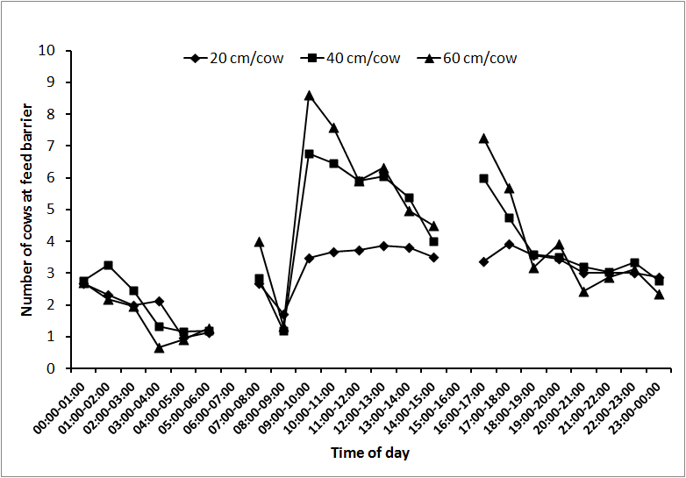

**Figure 2** Effect of feed space allowance on the mean number of cows standing throughout a 24-hour period (Experiment 1)

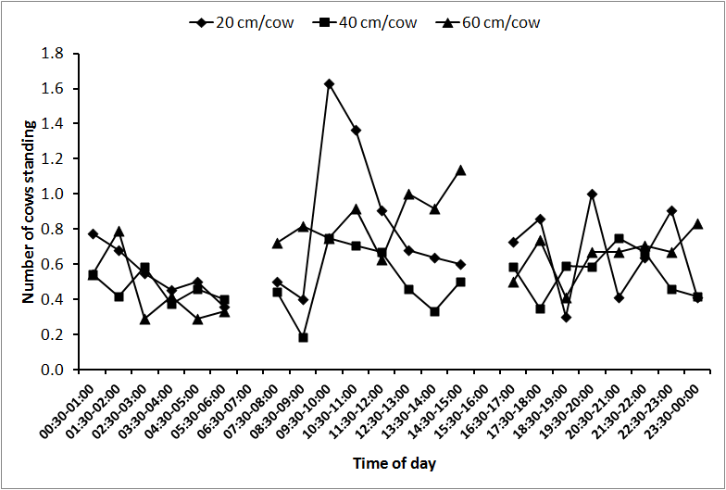

**Figure 3** Effect of feed space allowance on the mean number of cows lying throughout a 24-hour period (Experiment 1)

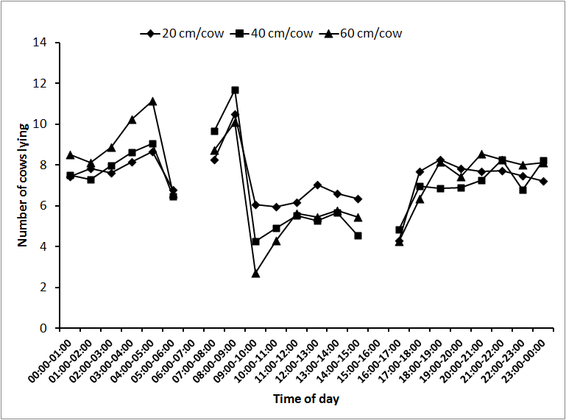

**Figure 4** Effect of feed space allowance and period of access to food on the mean number of cows at the feed barrier throughout a 24-hour period (Experiment 2)

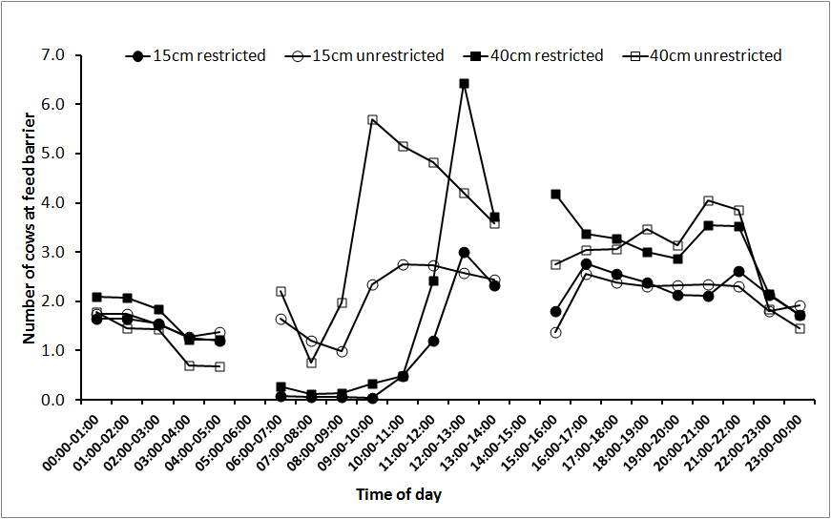

**Figure 5** Effect of feed space allowance and period of access to food on the mean number of cows standing in the passage throughout a 24-hour period (Experiment 2)

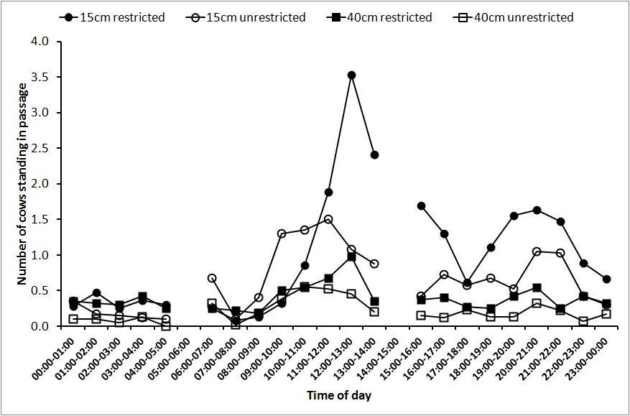

**DISCUSSION**

***Feed space allowance and cow performance***

Experiments 1 and 2 clearly demonstrate that milk production performance was unaffected when feed space allowance was reduced from either 60 to 20 cm per cow, or from 40 to 15 cm per cow. In addition, although group intake data precludes a statistical comparison of differences in intakes between treatments, the numerical difference in intake between the 20 and 60 cm treatment in Experiment 1 was 0.3 kg DM/cow/day, while in Experiment 2 the difference between the 15 and 40 cm/cow treatments was 0.2 kg DM/cow/day. These differences represent less than 1.5 and 1.1% of total food intake with the high feed space allowance treatments in Experiments 1 and 2, respectively.

While the effect of feed space allowance has been examined in a number of experiments, most of these have been designed with cow behaviour as the primary focus. This is highlighted in that a number of experiments examining the effects of feed space allowance make no mention of cow performance. These include studies by DeVries *et al.* (2004) and DeVries and von Keyserlingk (2006) which examined feed space allowances of 50 and 100 cm/cow, and 64 and 92 cm/cow, respectively. However, other studies in which animal performance data were presented have significant limitations due to performance being examined over short measurement periods. For example, Friend *et al*. (1976) and Collis *et al*. (1980) progressively reduced the feed space available for a group of cows on a weekly basis (decreasing incrementally from 50 to 10 cm/cow, and from 105 to 15 cm/cow, respectively). In the former study intake ‘appeared’ to decrease at the 10 cm space allowance, although milk yield was unaffected, while in the latter study milk yield was unaffected by feed space allowance. In one of the few studies in which feed space allowance was examined over a sufficiently long period so as to robustly examine milk production performance (5-week periods), O’Connell *et al.* (2010) found that neither food intake nor milk production performance differed between a feed space allowance of either 20 or 56 cm per cow.

While each of these experiments have examined the effect of linear feed space allowance per cow, a number of other studies have reduced the ‘feed space allowance’ per cow by increasing the number of animals sharing individual feeding places. These include studies by Olofsson (1999) (either one or four cows per feed box), Elizalde and Mayne (2009) (either 1, 3, 5, 7 or 9 cows per Calan gate) and Collings *et al.* (2011) (either one or two cows per feed bin). Neither food intake nor milk production was affected by treatment in any of these studies.

In summary, the results of the current experiments, together with evidence from the literature, provide relatively little evidence that restricted feed space allowances (except when severely restricted) have a negative effect on cow performance. Thus the recommendations that a feed space allowance of at least 60 cm per cow, or that all cows should be able to feed simultaneously, is not supported by data relating to milk production performance. While it is true that many earlier studies involved low yielding cows, the current experiments, together with the findings of O’Connell *et al*. (2010), demonstrate that milk production performance can be maintained at feed space allowances as restrictive as 15-20 cm/cow with groups of cows with a mean milk yield of approximately 30 kg/day.

Within the current experiment all of the diet (with the exception of 1.0 kg concentrate/cow/day offered in-parlour) was offered at the feed barrier in the form of a total mixed ration. This feeding practice was adopted so as to put maximum pressure on the available feed space. However, on many farms a considerable proportion (if not all) of the total daily concentrate allowance may be offered via in-parlour or out-of-parlour concentrate feeding systems. Thus in these situations the pressure on feed barrier space would be expected to be much reduced compared to that within the current experiments. While there appears to be no controlled studies in which the performance of very high yielding cows have been compared across a range of feed space allowances, in a field trial by Menzi and Chase (1994) rolling herd averages of 10 000 kg of milk per annum (40 litres per day) were observed with space allowances of between 37 and 40 cm/cow. Thus this study highlights that high levels of performance can be achieved with feed space allowances considerably lower than the 60 cm normally recommended.

While restricted feed space allowances appear to be possible from a cow performance point of view, severe feed space restrictions create very practical difficulties. For example, when food was offered once daily with the 15 and 20 cm/cow treatments (Experiments 2 and 1, respectively), the bulk of food in front of the feed barrier was such that it tended to spill out over the feed passage, while it was also easier for cows to pull food into and onto the floor of the pen, thus causing wastage.

***Access time to food and cow performance***

As with feed space allowance, information on the impact of restricted access times to food on cow performance is limited, with most published studies having been designed primarily to examine cow behaviour, rather than cow performance. In addition, most studies examining the impact of restricted access time to food have involved cows confined in individual tie stalls, a situation that is quite different to that within a group housed environment. In one such study Erdman *et al.* (1989) observed that neither DM intake (per unit of live weight) nor milk yield differed when cows housed in individual tie stalls accessed food for 8, 12, 16 or 20 hours per day. Similarly, using animals in tie stalls, Munksgaard *et al.* (2005) found that neither intake nor milk yield was affected when period of access to food was reduced from 24 to 12 hours per day. In a separate study these same authors observed a reduction in both milk yield and intake when period of access to food, lying and social contact was reduced from 23 to 12 hours per day, and suggested that time constraints on lying behaviour will have more severe consequences than time constraints on eating. In a study similar to Experiment 2, Collings *et al.* (2011) examined the relationship between space allowances (one vs two cows per feed bin) and duration of access to food (14 hours vs 24 hours). While milk yield was unaffected by treatment, intakes were lower with the restricted access time treatment (P<0.06), although there was no interaction between access time and ‘feeding density’. Nevertheless, cows were only on each treatment for a seven-day period. Similarly, Chapinal *et al.* (2011) imposed a restriction on access time to a TMR by putting cows overnight at pasture, and found no effect on food intake during the course of the day. Thus the results of the current study are largely in agreement with those cited in the literature, namely that cows are able to adapt to a period of restricted access to food without any detrimental effects on performance, even at very low feed space allowances.

However, within the current study cows on the restricted access treatments soon became accustomed to the fact that fresh food was not offered at 09.30 hours, when cows on the unrestricted access treatment were fed. Indeed, after a period of time these cows no longer came to the feed barrier when the latter groups food was being dispensed from the mixer wagon. In this situation, where restriction was associated with a regular feeding pattern, it is likely that cows suffer relatively little stress when food is not present at the barrier. Indeed, Erdman *et al*. (1989) concluded that when enough food is offered for *ad libitum* consumption, and timing of feeding is consistent from day to day, access to feed can be limited to 8 hours per day with no adverse effects. However, it is suggested that in a situation where cows have restricted access to food on an erratic basis, for example when feeding times are variable or when food runs out at various intervals prior to fresh food being offered, cows are more likely to experience stress, than during a regular period without access to food.

***Behaviour patterns***

The diurnal patterns of feed barrier occupancy observed within Experiments 1 and 2 are similar to those reported previously (DeVries *et al.,* 2003; O’Connell *et al.,* 2010), with the greatest level of occupancy observed during the day, especially after fresh food was offered, and after evening milking. However, with the high feed space allowance treatments a greater number of animals were able to feed immediately after fresh food was offered, while only 3-4 cows were able to feed simultaneously with the 20 cm/cow treatment. This difference remained evident during the five-hour period after fresh food was offered, and during the two-hour period after cows returned following evening milking. Thereafter, the number of cows feeding remained relatively constant with all three treatments.

In contrast, there was a trend for a greater number of cows to be observed standing in the feed passage, especially around the time that fresh food was offered, with the restricted access treatments. A similar effect was observed by Huzzey *et al*. (2006) and DeVries and von Keyserlingk (2006), with the latter suggesting that while these cows were motivated to feed at this time, they had to wait for feed space to become available. However, their numbers were relatively small. In contrast, in Experiment 1 there was a trend for a greater number of cows to be observed lying during the five-hour period after fresh food was offered with the 20 cm/cow treatment. This might indicate that less dominant cows simply waited for the feed barrier to become less crowded, before attempting to access food. However, the impact of diet sorting on the quality of diet being consumed by these later feeding cows has been highlighted by DeVries *et al*. (2005), with these authors suggesting that cows feeding later in the day are likely to consume a diet of a lower quality. Thus the results of these two experiments provide clear evidence that cows modify their time budgets to deal with restrictions in feed access. Munksgaard *et al*. (2005) have noted that changes in time budget may reflect adaptation to a specific environment without having any negative consequences for the welfare of animal.

That similar intakes were observed with restricted and unrestricted space allowance treatments, despite the mean number of cows feeding at any one time being quite different, demonstrates that cows modified their intake rates to maintain food intake. Evidence from the literature does indeed confirm that dairy cows have a high capacity to modify their feeding behaviour so as to maintain intakes when access to food is restricted. For example, when the number of cows sharing each feed space was increased from 1 to 9, Elizalde and Mayne (2009) observed that the number of meals per day increased, while mean duration of each meal and total feeding time per day decreased. However, cows were able to maintain their daily intakes by increasing their mean daily intake rates from 29 to 96 g DM/minute. Similarly, Munksgaard *et al.* (2005) using animals in tie stall barns found that neither intake nor milk yield was affected when period of access to food was reduced from 24 to 12 hours per day, although cows with restricted access time to food spent less time eating (243 vs 293 minutes per day) but had an increased rate of feed intake (0.104 vs 0.086 kg/minute). In addition, there is evidence that when access to food is restricted submissive cows will increase their intake rates to a greater extent than dominant cows (Harb *et al*., 1985). While it has been suggested that this increase in intake rate, which has been observed previously after restricted cows are given access to fresh food (Collings *et al*., 2011), could have a detrimental effect on rumen function, cow performance data within the current experiments suggests that rumen function was not impaired. Similarly, neither ruminating time or total chewing time was affected when feed access time was reduced from 20 to 8 hours/day (Erdman *et al.*, 1989).

***Impact of feed space allowance and restricted access to food on aggression***

While the primary aim of these two experiments was to examine the effect of feed space allowance and restricted access time to food on cow performance, the frequency of aggressive interactions were recorded during the 30 minute period after cows had access to fresh food, and after cows returned from evening milking. In common with the findings of previous studies (DeVries *et al*., 2004; DeVries and von Keyserlingk, 2006; O’Connell *et al*., 2010), the frequency of aggressive interactions increased as feed space allowance decreased. In addition, DeVries and von Keyserlingk (2006) observed that when feed space was increased, cows with lower social status at the feed bunk experienced the greatest decrease in the number of times they were displaced each day. As a consequence, DeVries and von Keyserlingk (2006) concluded that from a behavioural point of view there were benefits in increasing feed space allowances beyond the recommended allowance of approximately 60 cm/cow.

Nevertheless, the increased levels of aggression observed within Experiments 1 and 2 were not associated with any reduction in cow performance. However, von Keyserlingk *et al*. (2009) have highlighted that although it is often assumed that poor welfare will be reflected in low milk production, and vice versa, a high level of milk production is no guarantee of high welfare, nor is a low level of production to be taken as an automatic sign of poor welfare. Nevertheless, we can conclude that the increased frequency of aggressive behaviours observed with the lower feed space allowance treatments in Experiments 1 and 2 did not result in a reduction in cow performance.

**ACKNOWLEDGEMENTS**

Thanks are due to the Dairy Unit staff at AFBI Hillsborough for care of the experimental animals and for assisting with experimental measurements. This study was co-funded by the Department of Agriculture and Rural Development (DARD) in Northern Ireland and by AgriSearch (farmer levy).

**REFERENCES**

Albright J.L. (1993) Feeding behavior of dairy cattle. *Journal of Dairy Science,* **76,** 485-498.

Bach A., Valls N., Solans A. and Torrent T. (2008) Associations between non-dietary factors and dairy herd performance. *Journal of Dairy Science,* **91,** 3259-3267.

Chapinal N., Goldhawk C., de Passillé A.M., von Keyserlingk M.A.G., Weary D.M. and Rushen J. (2010) Overnight access to pasture does not reduce milk production or feed intake in dairy cattle. *Livestock Science,* **129,** 104-110.

Chapinal N., Weary D.M., Rushen J., de Passillé A.M., von Keyserlingk M.A.G. (2011) Effects of temporal restriction in availability of the total mixed ration on feeding and competitive behaviour in lactating dairy cows. *Livestock Science,* **137,** 282-286.

Collings L.K.M., Weary D.M., Chapinal N. and von Keyserlingk M.A.G. (2011) Temporal feed restriction and overstocking increase competition for feed by dairy cattle. *Journal of Dairy Science,* **94,** 5480-5486.

Collis K.A., Vagg M.J., Gleed P.T., Copp C.M. and Sansom B.F. (1980) The effects of reducing manger space on dairy cow behaviour and production. *The Veterinary Record,* **107,** 197-198.

Defra (2006) Action of animal health and welfare: housing the modern dairy cow. *hhtp://defra.gov.uk/animalh/welfare/farmed/advice/moderndairycow.pdf.*

DeVries T.J. and von Keyserlingk M.A.G. (2006) Feed stalls affect the social and feeding behavior of lactating dairy cows. *Journal of Dairy Science,* **89,** 3522-3531.

DeVries T.J., Holtshausen L., Oba M. and Beauchemin K.A. (2011) Effect of parity and stage of lactation on feed sorting behavior of lactating dairy cows. *Journal of Dairy Science,* **94,** 4039-4045.

DeVries T.J., von Keyserlingk M.A.G. and Beauchemin K.A. (2003) *Short communication:* Diurnal feeding pattern of lactating dairy cows. *Journal of Dairy Science,* **86,** 4079-4082.

DeVries T.J., von Keyserlingk M.A.G. and Weary D.M. (2004) Effect of feeding space on the inter-cow distance, aggression, and feeding behavior of free-stall housed lactating dairy cows. *Journal of Dairy Science,* **87,** 1432-1438.

Endres M.I. and Espejo L.A. (2010) Feeding management and characteristics of rations for high-producing dairy cows in freestall herds. *Journal of Dairy Science,* **93,** 822-829.

Endres M.I., DeVries T.J., von Keyserlingk M.A.G. and Weary D.M. (2005) *Short Communication:* Effect of feed barrier design on the behavior of loose-housed lactating dairy cows. *Journal of Dairy Science,* **88,** 2377-2380.

Erdman R.A., Moreland T.W. and Stricklin W.R. (1989) Effect of time of feed access on intake and production in lactating dairy cows. *Journal of Dairy Science,* **72,** 1210-1216.

Ferris, C.P., Gordon, F.J., Patterson, D.C., Kilpatrick, D.J., Mayne, C.S. and McCoy, M. (2001) The response of dairy cows of high genetic merit to increasing proportion of concentrate in the diet with a high and medium feed value silage. Journal of Agricultural Science, Cambridge, 136, 319 - 329.

Fregonesi J.A., Tucker C.B. and Weary D.M. (2007) Overstocking reduces lying time in dairy cows. *Journal of Dairy Science,* **90,** 3349-3354.

Friend T.H. and Polan C.E. (1974) Social rank, feeding behaviour, and free stall utilization by dairy cattle. *Journal of Dairy Science,* **57**, 1214 – 1220*.*

Friend T.H., Polan C.E. and McGilliard M.L. (1977) Free stall and feed bunk requirements relative to behavior, production and individual feed intake in dairy cows. *Journal of Dairy Science*, **60**, 108 – 116.

Gibson J.P. (1984) The effects of frequency of feeding on milk production of dairy cattle: an analysis of published results. *Animal Production,* **38,** 181.

Goings R.L. and Bruand D.G. (1975) Effect of free choice versus restricted TMR feeding on cow performance and feed intake. *Coop. Research Farms Trial - D 74F303,* Charlottesville, N.Y. (Agway Inc. Syracuse, N.Y.).

Grant R.J. and Albright J.L. (2001) Effect of animal grouping on feeding behavior and intake of dairy cattle. *Journal of Dairy Science,* **84,** E. (Suppl) E156-E163.

Harb M.Y., Reynolds Vivien S. and Campling R.C. (1985) Eating behaviour, social dominance and voluntary intake of silage in group-fed milking cattle. *Grass and Forage Science,* **40,** 113-118.

Hosseinkhani A., DeVries T.J., Proudfoot K.L., Valizadeh R., Veria D.M. and von Keyserlingk M.A.G. (2008) The effects of feed bunk competition on the feed sorting behavior of close-up dry cows. *Journal of Dairy Science,***91**, 1115-1121.

Manson F. J. and Appleby M.C. (1990) Spacing of dairy cows at a food trough. *Applied Animal Behaviour Science,* **26**, 69-81.

Mentink R.L. and Cook N.B. (2006) *Short Communication:* Feed bunk utilization in dairy cows housed in pens with either two or three rows of free stalls. *Journal of Dairy Science,* **89,** 134-138.

Munksgaard L., Jensen M.B., Pedersen L.J., Hansen S.T., Matthews L. (2005) Quantifying behavioural priorities – effects of time constraints on behaviour of dairy cows, *Bos taurus. Applied Animal Behavioural Science,* **92,** 3-14.

Nikkhah A., Furedi C.J., Kennedy A.D., Crow G.H. and Plaizier J.C. (2008) Effects of feed delivery time on feed intake, milk production and blood metabolites of dairy cows. *Journal of Dairy Science,* **91,** 4249-4260.

O’Connell N.E., Ferris C.P., Patterson D.C. and Mayne C.S. (2010) Effect of feed barrier design and feed space allowance on performance and behavioural parameters in dairy cows. *Applied Animal Behaviour Science,* **127,** 20-27.

Olofsson J. (1999) Competition for total mixed diets fed for ad libitum intake using one or four cows per feeding station. *Journal of Dairy Science,* **82,** 69-79.

Proudfoot K.L., Veria D.M., Weary D.M. and von Keyserlingk M.A.G. (2009) Competition at the feed bunk changes the feeding, standing, and social behavior of transition dairy cows. *Journal of* *Dairy Science,* **92**, 3116-3123.

**CHAPTER 2**

**Effect of feed barrier design and feed space allowance on performance and behavioural parameters in dairy cows (Experiment 3)**

**Effect of feed barrier design and feed space allowance on performance and behavioural parameters in dairy cows**

**ABSTRACT**

Sixty mid-lactation Holstein-Friesian dairy cows (40 multiparous (cows) and 20 primiparous (heifers)) were allocated to one of four treatments in a 2x2 factorial design arrangement. The treatments involved two feed barrier space allowances (56 cm/animal (“high”) or 20 cm/animal (“low”)) and two feed barrier designs (‘open’ or ‘individual head spaces’). The ‘open’ barrier was a standard post and rail design, whereas ‘individual head spaces’ were created using vertical bars. Cows were housed in groups of 15 animals (10 cows and 5 heifers). A completely balanced changeover design was applied over four 5-week periods. Behavioural parameters were recorded during weeks 4 and 5 of each experimental period, while cow performance was recorded during week 5. Behavioural scans were taken at 30 minute intervals during two non-consecutive 24-hour periods in each recording week. The total number of animals, and the proportion of these animals that were heifers, at the feed barrier and in the passageway behind the feed barrier were recorded. In addition, aggressive behaviour was recorded for 1 hour after morning and evening milking on one day during each recording week. Due to technical difficulties, aggressive behaviour was not recorded in the ‘open barrier/high space allowance’ treatment. There was no significant effect of treatment on production performance parameters including dry matter intake (DMI) and average daily milk yield (average values: 21.7 kg/day and 32.0 kg/day respectively). The average number of animals at the feed barrier increased as feed barrier space allowance increased (‘high’ 3.8, ‘low’ 2.8, SEM 0.08, F1,9 78.3, P<0.001), but was not significantly affected by barrier design. The proportion of animals at the feed barrier or in the feed passage that were heifers, and the total number of animals in the feed passage, was not significantly affected by treatment (average values: 0.34, 0.31, 0.55 animals, respectively). The total level of aggression was significantly higher in the ‘individual head spaces/low feed space allowance’ treatment than in the other two treatments (‘Individual head spaces/low’ 1.07, ‘open/low’ 0.41, ‘individual head spaces/high’ 0.29, SEM 0.170 (interac./animal/10 min), F2,15 12.04, P<0.001). It is suggested that it is more difficult to displace animals when individual head spaces are used, and that this exacerbates aggression in competitive situations.

It is concluded that reducing feed barrier space allowance from 56 to 20 cm/animal does not adversely affect feed intake or milk yield levels in mid-lactation dairy cows when using either open barrier or individual head space barriers. In addition, using individual feed spaces at low feed barrier space allocations appears to exacerbate aggression, which may have negative welfare implications.

**INTRODUCTION**

Housed dairy cows are commonly fed using a communal barrier, which allows them to access feed placed along a feeding area outside of the barrier. For commercial milk producers, it is important that the design of this barrier maximises feed intake while minimising aggression during feeding. This may be particularly important for animals with low social rank, such as first lactation heifers, which can have difficulties accessing resources such as feed in the pen (Grant and Albright, 2001). A key design element likely to affect productivity and welfare is feed barrier space allowance per cow. In the UK, the recommended allowance is 0.65–0.67 m for a 600 kg cow (Defra, 2006; Kingshay, 2006). In reality, however, feed barrier space allowances vary considerably from farm to farm. In particular, overstocking of pens may be a key factor contributing to reduced feed barrier space allowances on some commercial farms (Bewley *et al*., 2001).

Earlier research has investigated reducing feed barrier space allowances from 1 to 0.5 m/cow (DeVries *et al*., 2004), from 0.92 to 0.64 m/cow (DeVries and von Keyserlingk, 2006), and from 0.81 to 0.21 m/cow (Huzzey *et al*., 2006), and found that it leads to increased aggression and reduced feeding behaviour. However the effects of reducing feed barrier space allowances on performance parameters such as feed intake and milk yield remain unclear. It is likely that the effects of feed barrier space allowance on both performance and behavioural parameters will differ depending on the type of barrier used. Two common barriers used in the United Kingdom are open barriers (or ‘post and rail’ barriers), and individual head space barriers (Defra, 2006). Open barriers provide no restrictions to sideways movement of the animal, whereas this movement is curtailed by vertical bars in individual head space barriers. Research in Canada has investigated the use of ‘headlock’ feed barriers, and found that they reduce aggression relative to open barriers, and appear to promote feeding behaviour in socially subordinate animals (Endres *et al*., 2005). However research is required to determine if these effects are also shown when individual head space barriers are used.

The aim of this study was to assess the effect of feed barrier space allowance and feed barrier design (‘individual head space’ or ‘open’ barriers) on performance and behavioural parameters in lactating dairy cows. The behavioural parameters assessed included feed barrier and feed passage occupancy levels and apparent ability of heifers to access the feed barrier. Aggressive behaviour during key feeding periods was also recorded in both feed barrier designs at a low feed space allowance, and in the individual head space treatment at a high feed space allowance.

**MATERIALS AND METHODS**

***Animals, treatments and housing***

Sixty Holstein-Friesian dairy cows, with a mean Predicted Transmitting Ability (2005 basis) for milk and for fat + protein yield of 403 (s.d., 283.4) kg and 33.7 (s.d., 12.9) kg respectively, were used in a four-period (each of 5 weeks duration) completely balanced changeover design experiment. Twenty cows were in their first lactation, while the remaining 40 cows were in their second or subsequent lactations (mean lactation number, 2.5). Cows were a mean of 87 (s.d., 28.9) days calved when the study started. During the week prior to the start of the study, cows had a mean milk yield and live weight of 34.2 (s.d., 5.34) kg/day and 572 (s.d., 43.6) kg, respectively, and a mean withers height and a mean girth circumference of 140 (s.d., 3.2) cm and 195 (s.d., 6.6) cm, respectively. Cows were blocked (n=15) according to calving date, with primiparous and multiparous cows blocked separately. The four cows within each block were subsequently allocated at random to one of four treatments, with treatment structure within each block arranged according to Patterson and Lucas (1962) (Design No. 6). The four treatments were arranged in a 2 x 2 factorial design, and comprised two feed barrier designs (‘Open feed barrier’ vs ‘Individual head space’), and two feed space allowances, namely ‘Low’ (20 cm/cow) and ‘High’ (56 cm/cow).

Throughout the experiment cows were housed in one of four adjacent pens, with the layout of pens 1 and 3 being a mirror image of pens 2 and 4. Each pen (dimensions: 855 cm x 1306 cm) was fitted with sixteen cubicles configured in three rows (Figure 1). The layout of each pen (from the front to the back of the pen) was as follows: a feed barrier (with a potential feed space allowance of 845 cm), a standing passage (375 cm wide), two rows each of five cubicles (cubicle dimension: 220 x 122 cm) arranged ‘head to head’, a second standing passage (246 cm wide), and a row of 6 cubicles (cubicle dimension: 246 x 122 cm) facing the back wall of the pen. Cows accessed the front and back of the pen via a 145 cm wide ‘cow pass’, and exited the pen via a gate located in the back wall. Each pen was fitted with a drinker and an out-of-parlour feeder (not in use), while each standing passage was scraped by an automatic scraper which operated four times daily. Cubicles were fitted with a rubber filled cow mat (approximately 8.0 cm deep). The divisions between pens were solid from 60 cm to 185 cm above floor level, thus visually isolating cows from those in adjacent pens.



**Figure 1** Layout of experimental pens (“Feeder” was an out-of-parlour feeder that was not in use during the study)

The base of the feed barrier in all pens comprised a 10 cm wide concrete wall, with an inside pen height of 45 cm, while the feed passage where food was placed was 5.0 cm higher than the floor or the pen. With the high feed space allowance treatment, the 15 cows had access to the full length of the feed barrier (845 cm), giving a nominal feed space allowance of 56 cm/cow. This space included two permanent upright steel support bars (10 cm x 10 cm). With the low space allowance, part of the feed space was sheeted to prevent cow access, with the remaining 300 cm of space (not divided by upright steel support bars) giving a nominal feed space allowance of 20 cm/cow. The upper and lower rails comprised 6.0 cm diameter steel. With the individual head space treatment (at the high space allowance) the feed space was subdivided into a total of 22 individual head spaces, with each space 33 cm wide, with this treatment incorporating the two vertical support bars described earlier. With the low space allowance treatment, cows had access to a total of eight individual head spaces. Individual head spaces were constructed from 4.0 cm box iron.

With the restricted feed space treatments, the boundary of the feed space on the inside of the pen was defined by a ‘divider’ which extended 95 cm into the pen. This divider restricted access to the feed barrier so that only cows standing directly behind the barrier were able to gain access to feed.

***Feeding***

Cows were offered fresh feed at 10.25 hours (s.d., 21 min), with the ration offered comprising grass silage and concentrates, mixed in a 40:60 dry matter (DM) ratio. The concentrate component of the diet was in the form of a meal, and had an ingredient composition (on a kg/t air dry basis) as follows: barley, 140; wheat, 140; unmolassed sugarbeet pulp, 95; citrus pulp, 95; maize gluten feed, 100; maize distillers grains, 100; soya bean meal, 165; rape meal, 100; megalac, 12; minerals, 23; molasses, 30. This was formulated to have a crude protein and starch content of 225 and 215 g/kg DM, respectively, and a metabolisable energy content of 13.1 MJ/kg DM. The silage and concentrate mix was offered along the feed barrier at each pen at proportionally 1.07 of the previous days intake. The order in which food was offered to each of the four treatment pens was rotated daily, with for example, pen 1 being fed first, second, third and fourth on days 1–4 respectively. Uneaten food was ‘pushed up’ to the barrier by hand on four occasions during each 24-hour period, at approximately 12.00 hours, at 15.30 hours (after cows were removed for evening milking), at 21.00 hours and at 06.30 hours (after cows were removed for morning milking). Uneaten feed was removed at 09.00 hours the following day and the weight of uneaten food recorded for each pen. In addition, 1.0 kg of a commercial concentrate was offered in the parlour during milking (0.5 kg at each milking). Artificial lighting was maintained in the cow house throughout the duration of the experiment.

***Measurements***

Cows were milked twice daily, between 05:15 and 06.45 hours and between 14:30 and 16:30 hours, with milk yields recorded automatically at each milking. The order in which groups of cows were removed for milking, milked, and returned to the pen post milking was the same throughout the study, thus ensuring a similar time away from the pen for each group. During the final week of each experimental period, milk samples were collected from each individual cow during six consecutive milkings, with each sample analysed for fat, protein and lactose concentrations using a Milkoscan FT120 (Foss Electric, Hillerød, Denmark). A weighted mean milk composition for each animal over the three day sampling period was subsequently calculated. Cow live-weights were recorded weekly throughout the experiment. Food intakes were recorded daily throughout the experiment, as the difference between food offered and food refused, with the calculation assuming no preferential selection of individual feed ingredients from the mixture offered. The oven dry matter (ODM) of the silage offered was determined weekly throughout the experiment, while a fresh sample of the silage offered was analysed weekly throughout the study using Near Infra Red Reflectance Spectroscopy for volatile corrected DM, nitrogen, pH and digestible organic matter in the dry matter.

Each group was video recorded (in 24-hour timelapse mode) continuously during two non-consecutive 24-hour periods during the fourth and fifth week of each experimental period. Tapes were scanned at 30-minute intervals to determine the total number of animals, and the number of heifers (identified by a mark painted on their backs), at the feed barrier and standing in the passageway behind the feed barrier. An animal was defined as being at the feed barrier if its head was through, or in contact with, the barrier, or if the cow was part of a row of animals feeding at the barrier. The average number of animals at the feed barrier, and the average proportion of animals at the feed barrier that were heifers over a 24-hour period was calculated. The observations where animals were not present in the pen due to milking were not included in analysis. The average number of animals at the feed barrier during each hour over a 24-hour period was used to plot diurnal feeding patterns.

All treatment groups were video recorded in real time for 1 hour immediately after returning from morning and evening milking on one day during the fourth and fifth weeks of each experimental period. The total frequency of aggressive behaviours (Table 1) that occurred at the feed barrier during each 10-minute period within that 1-hour period was recorded. At the end of each 10-minute period, the number of animals at the feed barrier was recorded. The frequency of aggressive behaviour per animal at the feed barrier per 10-minute period was calculated and used in statistical analysis.

There were technical difficulties with all behavioural recordings taken during Week 4 in Period 1, and these recordings were excluded from further analysis. There were also specific technical problems associated with behavioural recordings from the ‘open barrier/high space allowance’ treatment. One 24-hour behavioural recording was missing for this treatment during Week 4 of Periods 2 and 4, and both 24-hour recordings were missing from Week 5 of Period 4. Additional observations of aggressive behaviour were missing from this treatment, which made these data too unreliable to be included in statistical analysis.

**Table 1** Ethogram of different aggressive behaviours that were recorded at the feed barrier

|  |  |
| --- | --- |
| Behaviour | **Description** |
| Butting | Butting another cow through upward or sideways swing of head (isolated incident, not recorded as part of fight) |
| Pushing | Pushing another cow with the head, head to head or perpendicular (isolated incident, not recorded as part of fight) |
| Threatening | When two cows are oriented in a ‘head to head’ manner and one animal actively withdraws |
| Resting head | A cow resting its head on the back of another cow |
| Pushing into silage | Pushing against another cow to gain access to silage |
| Fighting | Mutual pushing, head-to-head, parallel or perpendicular, or mutual butting |
| Mounting | Mounting the back of another cow with the two front legs |

***Statistical analysis***

Data were analysed by GenStat® Version 11.1 (Payne *et al*., 2008). One cow sustained a leg injury in Period 1 and had to be replaced in the group. Data collected from the replacement animal during Periods 2, 3 and 4 were included in analysis. Another cow was removed from the study with a rumen disorder during Period 4, and performance and behavioural data from this animal for Periods 1, 2 and 3 were included in analysis. This animal was replaced during period 4 in order to maintain group size, but the individual performance data from this replacement animal were not included in analysis. Milk production and intake data refer to the final week of each experimental period (Week 5), and behavioural data were recorded during weeks 4 and 5 of each experimental period. In the case of production performance and feed barrier occupancy measures, data were averaged to give one value per parameter for each treatment within each period. These data were then subject to analysis of variance (ANOVA) according to the 2 (barrier designs) x 2 (space allowances per cow) changeover nature of the experiment. This analysis used ‘Experimental period’ as a blocking factor, and assessed the effect of open versus individual head spaces, of high versus low space allowance and interactive effects between barrier design and space allowance.

The main and interactive effects of treatment (‘individual head space/high’ individual head space/low’ and ‘open/low’) and time of observation (post am or pm milking) on aggression parameters during the post milking period were assessed by ANOVA. The behaviours ‘threatening’, ‘fighting’, resting head’ and ‘mounting’ did not occur with sufficient frequency to be included in analysis. This analysis used ‘experimental period’ as a blocking factor. Average pen values per 10 minute observation period per milking time (am or pm), treatment and experimental period were used as experimental units.

**RESULTS**

***Productivity***

The silage offered had a DM concentration of 418 (s.d. 69.6) g/kg, a digestible organic matter in the dry matter concentration of 689 (s.d. 23.8) g/kg, a crude protein concentration of 140 (s.d. 28.5) g/kg DM, and a pH of 4.49 (s.d. 0.258). There were no significant interactive effects of treatments on production performance parameters (P>0.05), therefore main treatment effects are shown in Table 2. Neither feed barrier design nor barrier space allowance per cow had a significant effect on dry matter intake, milk yield, milk composition or on milk component yield (P>0.05).

**Photos demonstrating different feed space allowances and feed barrier designs in Experiment 3**

**20 cm/cow, open barrier**

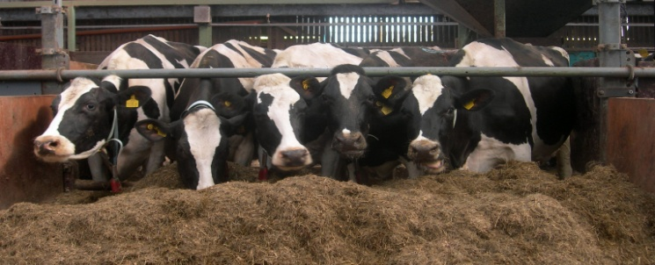

**20 cm/cow, individual head spaces**

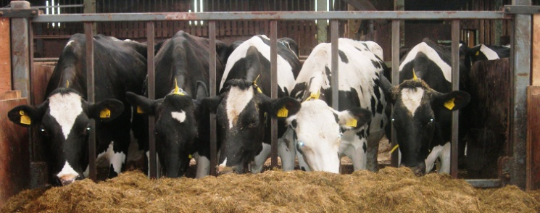

**57 cm/cow, open barrier**

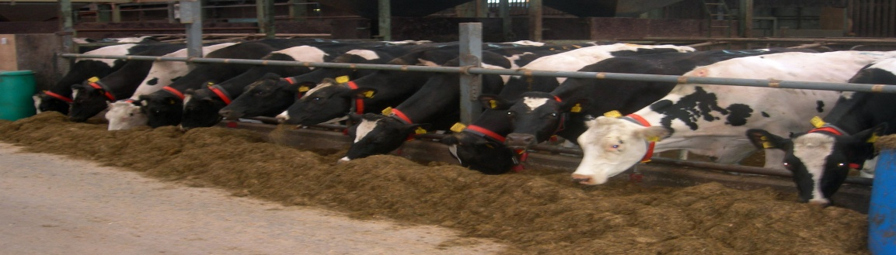

**57 cm/cow, individual head spaces**

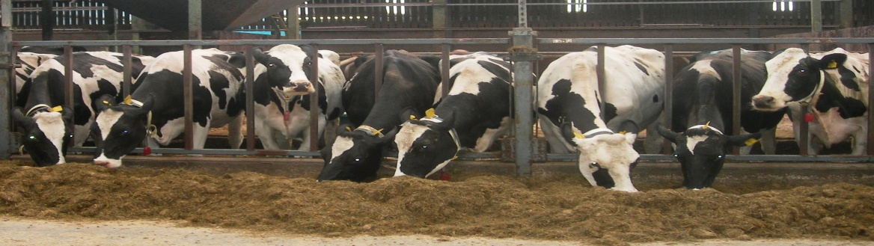

**Table 2** Effect of feed barrier design and feed space allowance per cow (high and low: 56 cm/cow and 20 cm/cow, respectively) on cow performance

|  |  |  |  |  |  |  |  |  |  |  |  |
| --- | --- | --- | --- | --- | --- | --- | --- | --- | --- | --- | --- |
|  | Barrier design | | SEM | F(1,9) Value | P |  | Space allowance | | SEM | F (1,9) value | P |
| Individual spaces | Open |  | High | Low |
| Silage DMI (kg/day) | 8.5 | 8.5 | 0.13 | 0.02 | NS |  | 8.4 | 8.7 | 0.13 | 2.06 | NS |
| Concentrate DMI (kg/day) | 12.2 | 12.2 | 0.17 | 0.01 | NS |  | 12.0 | 12.3 | 0.17 | 1.75 | NS |
| Total DMI (kg/day) | 21.5 | 21.7 | 0.16 | 0.89 | NS |  | 21.4 | 21.9 | 0.16 | 3.91 | NS |
| Milk yield (kg/day) | 32.0 | 32.0 | 0.33 | 0.00 | NS |  | 32.1 | 32.0 | 0.33 | 0.09 | NS |
| Milk fat (g/kg) | 45.7 | 46.0 | 0.60 | 0.15 | NS |  | 46.2 | 45.5 | 0.60 | 0.80 | NS |
| Milk protein (g/kg) | 35.6 | 35.6 | 0.28 | 0.00 | NS |  | 35.8 | 35.4 | 0.28 | 1.02 | NS |
| Milk lactose (g/kg) | 46.7 | 46.8 | 0.07 | 2.43 | NS |  | 46.7 | 46.8 | 0.07 | 0.69 | NS |
| Fat yield (kg/day) | 1.46 | 1.47 | 0.019 | 0.21 | NS |  | 1.48 | 1.45 | 0.019 | 1.01 | NS |
| Protein yield (kg/day) | 1.14 | 1.14 | 0.007 | 0.05 | NS |  | 1.15 | 1.13 | 0.007 | 2.19 | NS |
| Fat + protein yield (kg/day) | 2.59 | 2.61 | 0.024 | 0.19 | NS |  | 2.62 | 2.58 | 0.024 | 1.50 | NS |
| Liveweight (kg) | 598.2 | 600.6 | 4.37 | 0.15 | NS |  | 600.5 | 598.4 | 4.37 | 0.11 | NS |

***Behaviour***

*Feed barrier and feed passage occupancy*

Diurnal patterns of feed barrier occupancy for all animals, and for heifers, are shown in Figures 2 and 3, respectively. The number of animals standing in the feed passage is shown in Figure 4. Overall occupancy of the feed barrier rose to its highest peak in the morning between 11.00 and 12.00 hours. Smaller peaks in feed barrier occupancy were also observed between 07.00 and 08.00 hours, and between 16.00 and 17.00 hours (i.e. after morning and evening milking).

There were no significant interactive effects between treatment factors on feed barrier and feed passage occupancy parameters (P>0.05), therefore main treatment effects are presented in Table 3. The average number of animals at the feed barrier increased as feed barrier space allowance increased (P<0.001). There was no significant effect of feed barrier design on feed barrier occupancy (P>0.05). There were no main treatment effects on the average number of animals standing in the feed passage, and on the proportion of animals at the feed barrier or in the feed passage that were heifers (P>0.05).

*Aggression at the feed barrier*

Treatment effects are presented in Table 4. There were significantly higher levels of butting, pushing, pushing into silage, and in total aggression in the ‘individual head space/low’ treatment than in the other two treatments (P<0.05). There were no significant differences in levels of aggression between the ‘open/low’ treatment and the ‘individual head space/high’ treatment (P>0.05).

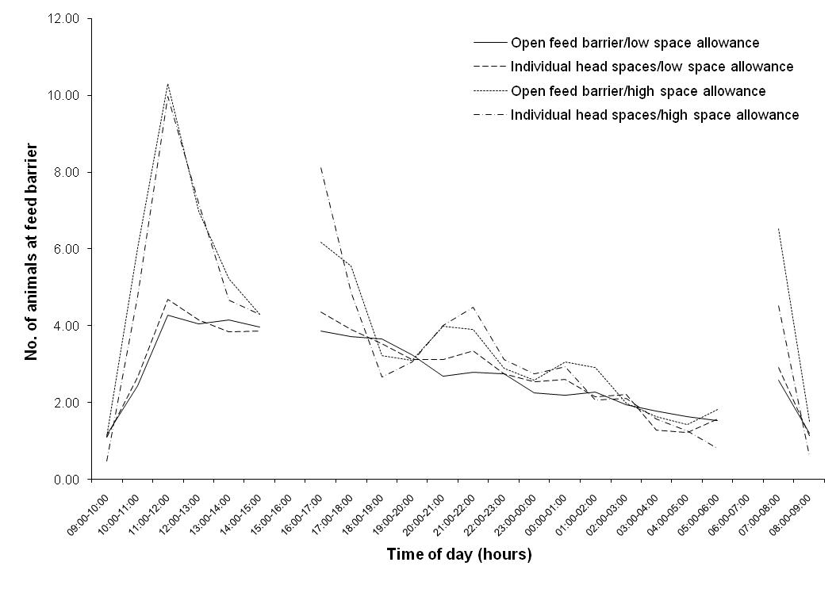

**Figure 2** Influence of feed barrier space allowance and design on feed barrier occupancy levels over a 24-hour period (Low space allowance: 20 cm/animal; high space allowance: 56 cm/animal)

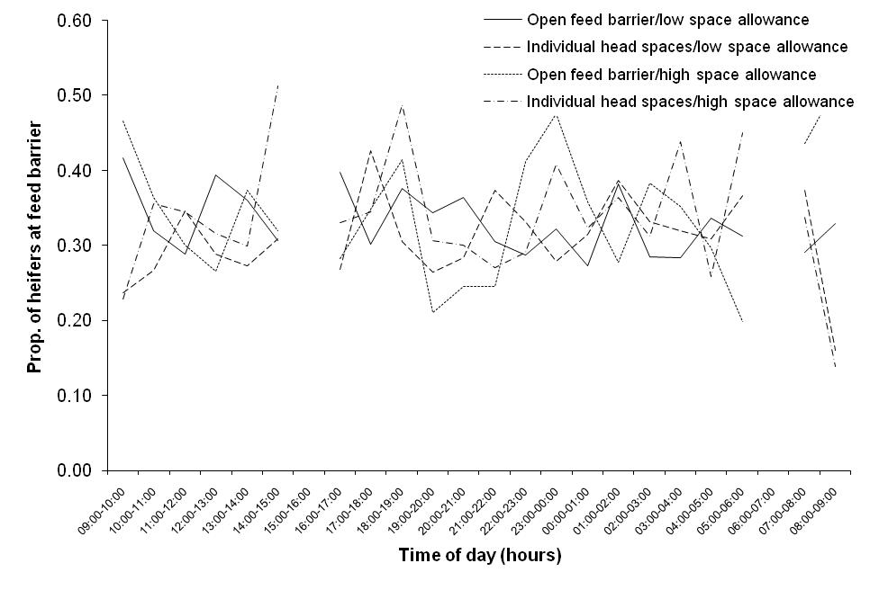

**Figure 3** Influence of feed barrier space allowance and design on the proportion of heifers at the feed barrier over a 24-hour period (Low space allowance: 20 cm/animal; high space allowance: 56 cm/animal

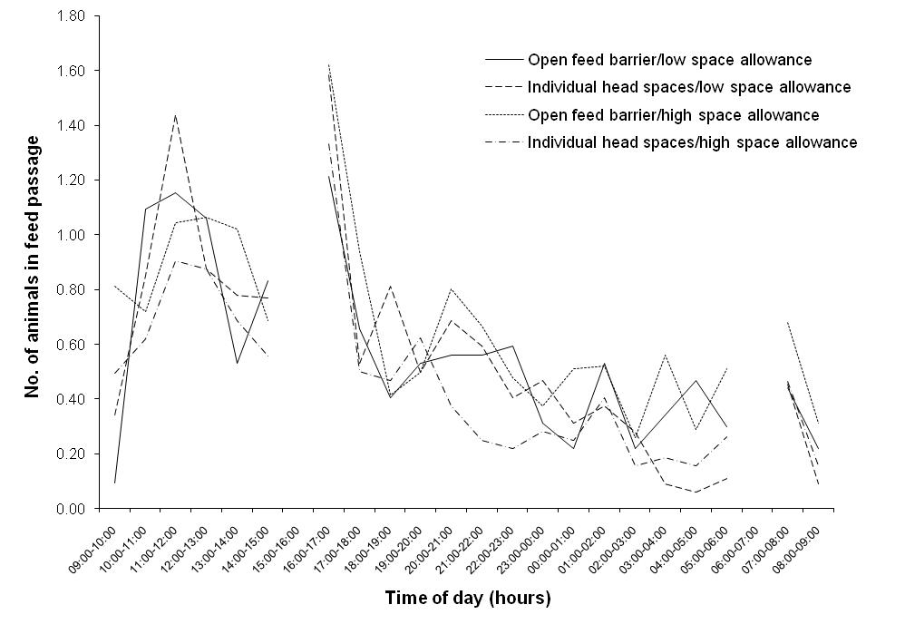

**Figure 4** Influence of feed barrier space allowance and design on the number of animals in the feed passage over a 24-hour period (Low space allowance: 20 cm/animal; high space allowance: 56 cm/animal)

**Table 3** Effect of feed barrier design and feed space allowance per cow (high and low: 56 cm/cow and 20 cm/cow, respectively) on average occupancy of the feed barrier (FB) and feed passage (FP) over a 24-hour period

|  |  |  |  |  |  |  |  |  |  |  |  |
| --- | --- | --- | --- | --- | --- | --- | --- | --- | --- | --- | --- |
|  | **Barrier design** | | **SEM** | **F(1,9) value** | **P** |  | **Space allowance** | | **SEM** | **F(1,9) value** | **P** |
| **Individual spaces** | **Open** | **High** | **Low** |
| Average no. at FB | 3.21 | 3.33 | 0.081 | 1.12 | NS |  | 3.78 | 2.77 | 0.081 | 78.30 | <0.001 |
| Proportion heifers at FB | 0.33 | 0.34 | 0.049 | 0.02 | NS |  | 0.33 | 0.34 | 0.049 | 0.05 | NS |
| Average no. in FP | 0.50 | 0.60 | 0.058 | 1.53 | NS |  | 0.55 | 0.55 | 0.058 | 0.00 | NS |
| Proportion heifers in FP | 0.33 | 0.29 | 0.057 | 0.34 | NS |  | 0.32 | 0.30 | 0.057 | 0.04 | NS |

**Table 4** Effect of feed space allowance (high and low: 56 cm/cow and 20 cm/cow, respectively) within individual headspace barriers, and of barrier design at low feed space allowances on average frequency of aggressive behaviours (per animal at the feed barrier per 10 minutes) during the post milking period

|  |  |  |  |  |  |  |
| --- | --- | --- | --- | --- | --- | --- |
|  | **Feed barrier treatment** | | | **SED** | **F(2,15) Value** | **P** |
| **Individual headspace/low** | **Open/low** | **Individual headspace/high** |
| Butting | 0.22b | 0.03a | 0.03a | 0.077 | 3.90 | <0.05 |
| Pushing | 0.46b | 0.18a | 0.12a | 0.060 | 19.53 | <0.001 |
| Pushing into silage | 0.36b | 0.16a | 0.13a | 0.057 | 9.69 | <0.01 |
| Total | 1.07b | 0.41a | 0.29a | 0.170 | 12.04 | <0.001 |

a,b Means within the same row with a different superscript differ significantly

There was no significant effect (P>0.05) of time of day (i.e. following am or pm milking) on levels of aggression at the feed barrier during the post milking period (Butting: am 0.08, pm 0.11, SED 0.063, F1, 15 0.16; pushing: am 0.23, pm 0.28, SED 0.049, F1,15 1.13; pushing into silage: am 0.20, pm 0.23, SED 0.047, F1, 15 0.55; total aggression: am 0.54, pm 0.64, SED 0.139, F1,15 0.46). In addition, there were no significant interactive effects between treatment and time of day on aggressive behaviours (P>0.05).

**DISCUSSION**

The diurnal patterns of feed barrier occupancy shown in the present study are similar to those reported previously. Von Keyserlingk and DeVries (2004) suggested that management practices of milking and delivery of fresh food were key in terms of mobilising animals to come to the feed barrier, and this was evident in the current study. The greatest levels of feed barrier occupancy were shown after fresh feed was provided, which corresponds with previous research (Huzzey *et al*., 2006). Olofsson (1999), DeVries *et al*. (2003) and von Keyserlingk and DeVries (2004) also found that number of cows at the feed barrier increased after milking. This effect was evident in the present study and may have been enhanced by the fact that feed was ‘pushed up’ closer to the barrier while cows were being milked. Pushing silage closer to the feed barrier independently of milking (i.e. at 21.00 hours) also caused a smaller peak in feeding behaviour, which is in agreement with previous research (Huzzey *et al*., 2006).

Increasing feed barrier space allowance led to a significant increase in the number of animals at the feed barrier and this effect was particularly evident during peak feeding periods. This increase in feed barrier occupancy did not lead to increased feed intake or milk yield levels. This agrees with previous research that found that feed barrier space allowances for dairy cows need to be reduced to 0.1 m/cow before reductions in feed intake become apparent (Friend *et al*., 1977). However, it should be noted that effects of feed barrier space allocation may differ depending on stage of lactation, cow yield potential and cow size. While the current study was carried out with mid-lactation animals, it is possible that reduced access to feed has greater implications in early lactation when feed intakes are higher. The lack of effect on food intake, despite the increased level of feed barrier occupancy observed at greater feed barrier space allocations in the present study, may have reflected slower feed consumption rates (Hosseinkhani *et al*., 2008). However, Olofsson (1999) suggested that reducing feed space allocation reduced the amount of non-feeding behaviour at feed stations, and this may also have been the case at the feed barrier in the present study.

While not affecting production performance, it is possible that a reduced feed barrier space allowance forced animals to alter behavioural patterns, and this may have had a negative effect on welfare. For example, previous research suggests that reducing feed space allowance forces some animals to feed later in the day than they normally would (Huzzey *et al*., 2006; DeVries and Von Keyserlingk, 2006). This may adversely affect welfare through preventing animals from achieving preferred feeding patterns. In addition, animals forced to eat later may receive poorer quality feed due to sorting of feed ingredients by early feeding animals (Huzzey *et al*., 2006). This may be a particular problem for heifers as they tend to attain relatively low social status within groups of older cows, and therefore may have difficulty accessing resources such as the feed barrier (von Keyserlingk and DeVries, 2004). However, in the present study, there appeared to be no increase in feeding during ‘off-peak’ periods in the low feed barrier space allowance treatment (see Figure 2). In addition, the proportion of heifers at the feed barrier did not appear to increase during off-peak feeding periods at the reduced space allowance (see Figure 3). It has also been suggested that reducing feed space allowance increases time spent standing (not eating) in the feed area (which could potentially exacerbate lameness problems) (Huzzey *et al*., 2006; DeVries and von Keyserlingk, 2006), however this did not appear to be the case in the current study.

Other recent studies have also assessed the benefits of providing individual head spaces in feed barriers for dairy cows, however they do not appear to be directly comparable to the current study. For example, DeVries and von Keyserlingk (2006) investigated individual feeding spaces created by using divisions that extended past the shoulders of the feeding animals. The results showed a trend towards increased feeding behaviour when these divisions were used, and this is likely to reflect the greater protection afforded by them. Huzzey *et al*. (2006) found that headlock feed barriers led to a reduction in time spent feeding relative to open barrier designs, and suggested this may have been due to reduced comfort associated with this barrier design. The authors also suggested that cows may have developed a learned aversion to using headlock barriers as they were also used to restrain animals for uncomfortable procedures. The current trial shows that replacing a post and rail type barrier with a barrier comprising individual head spaces did not significantly affect feed barrier occupancy levels. In addition, feed intake and milk yield levels were not affected by barrier design, which is similar to previous studies (Brouk *et al*., 2003; Endres *et al*., 2005).

Aggression at the feed barrier can be a key problem in dairy cow systems. In addition to affecting welfare directly, it may also contribute to increased lameness levels (Leonard *et al*., 1998). In the present study, aggression at the feed barrier was measured in the post milking period as competition is likely to be relatively high during this period (von Keyserlingk and DeVries, 2004). At low feed space allowances, the use of individual head spaces led to an increase in aggressive interactions at the feed barrier. This does not correspond with previous similar work (i.e. Huzzey *et al*., 2006), and is difficult to explain. It is possible that enhanced protection offered by the head spaces may have meant that increased aggression was required to displace animals, and this effect was exacerbated under competitive circumstances. These effects were reduced when either an open barrier was used, or when increased space allowance was provided. Unfortunately there were insufficient data to accurately access the effect of barrier design at high feed space allowances. However previous research showed that headlock barriers led to less aggression than open barriers when 0.6 m of feeding space was provided per cow (Endres *et al*., 2005). This may be due to the vertical bar restricting cows from swinging their head from side to side and displacing other animals (DeVries and von Keyserlingk, 2006).

**CONCLUSIONS**

Reducing feed barrier space allowance from 56 to 20 cm per animal did not adversely affect feed intake or milk yield in dairy cows offered feed via either an open or individual headspace feed barrier. In addition, feed barrier space allowance and design did not appear to adversely alter feeding patterns, or the incidence of animals standing in the feed passage. It is worth noting that these findings relate to mid-lactation animals, and additional similar trials with early lactation animals would be beneficial. The results suggest that using individual head space barriers at low feed space allocations promotes aggression, and therefore has negative welfare implications. This may have been due to increased difficulty in displacing animals from the feed barrier in this treatment. These effects can be alleviated by either using an open barrier design at low feed space allocations, or by increasing feed space allowance.

**ACKNOWLEDGEMENTS**

Funding for this research from AgriSearch and from the Department of Agriculture and Rural Development for Northern Ireland is gratefully acknowledged. Thanks are also due to staff from the Dairy Unit and the Animal Welfare Unit at the Agri-Food and Biosciences Institute (Hillsborough) for excellent technical assistance.

**REFERENCES**

Bewley, J., Palmer, R.W. and Jackson-Smith, D.B., 2001. A comparison of free-stall barns used by modernized Wisconsin dairies. *Journal of Dairy Science,* **84:** 528-541.

Brouk, M.J., Smith, J.F. and Harner, J.P., 2003. Effect of feedline barrier on feed intake and milk production of dairy cattle. *Proceedings of the Fifth International Dairy Housing Conference, Fort Worth, Texas*, pp. 192-195.

DEFRA, 2006. Action of animal health and welfare: housing the modern dairy cow. <http://defra.gov.uk/animalh/welfare/farmed/advice/moderndairycow.pdf>.

DeVries, T.J. and von Keyserlingk, M.A.G., 2006. Feed stalls affect the social and feeding behaviour of lactating dairy cows. *Journal of Dairy Science,* **89:** 3522-3531.

DeVries, T.J., von Keyserlingk, M.A.G. and Beauchemin, K.A., 2003. Short communication: Diurnal feeding pattern of lactating dairy cows. *Journal of Dairy Science,* **86:** 4079-4082.

DeVries, T.J., von Keyserlingk, M.A.G. and Weary, D.M., 2004. Effect of feeding space on the inter-cow distance, aggression, and feeding behaviour of free-stall housed lactating dairy cows. *Journal of Dairy Science,* **87:** 1432-1438.

Endres, M.I., DeVries, T.J., von Keyserlingk, M.A.G. and Weary, D.M., 2005. Short Communication: Effect of feed barrier design on the behaviour of loose-housed lactating dairy cows. *Journal of Dairy Science,* **88:** 2377-2380.

Friend, T.H., Polan, C.E. and McGilliard, M.L., 1977. Free stall and feed bunk requirements relative to behaviour, production and individual feed intake in dairy cows. *Journal of Dairy Science,* **60:** 108-116.

Grant, R.J. and Albright, J.L., 2001. Effect of animal grouping on feeding behaviour and intake of dairy cattle. *Journal of Dairy Science,* **84 (E. Suppl.):** E156-E163.

Hosseinkhani, A., DeVries, T.J., Proudfoot, K.L., Valizadeh, R. and Veira, D.M. and von Keyserlingk, M.A.G., 2008. The effects of feed bunk competition on the feed sorting behaviour of close-up dry cows. *Journal of Dairy Science,* **91:** 1115-1121.

Huzzey, J.M., DeVries, T.J., Valois, P. and von Keyserlingk, M.A.G., 2006. Stocking density and feed barrier design affect the feeding and social behaviour of dairy cattle. *Journal of Dairy Science,* **89:** 126-133.

Kingshay, 2006. Barrier Design. Farming Notes from Kingshay, Bridge Farm, Glastonbury, July 2006.

Leonard, F.C., Stienezen, I. and O’Farrell, K.J., 1998. Overcrowding at the feeding area and effects on behaviour and claw health in Friesian heifers. *Proceedings of the 10th International Symposium on Lameness in Ruminants, Lucerne, Switzerland,* pp. 40-41.

Olofsson, J., 1999. Competition for total mixed diets fed for *ad libitum* intake using one or four cows per feeding station. *Journal of Dairy Science,* **82:** 69-79.

Patterson, H.D. and Lucas, H.L., 1962. *Change-Over Designs. Technical Bulletin of the North Carolina Agricultural Experiment Station*, No. 147.

Payne, R.W., Harding, S.A., Murray, D.A., Soutar, D.M., Baird, D.B., Welham, S.J., Kane, A.F., Gilmour, A.R., Thompson, R., Webster, R. and Tunnicliffe Wilson, G., 2008. The Guide to GenStat Release 11.1, Part 2: Statistics. VSN International, Hemel Hempstead.

von Keyserlingk, M. and DeVries, T., 2004. Designing better environments for cows to feed. *Advanced Dairy Technology*, **16:** 65-73.

**CHAPTER 3**

**Effect of feed delivery time on the performance of mid/late lactation dairy cows (Experiment 4)**

**and**

**The effect of roughness of the feeding area surface on the short term intakes of dairy cattle (Experiment 5)**

**and**

**The effect of altering the floor surface, on the intake and behaviour of housed dairy cows (Experiment 6)**

**Effect of feed delivery time on the performance of mid/late lactation dairy cows (Experiment 4)**

**INTRODUCTION**

Meeting the higher nutrient requirements of high yielding dairy cows remains a key challenge on dairy farms. While many studies have examined nutritional strategies to achieve increased food intakes, for example increasing the nutrient density of the diet, ‘non-nutritional’ strategies, such as altering feed delivery time, may also have a role to play in achieving higher intakes. While there is evidence that under conditions of heat stress, evening feeding instead of morning feeding can improve feed efficiency and lactation persistency (Aharoni *et al*., 2005), less is known about the effects of time of feed delivery within in a non-heat stressed environment. This may be important, as within a grazing context cows are known to have one of their main grazing bouts during the evening, while on many farms fresh food is offered mid morning, at a time when cows graze relatively little. Thus it has been suggested that synchronising feeding with the time when cows naturally have one of their main ‘feeding bouts’ may encourage cows to consume more. Indeed, Nikkhah *et al*. (2005) observed that evening fed cows consumed 55% of their total daily intake within 3 hours post feeding, compared to 46% for morning fed cows, while total daily dry matter (DM) intake was 2.0 kg higher with the evening fed cows. Information on milk production was not provided. As this research does not appear to have been replicated elsewhere, a simple study was conducted to examine the impact of feed delivery time on cow performance under Irish conditions.

**MATERIALS AND METHODS**

Twenty-four multiparous Holstein-Friesian dairy cattle (mean lactation number, 3.7: mean live weight, 637 kg: mean days calved, 210) were used in a two-period (each of five weeks duration) completely balanced change-over design experiment involving two treatments. Treatments examined the effect of either morning (AM feeding) or evening (PM feeding) feed delivery time. Throughout the experiment each treatment group (12 cows/group) was housed in identical, but mirror image pens (16 cubicles). Cows were offered a completed diet (*ad libitum*) containing proportionally 0.55 grass silage (secondary re-growth) and 0.45 concentrate on a DM basis, together with an additional 0.5 kg concentrate (fresh) at each milking. With the AM feeding treatment cows were given access to fresh food at approximately 09.30 hours, while with the PM feeding treatment cows were given access to fresh food at approximately 18.00 hours. Cows were milked twice daily, being removed for milking at approximately 06.30 hours and 14.30 hours, with uneaten food from the AM feeding treatment removed when cows were absent for morning milking, while uneaten food with the PM feeding treatment was removed when cows were absent for evening milking. With both treatments, cows were offered fresh food approximately one hour after returning from being milked. Forage offered to cows on each treatment was obtained from adjacent blocks of silage within the silo each day to ensure similar quality. The quantity of fresh food offered, and uneaten food removed was recorded daily, to allow group intakes to be determined. Cow performance data collected during the final week of each experimental period was analysed by ANOVA, taking account of the changeover design nature of the study, with individual cows used as the experimental unit. Group intake data were not analysed statistically, with mean intakes for the two recording weeks presented.

**RESULTS AND DISCUSSION**

Total DM intakes were 20.5 and 20.1 kg/cow/day with the AM and PM feeding treatments, respectively (Table 1), with intakes numerically higher with the AM feeding treatment (0.4 kg DM/cow/day). However, this contrasts with the higher intake observed with evening fed cows by Nikkhah *et al*. (2005). In addition, feed delivery time had no effect on milk yield, milk composition or fat + protein yield, reflecting the similar intakes observed with both treatments. While it is possible that confined cows may prefer to follow similar feeding patterns as grazing cows, the current experiment was undertaken between early September and early November, at a time of rapidly decreasing day-length. Thus it is possible that a different outcome might have been observed if the study had been undertaken during the early/mid summer period. Indeed, with increasing numbers of high yielding cows now being managed within total confinement systems, and with summer temperatures predicted to increase, the impact of feed deliver time for these summer confined cows warrants further investigation.

**Table 1** Effect of feed delivery time on dairy cow performance

|  |  |  |  |  |
| --- | --- | --- | --- | --- |
|  | **Feeding time** | |  |  |
|  | **AM** | **PM** | **SEM** | **Sig.** |
| DM intake (kg/day) | 20.5 | 20.1 |  |  |
| Milk yield (kg/day) | 25.8 | 25.4 | 0.38 | NS |
| Milk fat (g/kg) | 46.1 | 45.1 | 0.79 | NS |
| Milk protein (g/kg) | 37.0 | 36.5 | 0.28 | NS |
| Fat + protein yield (kg/day) | 2.10 | 2.05 | 0.026 | NS |

**CONCLUSION**

Milk production performance was unaffected when fresh food was offered in the evening, rather than in the morning.

**ACKNOWLEDGEMENTS**

This study was co-funded by AgriSearch and DARD.

**REFERENCES**

Aharoni, Y., Brosh, A. and Harari, Y. 2005. Night feeding for high-yielding dairy cows in hot weather: effects on intake, milk yield and energy expenditure. *Livestock Production Science*, **92:** 207-219.

Nikkhah, A., Plaizier, J.C., Furedi, C. and Kennedy, A.D. 2006. Diurnal patterns in feed intake of evening and morning fed lactating dairy cows. In: *Proceedings of Canadian Society of Animal Science Joint Colloquium, Halifax*, 1-5 August 2006.

**The effect of roughness of the feeding area surface on the short term intakes of dairy cattle (Experiment 5)**

#### INTRODUCTION

In many livestock houses concrete feed passages have become corroded by long term exposure to silage acids, often exposing sharp aggregates within the concrete, and leaving the feeding surface rough. However, there is anecdotal evidence that rough feed passage surfaces may have a negative effect on the intake, behaviour and health of cattle. Indeed, Bickert (1990) suggested that the eating surface must be smooth, clean and free of left over feed and debris in order to encourage high food intakes and minimise the risk of disease. This may be particularly important with high yielding dairy cows where high food intakes are necessary to minimise negative energy balance. To address this issue, an experiment was conducted to examine the effect of roughness of the surface of the feeding area on the short term intake of dairy cattle.

# MATERIALS AND METHODS

Fourteen late lactation Jersey x Holstein crossbred cows (average milk yield, 15.6 kg/day) were used in a two-treatment completely balanced changeover design experiment, with cows paired on the basis of milk yield. Cows were offered a mixture of grass silage and maize silage (50:50 dry matter basis), together with 5.0 kg of concentrate in the milking parlour (split between two equal feeds) for a six-week period prior to measurements commencing. During this period cows were housed in a pen with a concrete feeding surface with an ‘intermediate roughness’ and were trained to enter the pen individually and to feed out of a ‘wooden frame’ placed on the feed passage surface. The frame had internal dimensions of 61 x 61 cm, a depth of 15.5 cm, while the corners of the frame were ‘filled in’ using wooden triangular blocks to a distance of 15 cm from the corner. The latter was to prevent food being pushed into the corners where it may have been inaccessible. The experiment was conducted in an adjoining pen where the surface of the concrete feeding area was extremely rough, with aggregate exposed. Treatment ‘Rough’ involved placing the wooden frame over a pre-defined area of the rough surface and allowing cows to feed off that surface. With treatment ‘Smooth’, cows fed from an identical wooden frame, fitted with a ‘Stock Board’ base (made of ‘smooth’ recycled plastic). The experiment was initially conducted using the forage mix described above as the test diet, and then repeated using a pelleted concentrate as the test diet. With each test diet, intakes were measured during two consecutive days. On each measurement day food was removed from the group of cows at 05.30 hours (during milking), with cows not having access to food thereafter, until the experiment commenced. On Day 1, one cow from each pair was assigned to the Rough treatment, and the second cow to the Smooth treatment, with treatments reversed on Day 2. Each cow was brought into the pen individually (in the same order each day) and offered 1.5 kg of the forage mix (fresh basis), placed in the centre of the wooden frame. The quantity of food remaining uneaten was recorded after 180 seconds, its DM determined and DM intake calculated. If cows stopped feeding during the observation period the duration of this ‘non-feeding’ period was recorded. Non-feeding was defined as the cow lifting her muzzle above the top of the wooden frames. This process was repeated approximately one week later, with cows given access to 1.0 kg of pelleted concentrate for 90 seconds. Dry matter intakes per second were subsequently calculated, with data from cows which had a non-feeding period of >30 seconds excluded (n=7 cows offered the forage mix). Data from each test diet were analysed by ANOVA, taking account of the changeover design nature of the experiment.

**RESULTS AND DISCUSSION**

When offered the forage mixture, DM intake was unaffected by roughness of the feeding surface (P>0.05). However, when offered the concentrate pellets, intakes were significantly higher for cows feeding from the smooth surface (P<0.05) (6.0 and 6.7 g/s for treatments Rough and Smooth, respectively). This experiment provided clear evidence that during a short term measurement period cows consumed concentrates at a slower rate from a rough surface than from a smooth surface. That forage intakes were unaffected by the feeding surface may be due to the cows being able to consume the bulky forage while making minimal contact with the surface with their tongues.

**CONCLUSIONS**

Eating rate of concentrate, but not forage, was reduced with a rough feeding surface.

**REFERENCES**

Bickert, W.G. 1990. Feed manager and barrier design. *Dairy Feeding Systems*. NRAES-38. Natural Resources, Agriculture and Engineering Service, Ithaca NY. pp. 199-206.

**ACKNOWLEDGEMENTS**

Co-funded by DARDNI and AgriSearch.

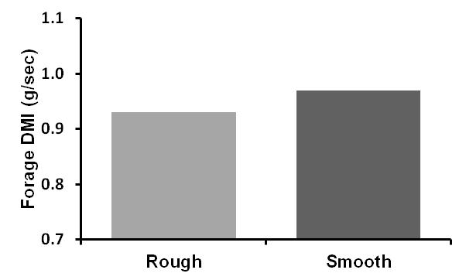

**SEM = 0.04, P Value = 0.49**

**SEM = 0.21, P Value = 0.04**

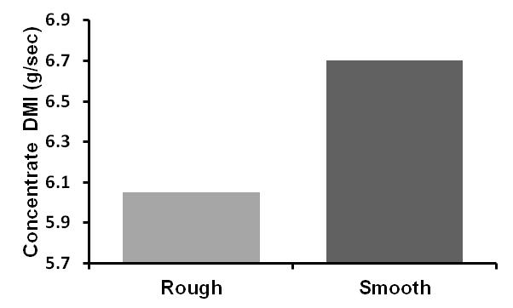

**Figure 1** Effect of roughness of the feeding surface on the short term intake of a) Forage and b) Concentrates

**The effect of altering the floor surface, on the intake and behaviour of housed dairy cows (Experiment 6)**

**INTRODUCTION**

Housed dairy cows spend approximately 4-5 hours per day eating, and normally stand on a concrete surface during this time. However, concrete surfaces are known to contribute to hoof lesions, and subsequent lameness problems. It has been suggested that improving cow comfort at the feeding area, for example, by providing a more ‘comfortable’ standing surface, may promote total dry matter (DM) intake, and improve hoof health and cow welfare. This study was designed to examine the effect on food intake and cow behaviour of placing matting along the standing area behind a feed barrier.

**MATERIALS AND METHODS**

Eighteen late lactation (mean, 398 days in milk) Holstein-Friesian dairy cows (mean milk yield, 14.3 kg) were used in a two-treatment (9 cows per treatment), four-period (period length, 10 days), changeover design experiment. Cows were divided into two groups, each of nine cows, with groups balanced for lactation number, days calved, milk yield, live weight and condition score. The two groups were housed separately, side by side, in cubicle accommodation. The floor area of each pen comprised an un-grooved concrete apron (1.5 m wide) behind the feed barrier, and a slatted area (2.1 m wide), each of which ran the full length of the pen (13.6 m). Each pen was equipped with a single row of nine cubicles. The feed barrier comprised a 0.55 m high stub wall, and a 1.20 m high top rail. The length of feed space within each pen was 5.3 m (0.59 m/cow). A 28 mm thick compression moulded mat made from expanded polymers (Pad-Mat, UVr D27 4L, Pemarsa S.A., Alicante, Spain), measuring 7.2 m x 2.3 m (density, 0.27) was attached to the floor behind the feed barrier in one pen. The two groups of cows rotated between pens, so that each group was on each treatment (Mat or Concrete) twice. Grass silage was offered *ad libitum* once daily, at approximately 10:00 hours, with feed being pushed up on four occasions each day. Uneaten food was removed at 09.00 hours the following day. Cows were milked twice daily (between 06.00-08.00 hours and 14.00-16.00 hours, and were offered 1.5 kg concentrate in the milking parlour at each milking. Feed intakes were measured during days 6-10 of each experimental period. On day nine of each period, a group scan was undertaken every 15 minutes, from 10.15 to 00.00 hours (excluding milking time), and the location of animals within the pen noted. Animals were identified as either being at the ‘feeding area’ (defined as having at least two feet on the mat, or equivalent area of the concrete apron), in the ‘alleyway’ (defined as standing on the concrete apron or slatted area, but excluding the ‘feeding area’), or on the ‘cubicles’ (defined as being either completely or partly on the cubicles). In addition, at each group scan, the number of animals involved in a range of activities (eating, standing at the feeding area, standing/walking in alleyway, drinking, standing in cubicle, and lying in cubicle) were recorded. Mean group feed intake data for the final five days of each experimental period, and mean behavioural data for the 12-hour observation period, were analysed by ANOVA, based on four replicates per treatment.

**RESULTS**

Total DM intakes were 15.4 and 15.8 kg/day (SEM, 0.22) with the Concrete and Mat treatments respectively (P>0.05). The number of animals observed at different locations within each pen, and the number of animals involved in a range of activities (over a 12-hour observation period) are presented in Table 1. Treatment had no significant effect on any of the parameters measured (P>0.05).

**CONCLUSIONS**

Placing a compression moulded mat behind a feed barrier had no significant effect on either intake or cow behaviour, compared to cows standing on concrete.

**Table 1** The effect of treatment on the number of animals observed in various locations within each pen, and on the number of animals involved in a range of behaviours, over a 12-hour observation period

|  |  |  |  |  |
| --- | --- | --- | --- | --- |
|  | **Concrete** | **Mat** | **SEM** | **Sig.** |
| Location within pen |  |  |  |  |
| Feeding area | 3.0 | 3.3 | 0.16 | NS |
| Alleyway | 1.0 | 0.7 | 0.23 | NS |
| Cubicles | 5.0 | 5.0 | 0.08 | NS |
| Activity |  |  |  |  |
| Eating | 2.8 | 2.9 | 0.15 | NS |
| Standing at feeding area | 0.1 | 0.4 | 0.11 | NS |
| Standing/walking in alleyway | 0.7 | 0.4 | 0.22 | NS |
| Drinking | 0.4 | 0.3 | 0.04 | NS |
| Standing in cubicle | 0.8 | 1.0 | 0.57 | NS |
| Lying in cubicle | 4.2 | 4.0 | 0.23 | NS |

**ACKNOWLEDGEMENTS**

This study was jointly funded by DARDNI and AgriSearch. L. Stroebel acknowledges support from CAH Dronten, Netherlands.

# PUBLICATIONS ASSOCIATED WITH THE PROJECT

**PUBLICATIONS IN SCIENTIFIC JOURNALS**

O’Connell, N, Ferris, C.P., Patterson, D.C. and Mayne, C.S. 2010. Effect of feed barrier design and feed space allowance on performance and behavioural parameters in dairy cows. *Applied Animal Behaviour Science*, **127:** 20-27.

**PUBLICATIONS IN CONFERENCE PROCEEDINGS**

Stroebel, L., Ferris, C.P. and Gordon, A., 2008. The effect of altering the floor surface, on the intake and behaviour of housed dairy cows. *Proceedings of the British Society of Animal Science, Winter Meeting, Scarborough*. 31 March-2 April 2008. Paper No. 161

O’Connell, N.E., Baird, L.G. and Ferris, C.P., 2008. Influence of feed barrier space allowance and design on behaviour of dairy cows. In: Applied Ethology - Addressing future challenges in animal agriculture: *Proceedings of the 42nd Congress of the ISAE. University College Dublin, Ireland*, 5-9 August 2008. Ed: L. Boyle, N. O’Connell and A. Hanlon.

Ferris, C.P., O’Connell, N., Patterson, D.C. and Kilpatrick, D.J., 2010. Effect of feed space allowance and period of access to food on the performance and behaviour of dairy cows offered a silage based diet. In: *Advances in Biosciences - Food, Feed, Energy and Fibre from Land*. *Proceedings of the British Society of Animal Science and the Agricultural Research Forum,* April 2010, Belfast, p.168.

Ferris, C.P., O’Connell, N., Patterson, D.C. and Kilpatrick, D.J., 2010. Effect of feed space allowance on the performance of dairy cows offered grass silage based diets. In: *Advances in Biosciences - Food, Feed, Energy and Fibre from Land. Proceedings of the British Society of Animal Science and the Agricultural Research Forum*, April 2010, Belfast, p.167.

Ferris, C.P and Mayne, C.S., 2012. Effect of feed delivery time on the performance of mid/late lactation dairy cows. *Proceedings of Agricultural Research Forum of the Irish Grassland and Animal Production Association, Tullamore, Ireland.* March 12 -13, Page 103.

Thompson, A.H and Ferris, C.P., 2012. The effect of roughness of the feeding area surface on the short term intakes of dairy cattle. *Proceedings of Agricultural Research Forum of the Irish Grassland and Animal Production Association, Tullamore, Ireland.* March 12 -13, Page 104.