
Measurement of physical and financial performance across 10 farms over three years to identify the main drivers of profitability on Northern Ireland dairy farms

End of Project Report to AgriSearch in Relation to Project D-28-06

June 2012

Research team: Andrew Dale, Sinclair Mayne, Conrad Ferris, Alan Hopps, Michael Verner, Martin Mulholland, Ian McCluggage, Dave Matthews

Report prepared by: Andrew Dale

Agri-Food and Biosciences Institute, Agriculture Branch, Hillsborough, County Down, Northern Ireland BT26 6DR



STRUCTURE OF REPORT

This report begins with an Executive Summary which briefly highlights the background to the research, the methods used to undertake the work, the key findings, and the practical implications of the work.

The main body of the report comprises a detailed description of the work undertaken, the main results of the project and an in-depth analysis of the results.

The report also includes a list of presentations/publications which have been outcomes of the work to date.

The report finishes with a series of appendices, which document the full range of data that were collected during the completion of this work.

TABLE OF CONTENTS

 | Page No
EXECUTIVE SUMMARY | vi
INTRODUCTION | 1
MATERIALS AND METHODS | 3
RESULTS | 8
DISCUSSION | 31
KEY FINDINGS | 52
ACKNOWLEDGEMENTS | 53
REFERENCES | 54
KEY PRESENTATIONS/MEETINGS | 57
APPENDICES | 59

EXECUTIVE SUMMARY

Background
The Northern Ireland (NI) dairy industry has changed significantly during the past 20 years in terms of herd size, milk yield per cow, dairy cow genetics and concentrate use. Some of these changes have contributed to an increase in the costs of production on local farms, which, given ongoing volatility in milk markets, creates a greater risk for long term sustainability. Although there is a need for producers to focus on reducing their costs of production, producing a single ‘blueprint’ for profitable milk production is not normally considered to be appropriate given the diversity of production systems in NI, whilst it is recognised that increasing reliance on grazed grass is a key factor influencing the competitiveness of local dairy enterprises.

The potential of grazed grass to lower the costs of milk production has been well documented. However, climate, soil type, grass growth potential and availability of grazing land are examples of important constraints on achieving this potential on NI dairy farms. One way to examine the relative importance of farm level factors affecting profitability is to quantify actual farm performance.

Project outline
This study commenced in 2006 and was designed to intensively monitor ten dairy herds from across Northern Ireland over three years, with the aim to establish the main factors affecting profitability on these farms. The farms were selected from within 300 farms participating in the Greenmount Dairy Benchmarking Programme, and the final ten were selected to provide a range of soil types, geographic locations, calving patterns, herd sizes and milk yields. The data were collected over three full years: Year 1 (April 2006 – March 2007)
Year 2 (April 2007 – March 2008)
Year 3 (April 2008 – March 2009)
The ten farms were visited once every four weeks during the grazing season (April – October), with measurements taken including; grazing stocking rate, pre- and post-grazing herbage mass and grass utilisation. Three full years of benchmarking data were collected at the end of each year. All physical and financial parameters collected were analysed against net profit, with year and farm included as factors within the analysis.
In addition to the dataset being collated from the ten monitored farms in Northern Ireland, Teagasc conducted a similar study in the North-West and North-East regions of the Republic of Ireland, with 16 farms being monitored over three years. The Teagasc study was conducted from April 2005 to March 2008, thus overlapping with Years 1 and 2 in the current study. Data from the Teagasc project are presented in Appendix 34 at the end of this report.

Range of data collected
Although the average herd size across the 10 farms in this study was 111 cows, there was a considerable range in herd sizes (Table A). The milk output achieved on the farms also varied widely, with a difference of almost 3,800 litres/cow/year between the highest and lowest yielding herd. Four of the farms had a compact calving pattern (>60% cows calved within 12 weeks), with three of those described as spring calving and one farm exclusively autumn calving. The other six farms had a spread calving pattern. The highest average annual concentrate input was 2.5 t/cow, with 0.8 t/cow the lowest concentrate input. Average milk from forage achieved across the farms over the study was 2,955 litres/cow/year, however this ranged from 4,500 to 2,300 litres/cow/year between the farms.

Although herds grazed full-time for an average of 150 days, the longest grazing season was 244 days, with one farm housing cows overnight throughout the main grazing season. On average, pre- and post-grazing herbage masses measured in early and late season were well in excess of those required to achieve efficient grass utilisation (Dale et al., 2009; Lee et al., 2008; McEvoy et al., 2008), with this grass surplus also reflected in the average grass cover across all the fields available for grazing (average farm cover).

Table A. The mean, maximum and minimum three year averages for the ten farms for a range of physical performance parameters

 | 3 year average across all farms | Range between farms
 | 3 year average across all farms | Maximum |  | Minimum
Herd size | 111 | 187 | 74
Milk yield (litres/cow/year) | 6894 | 8704 | 4912
Milk butterfat content (%) | 4.09 | 4.52 | 3.55
Milk protein content (%) | 3.29 | 3.57 | 2.99
Milk from forage (litres/cow/year) | 2955 | 4549 | 2259
Concentrates fed (kg/cow/year) | 1773 | 2549 | 762
Milk price (ppl) | 21.0 | 22.6 | 19.5
Length of grazing season (full-time) | 154 | 244 | 0
Pre-grazing herbage mass in early season (kg DM/ha) | 4697 | 5986 | 3363
Post-grazing herbage mass in early season (kg DM/ha) | 2262 | 2500 | 1763
Average farm cover in early season (kg DM/ha) | 3406 | 4125 | 2513

Production costs were also extremely variable between farms (Table B), reflecting the different systems used across the farms. The lower input farms recorded variable costs of 5.1 ppl compared to 8.7 ppl recorded on the higher input farms. Common margin also varied widely between farms and between years (Figure A), with 8.3 ppl and £564/cow common margin achieved on average across the farms across the three years. Common margin increased in Year 2 across the farms reflecting a 40% increase in the base price paid for milk compared to Year 1. The overall reduction in common margin in Year 3 largely reflected a decline in the base price of milk and the high fertiliser prices.

Table B. The mean, maximum and minimum three year averages for the ten farms for a range of financial performance parameters

 | 3 year average across all farms | Range between farms
 | 3 year average across all farms | Maximum | Minimum
Concentrate costs (ppl) | 4.3 | 6.0 | 1.9
Total variable costs (ppl) | 7.1 | 8.7 | 5.1
Gross margin (ppl) | 12.9 | 15.7 | 10.3
Common margin (ppl) | 8.3 | 11.2 | 4.9
Common margin (£/cow) | 564 | 804 | 356
Common margin (£/ha) | 1336 | 1898 | 676

Figure A. Boxplots showing distribution of common margin (£/cow) over the three years on each farm (Graph 1) and the distribution of common margin within each year (Graph 2)
Common margin (£/cow)
Graph 1
Graph 2

Factors affecting whole farm profitability
Relationships between all parameters recorded during the study and common margin (expressed on a per cow, per litre and per hectare basis) were examined. Although the variation in common margin between farms was expected, the extent of the influence of year on common margin was not, with average common margin almost doubling between Years 1 and 2 (£425 vs £750/cow). The year effect was linked to factors mostly outside of the farmers control (global markets for milk, cereals and fertilisers and the effects of these on farm expenditure and income), and this fluctuation in the costs of inputs and value of outputs made it more difficult to identify farm factors which affect common margin. However, the influence of the key parameters on common margin (£/cow) will be discussed under the following headings; scale, grazing management, milk price, production from forage/concentrate input and production systems.

Scale
Although the long term trend within Northern Ireland has been for dairy herds to increase in size, many remain ‘one person’ or ‘family run’ businesses. There are however an increasing number of farms, who in pursuit of further efficiencies of scale, are increasing herd size to 150 cows plus. Within this study, there was no evidence of any efficiency gains due to increasing scale in terms of costs, with no relationship established between cow numbers and forage, concentrate or variable costs (ppl). Furthermore, the number of cows in the herd at the end of each year was not related to common margin (£/cow, ppl or £/ha). The results of this study indicate that medium sized (80-120 cows), family run dairy farms can remain competitive within Northern Ireland, provided labour and overhead costs are kept in proportion to the scale of the business.

Milk yield and total milk output are also measures of scale, and many farms use milk production targets as benchmarks for their businesses. The results from this study highlight that there was no relationship between milk yield per cow and the costs of milk production (forage costs (ppl), common costs (£/cow)), with concentrate and total variable costs (ppl) tending to increase as milk yield increased. In addition, this study established that both the total volume of milk sold and the average annual milk yield per cow were poor indicators of common margin (ppl, £/ha) (P>0.05). Therefore, this emphasises that profitable milk production is not necessarily driven by maximising milk output, with the cost increases associated with high milk production systems eroding any competitive advantage over the moderate input/output systems. There is also a risk that if milk price should fall within a high input system, then the costs of production are such that the business could be operating at a net loss (ppl).

Grazing management
The Northern Ireland climate is well suited to the production of high quantities (10-12 t DM/ha) of grass within a typical grazing season. However, utilisation of grass on some farms, especially grazed grass, offers many challenges. Nevertheless, the results of this study demonstrate that common margin is positively associated with the total length of time cows spent grazing (P<0.05). Furthermore, grazing stocking rate in late season was identified as having a negative influence on common margin (£/cow), with the farms operating at higher stocking rates feeding additional supplements (concentrate and forage) to sustain these high stocking rates.

The positive effects of an extended period at grass and lower stocking rates suggest a financial reward for increasing the intake of grazed grass on farm. However, this reward will only be maximised if grass supply is consistent and the quality of the grass is high, reflected in the negative relationship between pre and post-grazing grass covers in late season on common margin (£/cow). Information from this study highlights that the majority of the farms were not achieving the herbage mass targets pre- and post-grazing associated with efficient grass utilisation, with significant surpluses of grass measured across the grazing platform, particularly in May and June. The data collected in early season indicates the detrimental effect these grass surpluses had on the metabolisable energy and crude protein contents of the grazing swards, with the efficiency of grass utilisation also negatively affected. Therefore, through improved grassland management, these farms could be expected to grow and utilise more grass, improve the quality of the grass, improve the response to inorganic fertiliser N and reduce the need for mechanical topping. All of these factors, combined with the established benefit of increasing the length of the grazing season, demonstrate a clear opportunity to improve profitability on these farms.

Milk price
Despite the fact that milk price is largely dictated by factors outside of the farm gate, within this study milk price had a significant and positive influence on common margin across the farms (P<0.001) (ppl, £/cow and £/ha). Although milk price varied widely between years, the effect of milk quality on milk price was also observed, particularly in Years 1 and 3 (r² 0.89 and 0.56) with milk price increasing with milk quality. As an important driver of profitability, it therefore reinforces the importance of optimising milk quality, and the practical on farm strategies which can be used to achieve this. Earlier spring turnout to grass, correct cow genotype and winter nutrition are all strategies which have been proven to improve milk quality, and therefore offer an opportunity to improve profitability on these farms.

Production from forage/concentrate input
The efficiency of milk production is commonly defined by how efficiently forage and concentrates are utilised within the system, with the positive effect of increased milk from forage on profitability widely acknowledged. Despite recording a wide range in values for milk from forage across the farms in this study, no relationship was established between milk from forage (Figure B), concentrates fed per cow per year or concentrate feeding rate (kg concentrate/litre milk) and common margin per cow. Indeed, common margin varied widely within a narrow range of milk from forage values, with a common margin of £268 and £1030 per cow achieved when milk from forage was approximately 3,000 litres/cow/year. Within a relatively small dataset such as this, the extent of this variation makes identifying significant effects difficult. Despite this, common margin was positively influenced by milk from forage when expressed per hectare (P<0.05), with common margin per litre negatively related to concentrate feeding rate (P<0.05).

Figure B. The relationship between milk from forage and common margin (£/cow) on each of the ten farms over the three years of the study
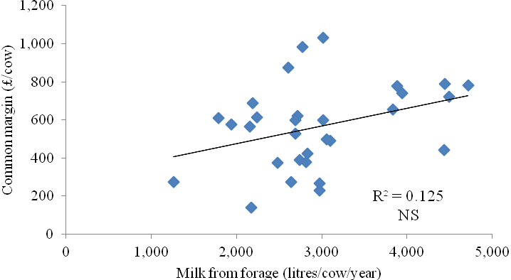
Production systems
Unlike many other milk producing regions that produce the majority of their milk from either a low input/low output grass-based system (Republic of Ireland, New Zealand), or a high input/high output concentrate-based system (USA), Northern Ireland dairy farmers have adopted a wide range of production systems. Indeed, the farms within this study represented this range, with low input spring calving systems, high input autumn calving systems and partial confinement systems all represented. The farms were also divided in terms of feeding systems, with four operating a total mixed ration system (TMR) whereas the other six operated an easy feed system. The farms using the TMR feeding system produced 600 litres/cow/year less from forage and fed 0.9 t/cow/year more concentrates, resulting in a lower common margin (7.8 vs 8.6 ppl). This highlights that despite the increasing popularity of the TMR-based feeding system on NI farms, the additional costs involved and the opportunity to adopt higher concentrate inputs need to be monitored, or profit margins could be adversely affected.

The differences in production systems between the ten farms is clear when comparing milk from forage and milk yields, with differences in concentrate input in particular clearly reflected in the lower variable costs achieved by the low input systems (Figure C). The analysis identifies that total variable costs and total common costs are negatively related to common margin per cow, hence identifying the importance of controlling the costs of production on dairy farms.

Figure C. Relationship between total variable costs and common margin (£/cow) for two low input farms ( ) and two high input farms over the three years of the study
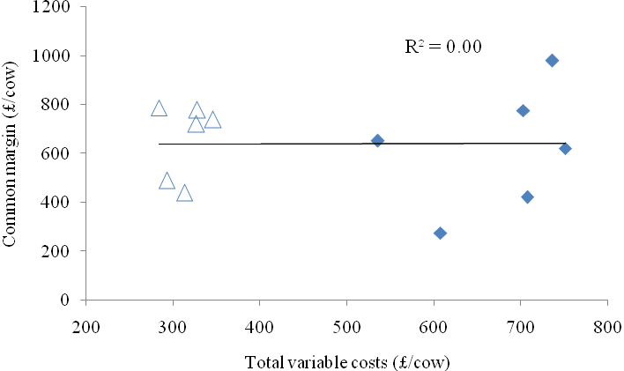

Much debate in Northern Ireland also revolves around the high level of machinery present on farms, with attention given to the efficiency gains of using contractors for most of the main farming operations (silage making, slurry spreading, reseeding). Within this study contractor costs were negatively associated with common margin per cow, with contractor costs lower on those farms that had their own silage making machinery. However, when machinery costs were considered, there was no relationship with common margin per cow, with machinery costs (£/cow) similar between farms. This highlights that despite some farms using contractors, machinery costs were not that different to those with their own silage making equipment. Although these relationships do not provide a clear guide as to the most profitable way to manage the machinery on the farm, they do highlight that machinery costs are a significant cost and that machinery levels must be kept appropriate to the scale of the farm.

INTRODUCTION

The Northern Ireland dairy industry has changed significantly during the last 20 years, as it responds to a rapidly evolving and competitive global market. Herd size continues to increase and is currently approaching 80 cows, with over 55% of dairy cows in Northern Ireland now found in herds of over 100 cows (Table 1). At the same time milk production per cow has risen significantly. Over the period from 1986 to 2006 milk yield per cow increased, on average, by 110 litres/cow/year, having risen from 4,635 to 6,830 litres/cow. However, there has been a slight reversal in this trend in recent years, with an average milk yield of 6,350 litres/cow achieved in 2009.

Table 1. Distribution of herd sizes within the Northern Ireland dairy industry (DARD, 2009)

Herd size | % Farms | % of cows
Less than 50 | 42 | 14
50-99 | 32 | 30
100 cows plus | 26 | 56

This increased production has been the result of increases in the genetic potential of cows for milk production and increased levels of concentrate feeding, rather than to changes in forage quality or improved utilisation of forage. The increase in concentrate use has resulted in an increase in the costs of production on NI farms, leaving the profitability of local milk producers at greater risk when prices are volatile. This is particularly important as recent history suggests that volatility within world commodity markets is going to be increasingly important in years to come. For Northern Ireland milk production to remain viable, producers must retain their focus on lowering the costs of milk production. Results from the benchmarking of 300 local dairy farms (CAFRE, 2006; 2007; 2008) highlights a wide range in production costs, indicating that there is room for improvement and that producers need a renewed focus on developing cost efficient milk production systems.

The diversity of soil type, farm infrastructure and labour availability on Northern Ireland dairy farms also makes the adoption of a single ‘blue print’ for successful and profitable milk production inappropriate. Furthermore, management decisions adopted by individual farmers are influenced by a wide range of pre-disposing and inter-related factors. Climate, soil type, grass growth potential and availability of grazing land are all examples of important constraints on dairy farms, with the relative importance of each of these factors dependent on geographic location.

Optimising the inclusion of grazed grass within dairy systems has long been advocated as a method by which production costs can be reduced (Keady and Anderson, 2000; Kilpatrick et al., 2002), although this is dependent on high yields of grass being grown and high utilisation rates. In reality many farms are under-utilising grazed grass. The performance of grazed grass was highlighted as an important factor requiring attention within the Irish dairy industry (Dillon et al., 2003), and this is also relevant to Northern Ireland given the range of grassland management being achieved on farm (Dale et al., 2009). Furthermore, a previous on-farm study (Dale et al., 2005) highlighted that there is a wide range in herbage production potential across Northern Ireland dairy farms. Variability in herbage growth within a single season, and indeed between seasons, as highlighted by Ferris (2007) for a single site in Northern Ireland (Hillsborough), provides a challenge to grazing management.

Given the complexity of factors that influence choice of milk production systems, it is vital to monitor actual farm businesses, and identify costs of production, grassland performance and farm output across Northern Ireland. Only by quantifying actual performance at a farm level across the country, can farmers be best advised as to the relative merits of different dairy production systems. With added uncertainty over subsidy payment levels and compliance conditions, consumer demand, carbon footprints, water quality and animal welfare, it is more important than ever for the industry to adopt production systems that are environmentally sustainable and financially robust over a range of circumstances. In order to identify the main drivers of profitability across a range of milk production systems and locations the physical (grassland and animal) and financial performance of ten dairy farms in Northern Ireland were intensively monitored for 3 years.

In addition to the dataset being collated from the ten monitored farms in Northern Ireland, Teagasc conducted a similar study in the north-west and north-east regions of the Republic of Ireland, with 16 farms being monitored over three years (Horan and Kelly, 2006). This study was conducted from April 2005 to March 2008, thus overlapping with the current studies years 1 and 2. This data is summarised at the end of this report (Appendix 34), with the average values collected across the farms presented and an analysis of the combined datasets presented.

MATERIALS AND METHODS

Farm selection
The 10 dairy herds monitored within this project were selected from within 300 farms participating in the Greenmount Dairy Benchmarking Programme in 2005. Farms were initially shortlisted from within this group by selecting only those farms that had updated their benchmarking figures for the two years previous to the start of this study (i.e. 2004 and 2005). Of these farms, herds with less than 50 cows and greater than 200 were excluded, as were herds with average milk yields lower than 4,800 litres/cow and greater than 9,200 litres/cow. This process resulted in a final list of 66 eligible farms. This list of 66 farms was distributed around the DARD regional dairy advisors for comment, to ensure that all farms on the list were appropriate for participation within this project. No significant comments were received, and this list of 66 farms was then discussed by the Project Team.

The Project Team decided that a further short listing criteria would be applied, namely the exclusion of farms already involved in research projects (with the exception of the three GrassCheck farms at Portaferry, Ballymoney and Fintona, which were included). This decision was taken to allow new links to be forged with the farming industry and to ensure that farmers already involved in research projects would not be overburdened. A final shortlist of 20 farms was then generated, with care taken to ensure that this group had a good range of:-
- Soil types
- Geographic location
- Milk yield/cow and herd size
- Calving patterns – spread and compact

A final group meeting was then held to select 14 farms from this list of 20. Four of these fourteen farms were identified as ‘reserve’, in case any of the ten first choice farms were unable to participate in the project. A member of the research team, together with each farm’s local dairy development advisor visited each farm at the outset of the project to outline the structure of the project and the measurements that would be taken. All farms were given the opportunity to decline being involved at this stage.

Farm details
The locations of the 10 farms are presented in Figure 1. In order to maintain the anonymity of the participating farmers, the farms were randomly allocated to identification numbers within the range 1-10, and the farms will be identified by these numbers throughout this report. In no particular order, the farm locations included; Mountnorris, Ballymoney, Banbridge, Cookstown, Fintona, Omagh, Lisnaskea, Aghadowey, Toomebridge and Portaferry.

Figure 1. The location of the 10 farms involved in this study

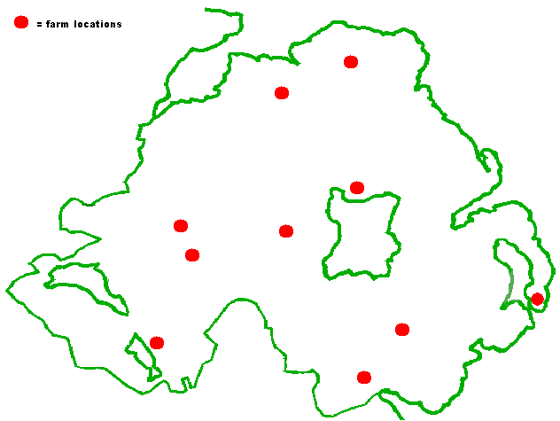

Data collection
Farms were monitored over a three-year period commencing March 2006, with intensive grassland information collected during the grazing seasons (April - October) in 2006, 2007 and 2008. Three years of physical and financial data were collected; Year 1 (April 2006 – March 2007), Year 2 (April 2007 – March 2008) and Year 3 (April 2008 – March 2009).

Physical data
The physical data collected related predominantly to grassland management during the grazing season, with this information collected by teams from AFBI Hillsborough and CAFRE Greenmount. Each team visited five farms, with all ten farms visited over a five-day period, with visits taking place once every four weeks during the grazing season. During each year of the study, these monthly visits commenced in April and finished in October.

During each visit, the grass heights within all the paddocks/fields that were available for grazing were assessed by walking fields in a ‘W’ formation and taking measurements with a rising plate meter (Jenquip, New Zealand). The number of readings taken within each paddock/field was dependent on its area, although generally 30-50 readings were taken. This compressed sward height was then converted to herbage mass (kg DM/ha) (Y) using the following equation: y = (316*x) + 330, where x is sward height (cm). In addition, during each farm walk the paddock to be grazed next was identified as was the paddock that had just been grazed, so that the pre- and post-grazing grass covers could be identified. Quantifying pre- and post-grazing herbage mass also allowed the estimation of grass utilisation by each farm, with this being quantified >4.0 cm (>1,600 kg DM/ha). Hence, utilised grass was the difference between the quantity of grass available in the paddock about to be grazed and the grass remaining in the paddock that had just been grazed. Measuring all the paddocks/fields also allowed the average herbage mass across the farm to be determined. This ‘average farm cover’ was calculated by multiplying the grass cover within each paddock/field by the area of the paddock/field, with the sum of this value for all the paddocks/fields then divided by the total grazing area. Identifying the total area available for grazing also allowed the grazing stocking rate to be calculated at each visit.

During each visit a grass sample was taken from the sward that was just about to be grazed. This grass sample was taken using battery operated clippers (Gardena Accu 6, Kress and Kastner, Weiterstadt, Germany), with the sampling depth determined by observing the post-grazing height being achieved by the grazing herd. The sample was analysed fresh by near infrared reflectance spectroscopy (NIRS) for water soluble carbohydrates (WSC), crude protein (CP), metabolisable energy (ME), dry matter (DM) and acid detergent fibre (ADF) contents.

Although measurements were collected from swards pre- and post-grazing, the four-week interval between visits meant that this was seldom from the same field/paddock during consecutive months. As a result these measurements could not be used to determine annual grass production on these farms. Therefore, to identify the potential annual herbage production on each farm, an area of grassland was fenced off and harvested at each visit. This plot area (5.0 m x 4.5 m) was generally selected from within the dairy cow grazing fields, and within this area three strips of grass (1.05 m x 5.0 m each) were harvested at each visit with a reciprocating knife bar mower (Goldini, Italy). The herbage harvested from each strip was weighed, and a sub-sample was taken to determine oven dry matter content (24 hours at 100ºC). Fertiliser was applied after each cut (Table 2), with 280 kg N/ha applied in 2006 and 2008 and 285 kg N/ha applied in 2007. Soil samples were taken from these sites at the start of each year and lime, phosphate and potash applied according to RB209 guidelines, if necessary.

Table 2. Quantity and timing of fertiliser applications for the plots used to measure total herbage production on each of the ten farms during the three years of the study

 | Rate of fertiliser applied (kg N/ha)
Application date | Year 1 | Year 2 | Year 3
Application at trim-off (urea) | - | 30 | 30
After first cut | 60 | 60 | 60
After second cut | 60 | 50 | 50
After third cut | 50 | 50 | 50
After fourth cut | 50 | 40 | 40
After fifth cut | 30 | 30 | 30
After sixth cut | 30 | 25 | 20
Total quantity applied | 280 | 285 | 280

In addition to the information collected by the technical teams, each farmer was given a diary in which to record daily information during the year, with number of cows milking, details of cow grazing (paddocks being grazed, turnout dates, housing dates, removal of surplus grass), and level of supplements being offered all being recorded.

Financial data
All financial data were collected through CAFRE Benchmarking, with each year’s data collected during a single visit by each farms dairy advisor at the conclusion of the financial year. The full range of data recorded are provided in Appendices 1 and 2, including where appropriate an explanation of how they were calculated. The data included:- total area being farmed, stock numbers, labour input, calving pattern, volume and quality of milk sold, an estimate of milk fed to calves, average milk price received and variable costs. Total variable costs included; concentrate, forage, vet and medicine, AI and miscellaneous costs, within common costs including; machinery, contractor, depreciation, electric/water/phone, property repairs and miscellaneous costs. The overhead costs included; common costs, paid labour, conacre and interest costs. The recording of these data and others allowed the calculation of each farms’ gross margin (£/cow) and common margin (£/cow, £/ha and ppl). The gross margin was calculated by subtracting the total variable costs from the total output, with common margin calculated by subtracting the common costs from the total output. All costs involved in each calculation are detailed in Appendices 1 and 2. The costs associated with labour, conacre and finance are not included in the calculation of common margin.

Statistical analysis
All physical and financial parameters measured across the farms were analysed for significant effects on common margin expressed on a per cow, per litre and per hectare basis. Analysis was carried out using mixed models for each parameter, with year (n=3) and farm (n=10) included as factors within the model, with year handled as a repeated random effect. Annual averages for the main physical and financial parameters were used in the analysis, with the monthly data combined into early (April, May, June) and late (July, August, September) season averages each year for analysis. In addition, the data were examined for relationships between non-profit parameters where appropriate, with these relationships identified by linear regression and scatter graphs.

RESULTS

Farm scale
There was a wide range in land area farmed and herd size across the ten farms (Table 3), with Farm 3 the largest farm in terms of land area and cow numbers. Although land area farmed remained fairly static over the three years of the study (Appendix 3), herd size on individual farms did change substantially. Whilst cow numbers on Farms 1, 6 and 10 decreased by 23, 12 and 30%, respectively, cow numbers on Farms 3, 4, and 8 increased by 13, 10 and 22%, respectively. However, despite these changes on individual farms, the overall average herd size remained similar between years. The majority of labour on the farms was family labour, with only Farms 1, 7 and 8 utilising more than 0.5 of an external labour unit on average over the three years.

Table 3. Total area farmed, average number of cows in the herd, and family and total labour units on each of the ten farms during the three years of the study

 |  | Total area farmed (ha) | Average number of cows in the herd | Family labour units | Total labour units
Farm | 1 | 62.0 | 128 | 1.0 | 1.8
 | 2 | 74.6 | 92 | 2.0 | 2.0
 | 3 | 132.4 | 187 | 2.0 | 2.1
 | 4 | 49.7 | 95 | 1.2 | 1.4
 | 5 | 64.0 | 117 | 1.5 | 1.5
 | 6 | 41.7 | 74 | 1.5 | 1.5
 | 7 | 85.8 | 123 | 1.0 | 2.1
 | 8 | 83.1 | 139 | 1.8 | 2.9
 | 9 | 37.0 | 81 | 1.3 | 1.3
 | 10 | 52.0 | 77 | 1.0 | 1.0
Overall average |  | 68.2 | 111 | 1.4 | 1.8
Year | 1 | 67.7 | 112 | 1.5 | 1.8
 | 2 | 66.7 | 112 | 1.4 | 1.7
 | 3 | 70.4 | 111 | 1.4 | 1.8

Milk production
On average over the three years of the study there was a difference of almost 3,800 litres/cow/year between the farm with the highest (Farm 2) and lowest milk production (Farm 10) (Table 4). Total milk production on the majority of farms did not vary widely between years (± 300 litres), however the milk production on Farm 8 dropped by in excess of 800 litres/cow/year between year 1 and year 3 (Appendix 4). Milk composition also varied widely between farms, with the highest milk composition over the three years achieved by Farm 1, with a combined fat + protein content 24% higher than the farm with the lowest composition (Farm 10). These two farms were consistent in achieving the highest and lowest milk composition values each year. Over the three years, the average milk price received by the farms was 3.1 ppl higher for Farm 1 (highest price) than Farm 10 (lowest price). Although Farm 1 and Farm 10 received the highest and lowest milk price in years 1 and 3, respectively, Farms 4 and 6 received the highest and lowest milk price in year 2, respectively. On average, milk price received was highest in year 2 and lowest in year 1, with milk price in year 2 being 40% higher than in year 1 (17.1 vs 24.0 ppl).

Table 4. Average milk produced per cow per year, milk composition, milk somatic cell count and milk price on each of the ten farms during the three years of the study

 |  | Milk produced per cow per year (litres)# | Milk butterfat content (%) | Milk protein content (%) | Somatic cell count ('000/ml) | Milk price (ppl)
Farm | 1 | 6036 | 4.52 | 3.57 | 190 | 22.6
 | 2 | 8704 | 4.18 | 3.25 | 193 | 21.2
 | 3 | 7446 | 4.08 | 3.24 | 177 | 20.5
 | 4 | 7312 | 4.29 | 3.35 | 220 | 21.8
 | 5 | 6243 | 4.13 | 3.34 | 118 | 21.1
 | 6 | 5838 | 3.91 | 3.29 | 169 | 20.5
 | 7 | 6886 | 4.34 | 3.41 | 198 | 21.3
 | 8 | 7627 | 3.97 | 3.17 | 280 | 20.9
 | 9 | 7934 | 3.98 | 3.32 | 234 | 20.3
 | 10 | 4912 | 3.55 | 2.99 | 263 | 19.5
Overall average |  | 6894 | 4.09 | 3.29 | 204 | 21.0
Year | 1 | 6995 | 4.11 | 3.26 | 196 | 17.1
 | 2 | 6871 | 4.06 | 3.30 | 217 | 24.0
 | 3 | 6815 | 4.12 | 3.32 | 200 | 21.8
# includes milk used in the farm house and fed to calves
Reproduction
On average, the highest proportion of cows (42%) calved during the months of January, February and March (Table 5). The average calving patterns on Farms 2, 3, 4, 9 and 10 were spread, with at least 20% of these herds calving during three of the three-month periods. Only Farms 1, 5, 6 and 7 had more than 60% of their herd calved within any of the three-month periods. Farms 1, 5, and 6 can be described as spring milk producers, with over 90% of the cows in these herds calving in the spring period (Table 6). Alternatively, only Farm 7 was exclusively autumn calving, however Farms 2, 4, 8 and 9 did calve the majority of their cows during the autumn. In general, over the three years of this study these trends did not change.

Table 5. Proportion of herd calving during each three month period on each of the ten farms during the three years of the study.

 |  | Proportion of herd calving during each three month period
 |  | April, May, June | July, August, September | October, November, December | January, February, March
Farm | 1 | 0.03 | 0.00 | 0.00 | 0.97
 | 2 | 0.04 | 0.25 | 0.40 | 0.31
 | 3 | 0.20 | 0.07 | 0.29 | 0.44
 | 4 | 0.04 | 0.44 | 0.31 | 0.21
 | 5 | 0.21 | 0.00 | 0.00 | 0.79
 | 6 | 0.25 | 0.00 | 0.08 | 0.66
 | 7 | 0.00 | 0.63 | 0.37 | 0.00
 | 8 | 0.09 | 0.16 | 0.55 | 0.20
 | 9 | 0.12 | 0.20 | 0.38 | 0.31
 | 10 | 0.27 | 0.05 | 0.40 | 0.28
Overall average |  | 0.12 | 0.18 | 0.28 | 0.42
Year | 1 | 0.13 | 0.18 | 0.29 | 0.40
 | 2 | 0.12 | 0.18 | 0.28 | 0.42
 | 3 | 0.12 | 0.17 | 0.27 | 0.44

Table 6. Percentage of herd calving in the spring (January – June) and the autumn (July -December), and average herd replacement rate on each of the ten farms during the three years of the study

 |  | Animals calving in spring (%) | Animals calving in autumn (%) | Replacement rate (%)
Farm | 1 | 100 | 0 | 20
 | 2 | 35 | 65 | 23
 | 3 | 64 | 36 | 23
 | 4 | 27 | 73 | 21
 | 5 | 100 | 0 | 21
 | 6 | 92 | 8 | 26
 | 7 | 0 | 100 | 24
 | 8 | 29 | 71 | 34
 | 9 | 43 | 57 | 29
 | 10 | 56 | 44 | 0
Overall average |  | 54 | 46 | 22
Year | 1 | 53 | 47 | 21
 | 2 | 54 | 46 | 20
 | 3 | 56 | 44 | 24

The replacement rate on Farm 10 was zero (Table 6) in all three years of the study reflecting a management decision to stop rearing replacements and to allow herd size to decrease. The highest average replacement rate (34%) occurred on Farm 8, a reflection of the high numbers of heifers brought into the herd in year 1 and 2 as part of a herd expansion programme (Appendix 5).

Stocking rate, forage utilisation and supplementation
While the majority of farms had a similar average stocking rate over the three years (2.2 – 2.4 CE/ha), Farms 1 and 9 were more intensively stocked, with Farm 10 more extensively stocked (Table 7). Although Farm 9 was managed intensively over the three years (Appendix 7), Farm 1 was only managed intensively in year 2. Average milk from forage (litres/cow) produced over the three years was highest on Farm 5, with milk from forage on a per cow basis on this farm twice that achieved on Farms 8 and 9. There was a trend for an annual increase in milk from forage over the period of this study, with the overall average increasing from 2,764 to 3,100 litres/cow/year from year 1 to 3. Average milk from forage over the three years on a per hectare basis was highest on Farm 1, with the levels achieved being twice that achieved by Farms 7 and 8.

Average milk output/labour unit over the study period was highest for Farm 3 (Table 7), with in excess of 1 million litres of milk sold per labour unit, compared with under 400,000 litres of milk sold per labour unit on Farms 6 and 10. Average concentrate input over the study period was highest on Farm 9 where 2.5 t/cow/year was fed, whereas Farms 1, 5 and 10 fed less than 1 t/cow/year. The highest annual concentrate input was 3 t/cow/year fed by Farm 9 in year 1 (Appendix 7), with Farm 5 feeding the lowest annual total of 0.65 t/cow/year in year 3. There was a trend for concentrate inputs to decrease over the course of the study. Average concentrate feeding rate over the study period was highest on Farms 8 and 9 (0.32 kg concentrate/litre milk), with Farms 1, 5 and 10 feeding less than 0.17 kg concentrate/litre milk. The highest concentrate feeding rate occurred on Farm 9 in year 1, when 0.38 kg concentrate/litre milk was fed, with the 0.11 kg concentrate fed/litre milk produced by Farm 5 in year 3 being the lowest feeding rate. There was a trend for concentrate feeding rates to decrease over the course of the study.

Table 8 highlights that only four of the ten farms fed exclusively grass silage during the winter months (Farms 1, 4, 6 and 10). The average quality of grass silage produced over the three years varied greatly between farms, with the range in values for DM, ME and CP being 18%, 1.0 MJ/kg DM and 3.7 % DM, respectively. During the three years, the highest quality grass silage was produced by Farm 3 in year 3 (12.3 MJ/kg DM, 115 intake value), with the poorest quality grass silage made in the same year by Farm 7 (9.4 MJ/kg DM, 67 intake value) (Appendix 16). On average, the best quality maize silage was made in year 1, with no real trends in grass silage quality between years.

Table 7. Average overall stocking rate, milk from forage (litres/cow and litres/ha), milk output per labour unit, concentrates fed per cow and concentrate feeding rate on each of the ten farms during the three years of the study

 |  | Overall stocking rate (CE/ha) | Milk from forage (litres/cow) | Milk from forage (litres/ha) | Milk output/labour unit ('000) | Concentrates fed (kg/cow/year) | Concentrate feeding rate  (kg concentrate/litre)
Farm | 1 | 2.7 | 3830 | 10762 | 592 | 993 | 0.16
 | 2 | 2.2 | 3501 | 7598 | 704 | 2342 | 0.27
 | 3 | 2.3 | 2468 | 5586 | 1053 | 2240 | 0.30
 | 4 | 2.4 | 2551 | 6077 | 630 | 2143 | 0.29
 | 5 | 2.3 | 4549 | 10592 | 611 | 762 | 0.12
 | 6 | 2.3 | 2767 | 6408 | 377 | 1382 | 0.24
 | 7 | 2.2 | 2335 | 5173 | 630 | 2048 | 0.30
 | 8 | 2.3 | 2259 | 5144 | 491 | 2415 | 0.32
 | 9 | 3.3 | 2270 | 7589 | 761 | 2549 | 0.32
 | 10 | 1.6 | 3015 | 4754 | 398 | 853 | 0.17
Overall average |  | 2.4 | 2955 | 6968 | 625 | 1773 | 0.25
Year | 1 | 2.3 | 2764 | 6306 | 596 | 1904 | 0.27
 | 2 | 2.4 | 2997 | 7431 | 657 | 1744 | 0.25
 | 3 | 2.3 | 3104 | 7168 | 622 | 1670 | 0.24

Table 8. Average quality of winter forage (grass, wholecrop and maize silages) on each of the ten farms during the three years of the study

 |  | Average quality of grass silage |  |  |  |  | Average quality of wholecrop silage |  |  |  |  | Average quality of maize silage
 |  | DM (%) | ME (MJ/kg DM) | Silage intake (g/kgW0.75) | CP  (% DM) |  | DM (%) | Starch (% DM) | ME (MJ/kg DM) | CP  (% DM) |  | DM (%) | Starch (% DM) | ME (MJ/kg DM) | CP  (% DM)
Farm | 1 | 28.5 | 10.7 | 91 | 11.4
 | 2 | 23.8 | 11.7 | 100 | 15.1 |  | 37.7 | 26.7 | 9.1
 | 3 | 31.5 | 11.2 | 102 | 13.8 |  | 41.1 | 31.1 | 9.5 |  |  | 25.7 | 21.8 | 10.1 | 7.5
 | 4 | 27.5 | 10.9 | 99 | 14.9
 | 5 | 31.7 | 11.2 | 101 | 13.0 |  | 43.6 | 25.4 | 9.4
 | 6 | 25.1 | 11.0 | 95 | 14.8
 | 7 | 22.8 | 10.7 | 84 | 11.9 |  | 27.0 | 13.9 | 8.9
 | 8 | 27.7 | 10.7 | 97 | 13.3 |  |  |  |  |  |  | 28.0 | 26.8 | 11.0 | 8.6
 | 9 | 40.8 | 11.1 | 108 | 13.7 |  | 33.2 | 18.2 | 9.3 |  |  | 28.0 | 29.4 | 10.9 | 7.3
 | 10 | 26.2 | 10.9 | 95 | 13.5
Overall average |  | 28.7 | 11.0 | 98 | 13.7 |  | 36.5 | 23.1 | 9.2 |  |  | 27.2 | 26.0 | 10.7 | 7.8
Year | 1 | 27.2 | 11.0 | 100 | 14.3 |  | 39.5 | 26.6 | 9.2 |  |  | 29.7 | 30.7 | 10.7 | 7.3
 | 2 | 28.2 | 11.0 | 96 | 12.9 |  | 36.3 | 22.9 | 9.3 |  |  | 25.9 | 25.4 | 11.1 | 7.9
 | 3 | 30.9 | 11.0 | 98 | 13.9 |  | 45.9 | 30.2 | 9.7 |  |  | 24.6 | 18.2 | 10.4 | 10.0

Grassland performance
Throughout the study the longest grazing season was consistently achieved on Farm 1 (Table 9), with grazed grass being part of the diet of the milking herd for 9 to 10 months each year. On Farm 8 the herd was housed overnight throughout the year, hence the herd was never full-time grazing. The shortest grazing seasons in years 1, 2 and 3 were 119 (Farm 9), 107 (Farm 8) and 123 (Farm 7) days shorter, respectively, than for Farm 1. On average across the farms, the grazing season was longer in year 2.

Table 9. The total number of days spent grazing full-time and full-time plus part-time on each of the ten farms during the three years of the study

 | Total time each herd spent grazing each year (days)
 | Year 1 |  | Year 2 |  |  |  | Year 3
Farm | Full-time | Full-time + part-time |  | Full-time | Full-time + part-time |  | Full-time | Full-time + part-time
1 | 237 | 293 |  | 245 | 288 |  | 251 | 274
2 | 141 | 190 |  | 149 | 192 |  | 127 | 183
3 | 146 | 198 |  | 157 | 212 |  | 150 | 206
4 | 183 | 200 |  | 197 | 225 |  | 168 | 175
5 | 184 | 205 |  | 219 | 250 |  | 182 | 228
6 | 152 | 188 |  | 172 | 228 |  | 148 | 181
7 | 150 | 204 |  | 166 | 209 |  | 129 | 151
8 | 0 | 189 |  | 0 | 181 |  | 0 | 152
9 | 115 | 174 |  | 171 | 197 |  | 152 | 175
10 | 180 | 199 |  | 188 | 205 |  | 156 | 171
Average | 149 | 204 |  | 166 | 219 |  | 146 | 190

Pre-grazing herbage mass was high on the majority of the farms throughout the grazing season, with only a few farms achieving an average pre-grazing herbage mass <3,500 kg DM/ha over the three years (Table 10). Pre-grazing herbage mass was particularly high in May and June, with many farms recording in excess of 4,500 kg DM/ha during the three-years (Appendix 8). Although average pre-grazing herbage mass in the second half of the year (July, August and September) across the farms was at least 500 kg DM/ha lower than for the first half of the year (April, May, June), average herbage masses were still high.
Average post-grazing herbage mass measured on the farms during the monthly visits were high (Table 11), with only a few farms achieving <2,000 kg DM/ha during individual months within the three years (Appendix 9). Although Farm 1 achieved an average post-grazing herbage mass of approximately 1,800 kg DM/ha in both halves of the season over the three years, all other farms had in excess of 2,100 kg DM/ha, on average. The average farm cover on these farms also reflects a high supply of grass, with average farm covers in excess of 3,500 kg DM/ha recorded on many farms during the monthly visits (Appendix 10). Farm 1 consistently achieved the lowest average farm cover throughout the study (Table 12), with an overall average cover during the first half and second half of each year of around 2,500 kg DM/ha. Grass supply was highest on Farm 2 with an average cover of 4,100 and 3,800 kg DM/ha, during the first and second halves of the year, respectively.

Average grazing stocking rate across the farms was highest in May, decreasing monthly thereafter as the grazing season progressed (Table 13). There was a wide range of grazing stocking rates recorded on the farms, with Farm 8 achieving 6.6 cows/ha on average in May over the three years of the study, compared to 3.2 cows/ha on Farm 10 in the same month. However, the high stocking rate with Farm 8 reflects the fact that cows on this farm were housed at night.

Table 10. Average pre-grazing herbage mass (kg DM/ha, above ground level) as measured each month on each of the ten farms during the three years of the study

 |  |  |  |  |  |  |  |  |  | Combined months
 |  | April | May | June | July | August | September | October |  | April, May, June | July, August, September
Farm | 1 | 3100 | 3600 | 3300 | 3533 | 2900 | 3867 | 3533 |  | 3363 | 3380
 | 2 | 4600 | 5433 | 5433 | 4633 | 4300 | 4867 | 4133 |  | 5225 | 4570
 | 3 | 3850 | 4933 | 4300 | 4533 | 4275 | 4200 | 3900 |  | 4425 | 4330
 | 4 | 3750 | 5167 | 4833 | 4433 | 3800 | 4267 | 3567 |  | 4688 | 4130
 | 5 | 2950 | 4133 | 4167 | 4300 | 3900 | 4200 | 3700 |  | 3850 | 4110
 | 6 | 4100 | 5400 | 4567 | 4633 | 3900 | 3333 | 4300 |  | 4763 | 3950
 | 7 | 4500 | 5467 | 4700 | 4100 | 4550 | 3800 | 3300 |  | 5000 | 4190
 | 8 | 4650 | 5567 | 4533 | 4100 | 4375 | 4233 | 3700 |  | 4950 | 4250
 | 9 | 5200 | 5167 | 3967 | 4033 | 4100 | 4267 | 4450 |  | 4725 | 4130
 | 10 | 3400 | 5967 | 6867 | 5033 | 5000 | 4600 | 3400 |  | 5986 | 4890
Overall average |  | 4010 | 5083 | 4667 | 4333 | 4110 | 4163 | 3798 |  | 4697 | 4193
Year | 1 | N/A | 4710 | 5170 | 4220 | 4035 | 4080 | 3586 |  | 4940 | 4093
 | 2 | 4330 | 4730 | 4460 | 4360 | 4020 | 4360 | 3780 |  | 4507 | 4247
 | 3 | 3625 | 5810 | 4370 | 4420 | 4350 | 4050 | 4043 |  | 4671 | 4273

Table 11. Average post-grazing herbage mass (kg DM/ha, above ground level) as measured each month on each of the ten farms during the three years of the study

 |  |  |  |  |  |  |  |  |  | Combined months
 |  | April | May | June | July | August | September | October |  | April, May, June | July, August, September
Farm | 1 | 1450 | 1869 | 1867 | 1833 | 1850 | 1700 | 1700 |  | 1763 | 1800
 | 2 | 2250 | 2567 | 2533 | 2533 | 2300 | 2367 | 2267 |  | 2475 | 2390
 | 3 | 1900 | 2400 | 2300 | 2433 | 2225 | 2233 | 2200 |  | 2238 | 2290
 | 4 | 1900 | 2267 | 2167 | 1967 | 2325 | 2167 | 2067 |  | 2138 | 2170
 | 5 | 2200 | 2233 | 2300 | 2500 | 2325 | 2300 | 2167 |  | 2250 | 2370
 | 6 | 2050 | 2233 | 2067 | 2133 | 2175 | 2033 | 2200 |  | 2125 | 2120
 | 7 | 2200 | 2667 | 2433 | 2500 | 2450 | 2400 | 2300 |  | 2500 | 2450
 | 8 | 2300 | 2633 | 2500 | 2533 | 2425 | 2433 | 2400 |  | 2500 | 2460
 | 9 | 2350 | 2300 | 2200 | 2333 | 2400 | 2267 | 2450 |  | 2275 | 2340
 | 10 | 1800 | 2367 | 2533 | 2533 | 2575 | 2300 | 2100 |  | 2357 | 2480
Overall average |  | 2040 | 2354 | 2290 | 2330 | 2305 | 2220 | 2185 |  | 2262 | 2287
Year | 1 | N/A | 2311 | 2290 | 2310 | 2325 | 2260 | 2143 |  | 2300 | 2305
 | 2 | 2200 | 2320 | 2330 | 2430 | 2330 | 2230 | 2200 |  | 2283 | 2330
 | 3 | 1850 | 2430 | 2250 | 2250 | 2240 | 2170 | 2071 |  | 2200 | 2220

Table 12. Average farm cover (kg DM/ha, above ground level) as measured each month on each of the ten farms during the three years of the study

 |  |  |  |  |  |  |  |  |  | Combined months
 |  | April | May | June | July | August | September | October |  | April, May, June | July, August, September
Farm | 1 | 2050 | 2767 | 2567 | 2533 | 2375 | 2700 | 2400 |  | 2513 | 2520
 | 2 | 3650 | 4433 | 4133 | 3900 | 3725 | 3800 | 3433 |  | 4125 | 3800
 | 3 | 3350 | 3633 | 3067 | 3367 | 3375 | 3267 | 2833 |  | 3350 | 3340
 | 4 | 2850 | 3433 | 3233 | 3100 | 3350 | 3400 | 2767 |  | 3213 | 3290
 | 5 | 2600 | 3320 | 3067 | 3300 | 3325 | 3367 | 2933 |  | 3045 | 3330
 | 6 | 3100 | 3733 | 3200 | 3133 | 3225 | 3067 | 2833 |  | 3375 | 3150
 | 7 | 3050 | 3933 | 3600 | 3567 | 3750 | 3867 | 2900 |  | 3588 | 3730
 | 8 | 3750 | 4067 | 3733 | 3367 | 3350 | 3400 | 2933 |  | 3863 | 3370
 | 9 | 3800 | 3500 | 2967 | 3467 | 3325 | 3500 | 3067 |  | 3375 | 3420
 | 10 | 2450 | 3800 | 4200 | 3733 | 3775 | 3633 | 2800 |  | 3613 | 3720
Overall average |  | 3065 | 3662 | 3377 | 3347 | 3358 | 3400 | 2890 |  | 3406 | 3367
Year | 1 | N/A | 3746 | 3700 | 3220 | 3310 | 3500 | 2930 |  | 3723 | 3335
 | 2 | 3260 | 3480 | 3280 | 3440 | 3360 | 3500 | 2830 |  | 3340 | 3433
 | 3 | 2870 | 3760 | 3150 | 3380 | 3450 | 3200 | 2911 |  | 3260 | 3343

Table 13. Average grazing stocking rate (cows/ha) during each month on each of the ten farms during the three years of the study

 |  |  |  |  |  |  |  |  |  | Combined months
 |  | April | May | June | July | August | September | October |  | April, May, June | July, August, September
Farm | 1 | 3.3 | 3.5 | 3.4 | 3.3 | 3.1 | 3.2 | 2.6 |  | 3.4 | 3.2
 | 2 | 3.8 | 4.5 | 4.3 | 4.0 | 3.4 | 3.3 | 3.5 |  | 4.2 | 3.6
 | 3 | 5.0 | 5.4 | 5.7 | 5.9 | 4.3 | 3.8 | 3.9 |  | 5.4 | 4.6
 | 4 | 3.2 | 4.8 | 3.5 | 2.9 | 2.3 | 2.8 | 2.6 |  | 3.9 | 2.6
 | 5 | 3.5 | 4.1 | 3.9 | 3.8 | 3.8 | 4.0 | 3.8 |  | 3.9 | 3.9
 | 6 | 3.1 | 4.1 | 3.8 | 3.4 | 3.0 | 2.7 | 2.7 |  | 3.7 | 3.0
 | 7 | 5.0 | 4.9 | 4.9 | 4.5 | 2.4 | 2.8 | 2.7 |  | 4.9 | 3.2
 | 8 | 6.3 | 6.6 | 6.4 | 6.2 | 5.5 | 5.0 | 4.7 |  | 6.5 | 5.6
 | 9 | 5.4 | 5.0 | 3.8 | 3.6 | 3.5 | 3.7 | 3.7 |  | 4.6 | 3.6
 | 10 | 2.6 | 3.2 | 3.3 | 3.4 | 3.5 | 2.7 | 2.2 |  | 3.1 | 3.2
Overall average |  | 4.1 | 4.6 | 4.3 | 4.1 | 3.5 | 3.4 | 3.2 |  | 4.4 | 3.6
Year | 1 | N/A | 4.8 | 4.5 | 4.1 | 3.4 | 3.3 | 3.1 |  | 4.7 | 3.6
 | 2 | 4.2 | 4.5 | 4.2 | 4.2 | 3.6 | 3.3 | 3.3 |  | 4.3 | 3.7
 | 3 | 4.1 | 4.5 | 4.2 | 4.0 | 3.5 | 3.6 | 3.1 |  | 4.3 | 3.7

Table 14. Average grass utilisation (% utilised >1,600 kg DM/ha) achieved each month on each of the ten farms during the three years of the study

 |  |  |  |  |  |  |  |  |  | Combined months
 |  | April | May | June | July | August | September | October |  | April, May, June | July, August, September
Farm | 1 | 1.00 | 0.86 | 0.85 | 0.88 | 0.81 | 0.95 | 0.95 |  | 0.89 | 0.87
 | 2 | 0.78 | 0.75 | 0.75 | 0.68 | 0.74 | 0.76 | 0.73 |  | 0.76 | 0.73
 | 3 | 0.88 | 0.76 | 0.74 | 0.71 | 0.76 | 0.75 | 0.74 |  | 0.78 | 0.74
 | 4 | 0.86 | 0.81 | 0.77 | 0.87 | 0.66 | 0.79 | 0.75 |  | 0.81 | 0.76
 | 5 | 0.56 | 0.75 | 0.73 | 0.67 | 0.68 | 0.73 | 0.72 |  | 0.69 | 0.69
 | 6 | 0.85 | 0.82 | 0.81 | 0.82 | 0.74 | 0.68 | 0.78 |  | 0.83 | 0.75
 | 7 | 0.79 | 0.71 | 0.73 | 0.64 | 0.69 | 0.63 | 0.59 |  | 0.73 | 0.66
 | 8 | 0.78 | 0.74 | 0.69 | 0.63 | 0.70 | 0.66 | 0.62 |  | 0.73 | 0.67
 | 9 | 0.79 | 0.78 | 0.74 | 0.69 | 0.68 | 0.75 | 0.70 |  | 0.77 | 0.70
 | 10 | 0.89 | 0.82 | 0.81 | 0.72 | 0.71 | 0.77 | 0.73 |  | 0.83 | 0.73
Overall average |  | 0.82 | 0.78 | 0.76 | 0.73 | 0.72 | 0.75 | 0.73 |  | 0.78 | 0.73
Year | 1 | N/A | 0.77 | 0.78 | 0.72 | 0.70 | 0.70 | 0.72 |  | 0.77 | 0.70
 | 2 | 0.77 | 0.76 | 0.75 | 0.69 | 0.69 | 0.78 | 0.73 |  | 0.76 | 0.72
 | 3 | 0.88 | 0.80 | 0.76 | 0.78 | 0.79 | 0.77 | 0.81 |  | 0.81 | 0.78

Average grass utilisation rates (% utilised >1,600 kg DM/ha) measured during the monthly visits ranged from 56% to 100% across the three years of this study (Table 14). On average, over the three years Farm 1 consistently achieved the highest utilisation at the monthly visits, with this reflected in an average utilisation of 89 and 87% for the first and second half of the three years, respectively. The lowest average utilisation during the first and second half of the three years was <70%, with the overall average utilisation across the ten farms being 78% and 73% in the first and second half of the grazing season, respectively. Total annual herbage production ranged from 7.0 t DM/ha on Farm 8 to 16.4 t DM/ha on Farm 2 (Table 15). On average over the three years, only Farms 6 and 8 produced <10.0 t DM/ha, with the annual average production across the farms highest in year 2.

Table 15. Total measured herbage production (t DM/ha) on cut plots on each of the ten farms during the three years of the study

 | Annual herbage production (t DM/ha)¹
Farm | Year 1 | Year 2 | Year 3 | Average
1 | 8.1 | 12.4 | 10.8 | 10.4
2 | 14.5 | 16.4 | 14.9 | 15.3
3 | 10.7 | 15.4 | 16.2 | 14.1
4 | 10.3 | 10.5 | 11.9 | 10.9
5 | 11.7 | 13.4 | 11.2 | 12.1
6 | 9.8 | 9.6 | 7.8 | 9.1
7 | 13.8 | 13.6 | 12.2 | 13.2
8 | 7.3 | 8.2 | 7.0 | 7.5
9 | 12.2 | 16.1 | 12.2 | 13.5
10 | 11.9 | 12.2 | 13.5 | 12.5
Average | 11.0 | 12.8 | 11.8 | 11.9
¹ Total inorganic N applied per hectare was 280 kg in Year 1 and Year 3, with 285 kg applied in Year 2

The average composition of the grass available pre-grazing has been summarised for early and late season in Table 16. Metabolisable energy content in the early part of the season ranged from 11.8 MJ/kg DM on Farm 5 to 10.7 MJ/kg DM on Farm 10. Herbage on Farm 10 had the lowest average ME in the second half of the grazing season (10.6 MJ/kg DM), and the lowest crude protein content in both halves of the season. The highest quality grass offered over the three years of the study was in late April in year 3, with the pre-grazing sward on Farm 5, having a ME of 13.0 MJ/kg DM and a crude protein of 22.0 % DM (Appendix 13).

Table 16. Average pre-grazing grass composition within each three month period on each of the ten farms during the three years of the study

 |  | Metabolisable Energy (MJ/kg DM) |  |  | Crude protein  (% DM) |  |  | Water soluble carbohydrates (% DM) |  |  | Acid detergent fibre  (% DM) |  |  | Dry matter  (%)
 |  | April, May, June | July, August, September |  | April, May, June | July, August, September |  | April, May, June | July, August, September |  | April, May, June | July, August, September |  | April, May, June | July, August, September
Farm | 1 | 11.5 | 11.0 |  | 18.8 | 17.2 |  | 17.1 | 12.4 |  | 26.9 | 29.5 |  | 17.6 | 16.6
 | 2 | 11.7 | 11.1 |  | 20.2 | 20.4 |  | 17.2 | 11.0 |  | 26.0 | 29.1 |  | 18.8 | 15.1
 | 3 | 11.5 | 11.3 |  | 20.3 | 21.1 |  | 16.0 | 9.3 |  | 26.8 | 28.2 |  | 18.6 | 14.3
 | 4 | 11.3 | 10.8 |  | 18.1 | 14.2 |  | 17.3 | 14.9 |  | 26.7 | 30.6 |  | 17.5 | 15.4
 | 5 | 11.8 | 11.3 |  | 20.4 | 20.2 |  | 17.7 | 12.2 |  | 24.9 | 27.8 |  | 19.3 | 16.8
 | 6 | 11.0 | 10.8 |  | 16.1 | 17.2 |  | 15.3 | 8.1 |  | 29.6 | 30.6 |  | 16.9 | 13.0
 | 7 | 11.4 | 11.2 |  | 21.1 | 19.0 |  | 15.4 | 11.5 |  | 27.1 | 28.5 |  | 18.2 | 16.0
 | 8 | 11.4 | 11.2 |  | 19.6 | 20.0 |  | 15.8 | 11.2 |  | 27.0 | 28.3 |  | 18.9 | 17.1
 | 9 | 11.7 | 11.3 |  | 19.2 | 21.2 |  | 17.9 | 11.5 |  | 25.9 | 27.9 |  | 19.4 | 15.6
 | 10 | 10.7 | 10.6 |  | 15.0 | 13.6 |  | 13.6 | 11.8 |  | 31.0 | 31.8 |  | 17.1 | 14.5
Overall average |  | 11.4 | 11.1 |  | 18.9 | 18.4 |  | 16.3 | 11.4 |  | 27.2 | 29.2 |  | 18.2 | 15.4
Year | 1 | 11.1 | 10.8 |  | 17.5 | 19.3 |  | 18.0 | 11.7 |  | 27.6 | 29.2 |  | 19.1 | 16.1
 | 2 | 11.2 | 11.1 |  | 20.9 | 16.7 |  | 12.0 | 12.6 |  | 28.1 | 30.1 |  | 16.1 | 15.5
 | 3 | 11.9 | 11.4 |  | 17.7 | 19.0 |  | 20.0 | 9.6 |  | 25.7 | 28.5 |  | 19.9 | 14.3

Costs of production and profitability
Average forage costs during the study (ppl) were lowest on Farms 2, 3, 7 and 8 at 1.2 pence per litre, with forage costs being highest on Farm 6, namely 1.7 ppl (Table 17). Across the entire study Farm 9 had the lowest annual forage cost in year 1 (0.6 ppl) and the highest forage cost in year 2 (2.6 ppl) (Appendix 6). Over all the farms, forage costs increased annually by 0.1 ppl. Over the duration of the study average concentrate costs varied by over 4.0 ppl, with the highest costs on Farm 8 (6.0 ppl) and the lowest on Farm 5 (1.9 ppl). The highest annual concentrate cost was recorded on Farm 4 in year 3 (7.3 ppl). Concentrate costs increased annually during the study. Average variable costs were in excess of 8.1 ppl for Farms 3, 8 and 9 over the duration of the study, with Farm 1 having the lowest overall variable costs, namely 5.1 ppl. Variable costs across the farms increased annually during the study. Over the duration of the study common costs were highest on Farms 8 and 9 being in excess of 13.7 ppl, while Farms 1, 5 and 10 had common costs of 10 ppl or less. Annual common costs where highest on Farm 8 in year 3 at 17.2 ppl, with average costs across the farms increasing annually by at least 1 ppl.

Table 17. Average forage costs, concentrate costs, total variable costs and common costs on each of the ten farms during the three years of the study

 |  | Forage costs (ppl) | Concentrate costs (ppl) | Total variable costs (ppl) | Common costs (ppl)
Farm | 1 | 1.5 | 2.3 | 5.1 | 9.7
 | 2 | 1.2 | 5.1 | 7.6 | 11.6
 | 3 | 1.2 | 5.2 | 8.1 | 12.8
 | 4 | 1.3 | 5.5 | 7.8 | 11.5
 | 5 | 1.5 | 1.9 | 5.2 | 9.8
 | 6 | 1.7 | 3.9 | 7.7 | 13.4
 | 7 | 1.2 | 4.6 | 7.0 | 10.6
 | 8 | 1.2 | 6.0 | 8.6 | 14.0
 | 9 | 1.5 | 5.1 | 8.7 | 13.7
 | 10 | 1.5 | 3.3 | 5.5 | 10.1
Overall average |  | 1.4 | 4.3 | 7.1 | 11.7
Year | 1 | 1.3 | 3.7 | 6.4 | 10.6
 | 2 | 1.4 | 4.3 | 7.0 | 11.6
 | 3 | 1.5 | 4.9 | 8.0 | 12.9
Average gross margin over the study was highest on Farm 1 (15.7 ppl), with the lowest margin achieved on Farm 8 (10.3 ppl) (Table 18). The lowest annual gross margin was achieved on Farm 9 in year 1 (8.3 ppl), with Farm 4 achieving the highest margin in year 2 (17.9 ppl). Average common margin over the duration of the study was lowest on Farm 6 when expressed on a per cow basis and Farm 8 on a per litre basis. Farm 2 achieved the highest average common margin per cow (£804/cow), although Farm 1 achieved the highest common margin per litre (9.3 ppl) and per hectare (£1898/ha). Average gross margin and common margin across the farms was highest in year 2 and lowest in year 1.

Table 18. Average gross margin (ppl) and common margin (£/cow, ppl and £/ha) on each of the ten farms during the three years of the study

 |  |  | Gross margin (ppl) |  | Common margin (£/cow) |  |  |  | Common margin (ppl) |  | Common margin (£/ha)
Farm |  | 1 |  | 15.7 |  | 674 | 11.2 |  |  |  |  | 1898
 |  | 2 |  | 13.3 |  | 804 | 9.3 |  |  |  |  | 1741
 |  | 3 |  | 11.2 |  | 484 | 6.5 |  |  |  |  | 1116
 |  | 4 |  | 13.7 |  | 735 | 10.1 |  |  |  |  | 1746
 |  | 5 |  | 15.0 |  | 648 | 10.4 |  |  |  |  | 1508
 |  | 6 |  | 11.9 |  | 356 | 6.1 |  |  |  |  | 832
 |  | 7 |  | 13.5 |  | 684 | 10.0 |  |  |  |  | 1513
 |  | 8 |  | 10.3 |  | 375 | 4.9 |  |  |  |  | 876
 |  | 9 |  | 10.5 |  | 439 | 5.5 |  |  |  |  | 1454
 |  | 10 |  | 13.7 |  | 441 | 9.0 |  |  |  |  | 676
Overall average |  |  | 12.9 |  | 564 |  |  | 8.3 |  | 1336
Year |  | 1 |  | 10.3 |  | 425 | 6.1 |  |  |  |  | 999
 |  | 2 |  | 15.6 |  | 750 | 11.0 |  |  |  |  | 1820
 |  | 3 |  | 12.8 |  | 517 | 7.8 |  |  |  |  | 1189

Factors affecting common margin on the farms
This section summarises the relationships between the main physical performance indicators and financial performance indicators and common margin on the ten farms. Only the main factors are presented here, with the full statistical analysis presented in Appendices 18 to 25. In each of Tables 19 to 21 P values have been presented. When P value is less than 0.05 the difference is assumed to be significant at the 5% (*) level. At a P value less than 0.01, the difference is assumed to be significant at the 10% (**) level. Values greater than 0.10 are assumed not to be significant. For all values with a P value less than 0.20, the tables highlight if the relationships are positive (+ve) or negative (-ve).

Physical performance indicators
In this section significance will be discussed if P<0.10. The total number of cows calved, total volume of milk sold, annual yield per cow, concentrate fed/cow/year and litres per labour unit were not related to common margin (ppl, £/cow or £/ha) (Table 19). The proportion of cows calving during April/May/June and concentrate feeding rate (kg/litres) was negatively correlated to common margin per litre (P<0.01). The average milk butterfat and protein content were positively correlated to common margin per litre (P<0.01). There was also a trend for milk from forage/cow (P=0.08) to be positively correlated to common margin per litre.

Common margin per cow was positively correlated to average milk butterfat and protein content (P<0.01 and P<0.05, respectively), and negatively correlated to the proportion of cows calving during April/May/June (P<0.01).

Common margin per hectare was negatively correlated to the total area farmed, total labour units (P<0.05), and the proportion cows calving during April/May/June (P<0.01). Common margin per hectare was positively correlated to average milk butterfat and protein content (P<0.001 and P<0.01, respectively), overall stocking rate (P<0.05) and milk from forage per hectare (P<0.05).

Total days grazing (full-time and part-time) were positively correlated to common margin (ppl, £/cow and £/ha), with average stocking rate in late season (P<0.05) negatively correlated to common margin per litre and per cow (Table 20). Common margin per litre was negatively correlated to grazing stocking rate in early season only (P<0.05). Pre- and post-grazing herbage mass in late season was negatively correlated to common margin per litre (P<0.01 and P<0.05, respectively). Average grass utilisation in late season was positively correlated to common margin per litre (P<0.05).

Table 19. Relationships between the main physical performance factors and common margin (ppl, £/cow, £/ha) on the ten farms during the three years of the study

 | Margin/litre (ppl) |  | Margin/cow (£/cow) |  | Margin/ha (£/ha)
Variable | P-value | relationship | P-value | relationship | P-value | relationship
Total area farmed | 0.867 |  | 0.881 |  | <0.05 | -ve
Total labour units per farm | 0.823 |  | 0.180 | +ve | <0.05 | -ve
Number of cows in herd at end of each year | 0.831 |  | 0.982 |  | 0.100 | -ve
Proportion cows calving during April/May/June | <0.01 | -ve | <0.01 | -ve | <0.01 | -ve
Proportion cows calving during July/August/September | 0.154 | +ve | 0.079 | +ve | <0.01 | +ve
Proportion of herd calving July to December | 0.974 |  | 0.454 |  | 0.101 | +ve
Proportion herd calving January to June | 0.976 |  | 0.456 |  | 0.102 | -ve
Total cows calved during the year | 0.741 |  | 0.599 |  | 0.408
Total volume milk sold (litres) | 0.585 |  | 0.691 |  | 0.470
Total concentrate input (tonnes/farm/year) | 0.180 | -ve | 0.253 |  | 0.250
Average milk butterfat content (%) | <0.01 | +ve | <0.01 | +ve | <0.001 | +ve
Average milk protein content (%) | <0.01 | +ve | <0.05 | +ve | <0.01 | +ve
Annual yield/cow (litres) | 0.695 |  | 0.391 |  | 0.217
Overall stocking rate (CE/ha) | 0.675 |  | 0.661 |  | <0.05 | +ve
Milk from forage/cow (litres) | 0.079 | +ve | 0.194 | +ve | 0.174 | +ve
Milk from forage/hectare (litres) | 0.120 | +ve | 0.176 | +ve | <0.05 | +ve
Concentrate fed/cow (kg/year) | 0.140 | -ve | 0.423 |  | 0.942
Replacement rate (%) | 0.852 |  | 0.708 |  | 0.866
Concentrate feeding rate (kg/litres) | <0.05 | -ve | 0.254 |  | 0.512
Litres/labour unit | 0.849 |  | 0.985 |  | 0.128 | +ve
Table 20. Relationships between the main grassland performance factors and common margin (ppl, £/cow, £/ha) on the ten farms during the three years of the study

 | Margin/litre (ppl) |  | Margin/cow (£/cow) |  | Margin/ha (£/ha)
Variable | P-value | relationship | P-value | relationship | P-value | relationship
Days full-time grazing | <0.05 | +ve | 0.068 | +ve | 0.067 | +ve
Days full-time and part-time grazing | <0.01 | +ve | <0.05 | +ve | <0.05 | +ve
Average pre-grazing cover^{1,#} | 0.563 |  | 0.616 |  | 0.625
Average pre-grazing cover^{2,#} | <0.01 | -ve | <0.05 | -ve | 0.341
Average post-grazing cover^{1,#} | 0.838 |  | 0.700 |  | 0.568
Average post-grazing cover ^{2,#} | <0.05 | -ve | 0.086 | -ve | 0.285
Average farm cover^{1,#} | 0.213 |  | 0.618 |  | 0.331
Average farm cover^{2,#} | 0.158 | -ve | 0.410 |  | 0.765
Average grazing stocking rate (CE/ha)¹ | <0.05 | -ve | 0.357 |  | 0.396
Average grazing stocking rate (CE/ha)² | <0.05 | -ve | <0.05 | -ve | 0.067 | -ve
Average grass utilisation^{1,} | 0.802 |  | 0.842 |  | 0.978
Average grass utilisation^{2,} | <0.05 | +ve | 0.057 | +ve | 0.137 | +ve
¹ Average of April, May and June each year
² Average of July, August and September each year
# kg DM/ha (>ground level)
 % (>1,600 kg DM/ha)

Financial performance indicators
Milk price, total output/cow, gross margin/cow and net profit/cow (P<0.001) were positively correlated to common margin per litre (Table 21), with concentrate cost/cow, machinery cost/cow (P<0.05), total variable costs/cow, total concentrate costs, contractor cost/cow (P<0.01) and total common costs/cow (P<0.001) negatively correlated to common margin (ppl).

Common margin per cow was positively correlated to milk price, total value of milk sold, total output/cow, gross margin/cow and net profit/cow (P<0.001). Common margin per cow was negatively correlated to total concentrate costs, total common costs/cow (P<0.001), contractor costs, total variable costs/cow (P<0.01) and concentrate cost/cow (P<0.05).

Common margin per hectare was positively correlated to milk price, total output/cow, gross margin/cow and net profit/cow (P<0.001). Common margin per hectare was negatively correlated to contractor costs/cow, total common cost/cow and total overhead costs/cow (P<0.05).

Table 21. Relationships between the main financial performance factors and common margin (ppl, £/cow, £/ha) on the ten farms during the three years of the study

 | Margin/litre (ppl) |  | Margin/cow (£/cow) |  | Margin/ha (£/ha)
Variable | P-value | relationship | P-value | relationship | P-value | relationship
Milk price (ppl) | <0.001 | +ve | <0.001 | +ve | <0.001 | +ve
Total value of milk sold¹ | <0.01 | +ve | <0.001 | +ve | 0.467
Total concentrate costs¹ | <0.01 | -ve | <0.001 | -ve | 0.060 | -ve
Total output/cow² | <0.001 | +ve | <0.001 | +ve | <0.001 | +ve
Forage costs/cow² | 0.652 |  | 0.956 |  | 0.419
Concentrate cost/cow² | <0.05 | -ve | <0.05 | -ve | 0.493
Total variable costs/cow² | <0.01 | -ve | <0.01 | -ve | 0.193 | -ve
Gross margin/cow² | <0.001 | +ve | <0.001 | +ve | <0.001 | +ve
Machinery cost/cow² | <0.05 | -ve | 0.109 | +ve | 0.359
Contractor cost/cow ² | <0.01 | -ve | <0.01 | -ve | <0.05 | -ve
Total common costs/cow² | <0.001 | -ve | <0.001 | -ve | <0.05 | -ve
Labour cost/cow² | 0.237 |  | 0.500 |  | 0.245
Total overhead cost/cow² | 0.979 |  | 0.798 |  | <0.05 | -ve
Net profit/cow² | <0.001 | +ve | <0.001 | +ve | <0.001 | +ve
¹ £/year
² £/cow/year

DISCUSSION

The ten farms involved in this project were selected from within the group of benchmarked farms, with this database including data gathered from more than 30,000 cows (CAFRE, 2008). Table 22 summarises the comparison of these 10 farms with the 175 farms recorded within the Benchmarking programme during Year 2 of the project. As a group, the monitored farms had a similar number of cows to the average of those farms involved in Benchmarking, and while average milk yield per cow was lower, milk quality was higher. Average concentrates fed were over 400 kg/cow lower for the monitored farms, and this is reflected in a higher value for milk production from forage (+38%). The ten monitored farms therefore do demonstrate improved utilisation of forage compared to the larger group of benchmarked farms.

Table 22. Comparison of the ten monitored farms with the farms recorded by the Greenmount Dairy Benchmarking Programme in Year 2.

Variable | Benchmarked Farms  (n=175) | Average performance of study farms (n=10)
Herd size (cows) | 111 | 112
Milk yield (litres/cow) | 7032 | 6871
Milk butterfat content (%) | 4.00 | 4.06
Milk protein content (%) | 3.24 | 3.30
Meal fed (kg/cow) | 2180 | 1744
Milk from forage (litres/cow) | 2186 | 2997
Replacement rate (%) | 24 | 20
Overall stocking rate (CE/ha) | 2.14 | 2.40
Total milk sold per year (litres) | 790,000 | 764,000

Physical performance
At an individual farm level, the decreasing herd size on Farms 1, 6 and 10 is in contrast to the general trend for increasing herd size within Northern Ireland (DARD, 2009). The unavailability of conacre in Year 2 forced a reduction in cow numbers on Farm 1, whereas the reduction in cow numbers on Farms 6 and 10 were dictated by personal circumstances on these farms.

With the exception of Farm 8, milk production per cow did not vary widely between years on most of the farms. On Farm 8, milk production was approximately 8,100 litres/cow/year in Year 1, with this having dropped to approximately 7,200 litres/cow/year in Year 3. A potential explanation for this drop could be the high replacement rate recorded in year 3. This high intake of heifers to facilitate herd expansion will ultimately have resulted in a reduction in overall herd milk output, given the lower milk yields achieved by heifers compared to mature cows. Throughout the three years the farm also constructed new milking facilities, and while this transition is unlikely to have reduced animal performance on its own, during the construction process it is possible that less time was available for herd management, which may have impacted on animal performance. Farm 8 was also the only farm to milk cows three times/day, with this carried out for 9 to 10 months of the year. Within Farms 1, 4 and 5, once daily milking was practised for up to 6 weeks when all lactating cows were in late lactation.

Figure 2. Average milk yield per cow (black + grey area combined) and milk from forage (black area) production on the ten farms over the three years of the study

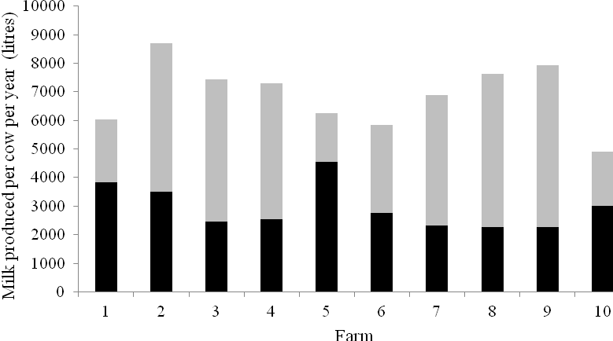

Milk from forage achieved by individual farms reflects the range of milk production systems being operated on the farms (Figure 2). The spring calving, grass-based production systems on Farms 1 and 5 achieved the highest milk from forage, with the higher concentrate inputs of the autumn calving herds on Farms 3, 7, 8 and 9 reflected in their reduced milk from forage, even though overall milk output was higher. Although Farm 2 was also predominantly autumn calving, achieving close to 9,000 litres/cow/year on average over the three years from 2.3 t concentrates, milk from forage was in excess of 3,500 litres/cow/year. Farms 1, 4, 5, 6, 8 and 10 offered forages via an easy feed system, with Farms 2, 3, 7 and 9 operating a total mixed ration system (TMR). Out-of-parlour feeding of concentrates was used on Farms 2 and 8. Results from the benchmarking programme have previously highlighted the higher concentrate inputs and poorer milk from forage when producers move to TMR based feeding systems (CAFRE, 2006; 2008). These trends are reflected in the 10 farms with the average milk from forage and concentrate input of the TMR fed herds being 2,600 litres/cow/year and 2.3 t/cow/year, compared to 3,200 litres/cow/year and 1.4 t/cow/year for the easy feed herds, respectively. Furthermore, the common margin was lower for the TMR fed herds (7.8 vs 8.6 ppl), which is in agreement with trends previously highlighted (CAFRE, 2006; 2008).

Figure 3. Milk produced per cow per year and concentrate input on each of the ten farms for each of the three years of the study

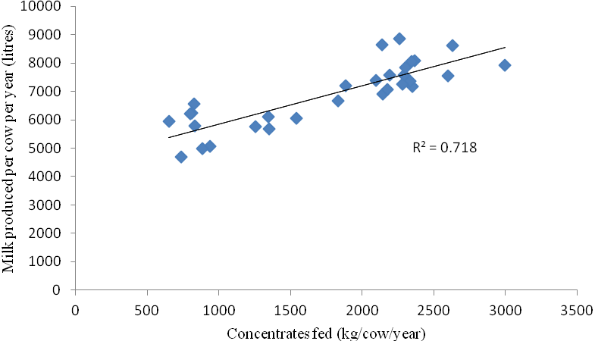

Although there was a clear trend for milk yields to increase with concentrate input (Figure 3), there was a considerable range in the milk yields achieved for similar concentrate inputs. Within the lower concentrate input systems (<1 t/cow/year) yields ranged from 4,700 to 6,600 litres/cow/year. Similarly, within the high input systems (2.2 t/cow/year) yields ranged from 6,900 to 8,900 litres/cow/year.

The availability of labour has widely been recognised as a major limiting factor for dairy farms in Northern Ireland, with an industry target for labour use efficiency of 600,000 litres milk sold per labour unit (CAFRE, 2007). Within this context the monitored farms were making efficient use of labour, with only Farms 6, 8 and 10 producing less than 590,000 litres milk per labour unit. The lower values on Farms 6 and 10 were due to the reduction of cow numbers on these farms. The lower value on Farm 8 reflected the extra requirements of milking three times per day.

Costs
The variable costs incurred by the ten farms are in line with the 6.8 ppl reported from the benchmarking programme (CAFRE, 2007), with average variable costs across the farms of 7.1 ppl. However, the low input grass-based systems on Farms 1 and 5 are clearly reflected in variable costs of 5.1 and 5.2 ppl, respectively, which is considerably lower than for the higher input systems of Farms 3, 8 and 9, where costs were in excess of 8 ppl. The benchmarking data also highlights that variable costs are generally dominated by feed costs, with concentrate and forage costs accounting for 68 and 13% of the total costs, respectively (CAFRE, 2008). In comparison, the average costs across the farms during the study were 60% concentrate costs and 19% forage costs. This reflects the lower input of concentrates on these farms compared to the benchmarking average, although the combined contribution of concentrate and forage costs remained very similar (79 vs 81% for Benchmarked farms). On Farms 1, 5 and 6 concentrates contributed 50% or less to the total variable costs, whereas on Farms 2, 4 and 8 this value approached 70%. The forage costs on Farms 1, 5 and 10 approached 30% of total variable costs, which is almost double the general trend of the benchmarked herds. There was also a clear increase in costs during each year of the study, and this was related to the increasing costs of cereals and fertilisers. The average cost of cereals increased by 14% in Year 1 and a further 49% in Year 2 (DARD, 2009). Cereal prices stayed high in Year 3 (DARD, 2010) and in that same year fertiliser prices reached record high levels.

Despite increasing costs, there was a clear trend for common margin to improve from years 1 to 2, with the average common margin across the farms increasing from £425/cow to £750/cow from years 1 to 2. This increase was also observed within the benchmarked herds, with net profits increasing from £271/cow to £603/cow (CAFRE, 2008) over the same period. In the Republic of Ireland, the National Farm Survey (2005) identified profit per hectare as 1,030 Euros, while Teagasc set a target of 2,500 Euros/ha in 2007 (French et al., 2007). This target was above the profits achieved on the ten farms, with only 4 farms achieving approximately £2,000/ha net profit, with this only occurring during Year 2. Therefore, although the ten farms are achieving margins that are reflective of the Benchmarked Farms, industry targets would suggest there is still room for improvement.

On individual farms there was considerable variation in common margin and ultimately profitability between years. Similarly, a range in profits was also observed in data collected from farms within the Republic of Ireland, with net profits during 2005 ranging from -1.2 to 14.4 cents/litre (Horan and Kelly, 2006). While Farm 8 had similar variable costs to the other high input farms on the study, the high overhead costs on this farm had a detrimental effect on this farms common margin (Figure 4). Although overhead costs were not the highest recorded in year 1 (£477/cow), they were still considerably higher than the group average (£372/cow). However, in years 2 and 3 the overhead costs were £144 and £120/cow higher than any other farm, and over £200/cow higher than the group average each year. These high costs are related to the significant investment that was made to improve the milking facilities on this farm during years 2 and 3, and are considerably higher than the overhead costs reported for the Benchmarking farms in years 1 and 2 (£374 and £430/cow, respectively).

Figure 4. The overhead costs (£/cow) for each of the ten farms during each of the three years of the study

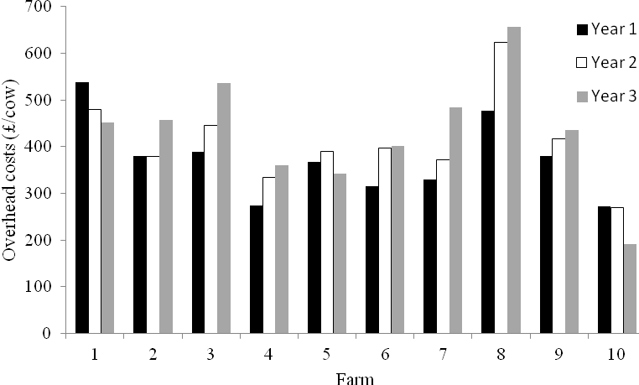

Although many farms strive to gain ‘efficiencies of scale’ in terms of increasing cow numbers and milk yields, the results from this study highlight that herd size had no effect on forage costs, concentrate costs, variable costs (ppl), or common costs (£/cow). Milk yield per cow had no effect on forage costs (ppl) or common costs (£/cow), with concentrate costs and total variable costs (ppl) tending to increase as milk yield increased (r² 0.37 and 0.30, respectively).

Milk price
Average milk price varied by more than 3 ppl between farms over the three years of the study, and although the ten farms were selling their milk to 5 different buyers, the biggest factor on milk price received was year (Figure 5). The ‘base’ price offered for milk during Year 2 was higher than in Year 1, with the ‘base’ price dropping again in Year 3, whilst still remaining above Year 1 levels. The average producer price paid in 2007 was over 28 ppl for October, November and December (DARD, 2011), with a milk price in excess of 24 ppl paid throughout the period from August 2007 to February 2008. In comparison, milk price peaked at 18 ppl during Year 1 (April 2006 to March 2007) and although milk price remained above 21 ppl through the majority of Year 3, milk price was under 19 ppl for the final four months of this period. However, despite these external factors affecting milk price, the price received by the individual farmers was also influenced by milk quality, with milk price increasing with milk quality, particularly in Year 1 (r² 0.89) and to a lesser extent in Year 3 (r² 0.56). However, when milk price was high in Year 2, the effect of milk quality on milk price was much reduced (r² 0.33).

Figure 5. Milk quality (milk fat plus protein %) compared to average milk price received by each of the ten farms over the three years of the study

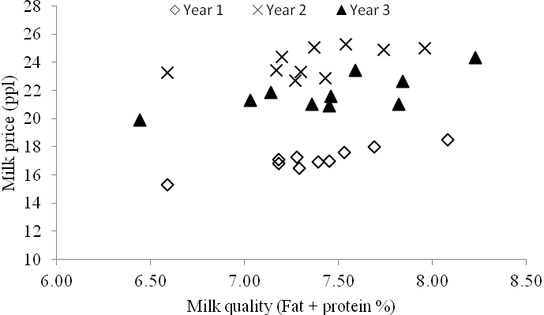

Grazing management
Although there is an increasing trend for herds in Northern Ireland to operate total or partial confinement milk production systems, only Farm 8 operated a partial-confinement system. Cows on the other farms were grazing full-time for at least 115 days in any of the three years, and approximately 170 days on average over the three years. Therefore, with cows grazing full-time for over 5.5 months on the majority of these ten farms, grassland management had the potential to have a large influence on animal performance. There is considerable evidence to highlight the detrimental effect on animal performance, grass quality and grass growth arising from grazing swards with >4,000 kg DM/ha (Kennedy et al., 2007; McEvoy et al., 2008), with other studies indicating the benefits of grazing swards <3,500 kg DM/ha (McEvoy et al., 2007). In general, the pre-grazing herbage mass in all three years of this study were excessive on the majority of farms, with the average farm covers highlighting that there were significant surpluses of grass on some farms, particularly in early season. These surpluses existed despite very different growing conditions in the three years (Figure 6), with growth on monitored sites within Northern Ireland highlighting that growth potential ranged from 110 to 59 kg DM/ha/day in early May. The detrimental effects of high herbage masses are particularly evident in early season, therefore this surplus in early season could have had a detrimental effect on subsequent regrowth, both in terms of the speed and the quality of regrowth.

Figure 6. The average grass growth measured across six sites in Northern Ireland during 2006, 2007 and 2008, compared to the long term average growth (1999-2005)

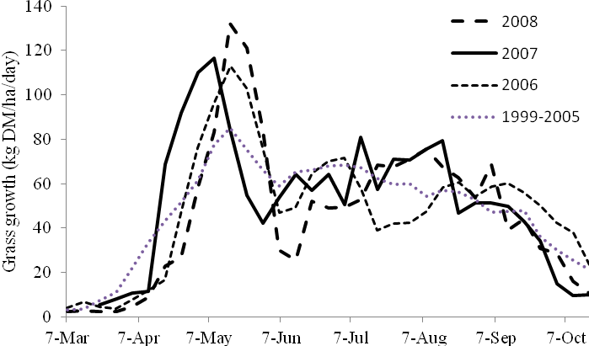
(Source: GrassCheck)

Due to the high herbage masses recorded pre-grazing, it was not surprising that post-grazing herbage masses were also high. While Farms 1, 4 and 5 routinely cut the grass in front of the cows to improve the utilisation of grass, all the other farms topped post-grazing. The benefits of grazing swards cleanly has also been well documented (Lee et al., 2008), and thus these farms could expect improved performance from forage by reducing the pre- and post-grazing herbage masses. Proven targets for pre- and post-grazing herbage mass to enable efficient utilisation of grazed grass are 3,000-3,300 kg DM/ha and 1,600-1,800 kg DM/ha, respectively. The heavy lines in Figure 7 highlight that only Farm 1 was close to achieving these targets, on average, over the study.

Figure 7. Average pre- (__) and post-grazing (.....) herbage mass recorded on each farm each month over the three years of the study, with Farm 1 represented by the two thicker lines

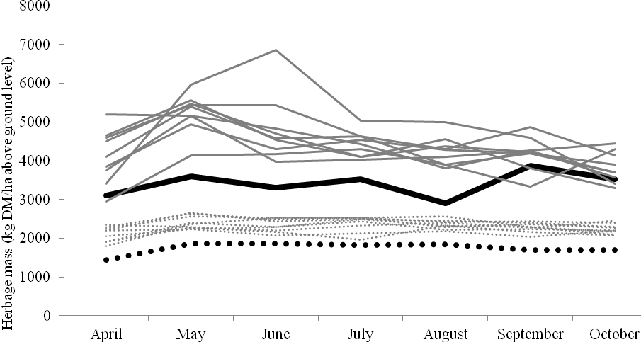

The difficulties of grazing swards with high herbage masses are reflected in the grass utilisation figures achieved, with the farms on average achieving 78 and 73% utilisation in early and late season, respectively. Whilst this is comparable with previous measurements taken from commercial dairy farms (Dale et al., 2005; Peel and Matkin, 1984; Peel et al., 1986) there is room for improvement, as demonstrated by the utilisation achieved on Farm 1. Although this farm operated a low input, spring calving grass-based system, and hence grassland management is at the centre of this farm’s success, it reinforces the potential to manage grass better. The reward for managing grass better is reflected in the average quality of the grass being offered in the first half of the grazing season, with Figure 8 demonstrating the decline in ME and WSC as herbage mass increases. Pre-grazing herbage mass had no effect on grass ME, WSC or crude protein content (r²<0.05) in late season (July, August, September).

Figure 8. The relationship between the a) average metabolisable energy content of herbage and pre-grazing herbage mass and b) average water soluble carbohydrate content and pre-grazing herbage mass of the grazed grass on the farms in early season (April, May, June)
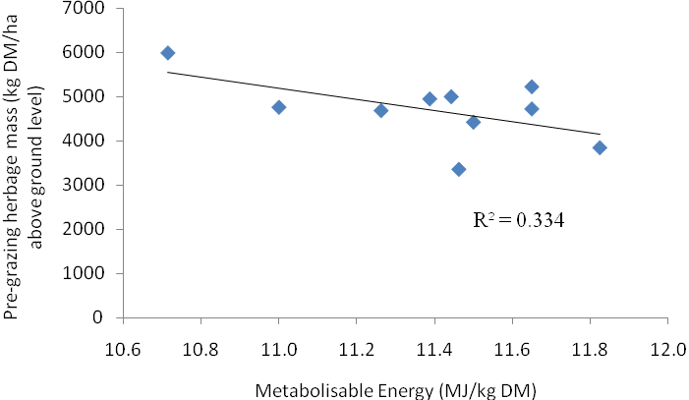
a)

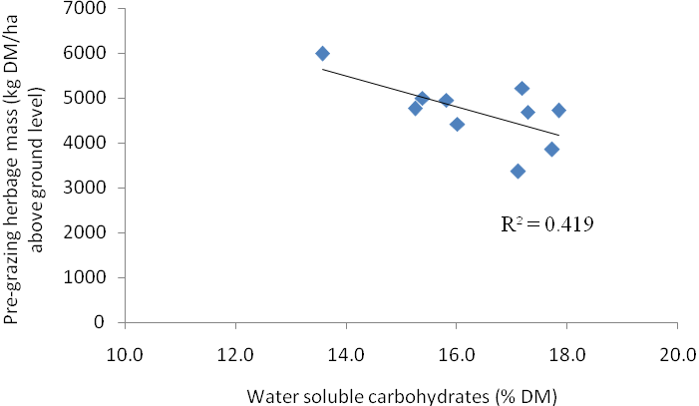
b)

The plot areas established on each farm were set up to provide data on the grass growth potential of the farms, and these data are comparable given the identical cutting and fertiliser regimes used between the sites. When comparing these data to published yields achieved previously on farm, the four-week cutting interval should be considered, as this is likely to result in a higher yield compared to the more normal three-week interval between grazings commonly adopted on farms (Binnie et al., 1997). This yield increase could be as much as 8%, as reported by Binnie et al. (1997), with these authors observing total annual yields to increase from 10.1 t DM/ha under a three-week cutting regime to 10.8 t DM/ha under a four-week regime. Previous on-farm data within Northern Ireland have identified annual herbage yields of 7.7 and 7.9 t DM/ha (Mayne et al., 2002) and 8.9, 11.7 and 10.8 t DM/ha (Dale et al., 2005). The measurements taken from the cut plots within the current study are generally higher than yields measured previously. However these earlier yields were recorded from pre- and post-grazing swards and based on the farms grazing interval and fertiliser N input. Furthermore, the low yields achieved in 2002 are reflective of the poor growing conditions during that year (GrassCheck, 2002).

Although these data reiterate the variability in herbage production that exists between sites, they are not necessarily a true reflection of the production achieved from each farms grazing area. The 16 t DM/ha measured on some sites is considerably higher than what has been reported under grazing, even in areas with a longer growing season than in Northern Ireland (O’Donovan et al., 2010). Equally the low yields achieved on Farm 8 may reflect the location of the plots on an exposed sloping site, although the sward was representative of the grazing area on that farm. However, given the surplus grass measured on this farm, this herbage yield is an underestimate of the grass grown by this farm. Therefore, although it was planned that these data could be used to characterise the growth potential of the farms, given the issues of over- and under-estimation of yield, these data should be interpreted with care.

Profitability
Before interpreting the relationships between common margin (£/cow, £/ha and ppl) and the other parameters recorded on farm, it is important to highlight how margin was clustered within farms and within years. The boxplots within Figure 9 highlight this ‘clustered’ distribution of margin between farms (Graph 1) and between years (Graph 2) for common margin/cow, with the distributions for margin per litre and margin per hectare similar (Appendices 19 and 20). The overall effects of farm and year are clear, particularly the significant change in margin between years.

All parameters were compared against common margin expressed per cow, per hectare and per litre, and the main influences per cow will be discussed here. The three measurements of margin are positively correlated to each other, with common margin per cow and per litre strongly related (r² = 0.81) (Figure 10). The relationships between common margin per cow and per hectare (r² = 0.77), and per hectare and per litre (r² = 0.57) are shown in Appendix 26.
Figure 9. Boxplots showing distribution of common margin (£/cow) between farms over the three years (Graph 1) and the effect of year on net profit measured on the ten farms (Graph 2)
Annual net profit (ppl)
Common margin (£/cow)
Graph 1
Graph 2
Graph 1

Figure 10. The relationship between common margin per litre and common margin per cow for each of the ten farms measured over the three years of the study

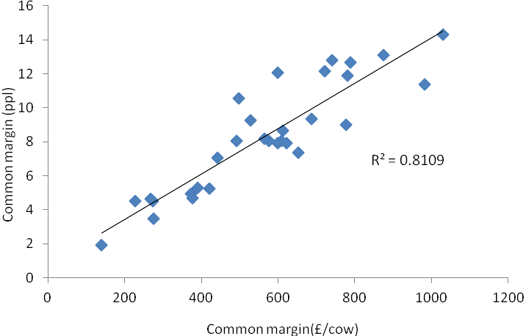
Scale
Within the variables recorded across the ten farms, a number related to the scale of the dairy enterprise. The analysis identified that total annual milk output from each farm, and average milk yield per cow were poor indicators of common margin (£/cow) (Figure 11), as was the number of cows in the herd at the end of each year (Appendix 27). The lack of an efficiency benefit from greater scale within these ten farms highlights that the smaller producers within this group remained competitive, especially as the larger farms within this group had similar costs of production to the smaller farms.

Figure 11. Relationship between a) the total milk sold per farm each year and common margin (£/cow) and b) the average milk yield of the cows on each farm and common margin (£/cow), over the three years of the study

a)
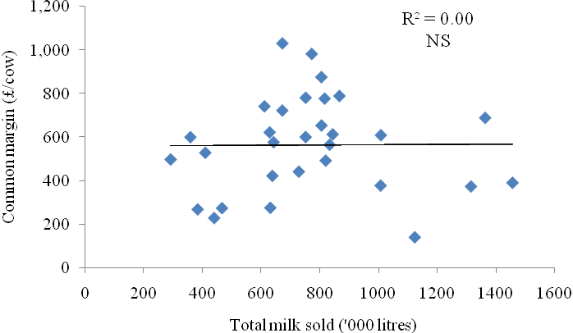

b)
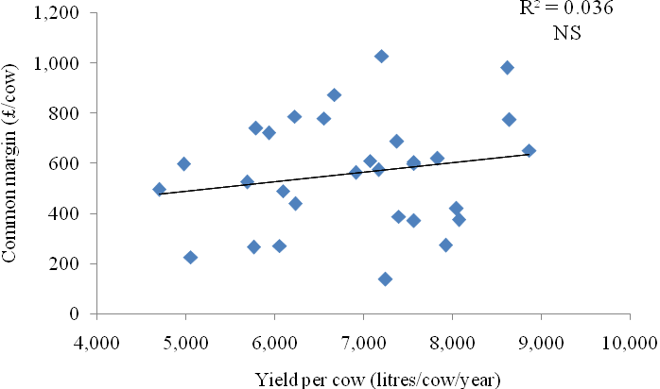

Efficiency of forage and concentrate use
The efficiency of milk production is often examined in terms of how efficiently forage and concentrates are utilised within a farm, with milk from forage (litres/cow/year) having previously been identified as an important driver of profitability (CAFRE, 2006). In that analysis the more profitable farms (top 25% based on net profit per litre) within Benchmarking produced in excess of 1,000 litres/cow more milk from forage than the farms making the lowest profit (bottom 25% based on net profit per litre). However, within the current study no relationship was identified between milk from forage per cow and common margin (£/cow) (Figure 12). However a positive relationship was established between milk from forage per hectare and common margin per hectare (P<0.05), and a positive trend between common margin per litre and milk from forage per cow (P=0.08) (Appendix 29). The absence of a relationship in terms of common margin per cow is disappointing, given the wide range in values for milk from forage production achieved across the ten farms. However, variability also existed within common margin at similar levels of milk from forage, which within a small dataset such as this, makes identifying significant effects very difficult. For instance, within a very narrow range in milk from forage (2973 to 3020 litres/cow/year) common margin per cow ranged from £268 to £1030. Similarly, farms achieving a common margin per cow of £420 to £440 had very different milk from forage values (2836 and 4437 litres/cow/year).

Figure 12. The relationship between milk from forage and common margin (£/cow) across the ten farms, over the three years of the study

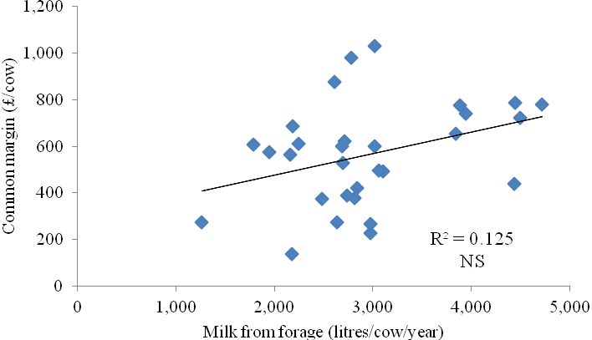

The farms also differed in terms of the forages grown, with three farms growing forage maize, three growing whole crop and four based on grass and grass silage only. The average common margin over the ten farms over the duration of the study was £564/cow, and the average common margin for the farms growing maize and whole crop were £433 and £712/cow, respectively. Therefore, over the duration of this study, the use of maize silage tended (P=0.09) to be associated with a reduction in common margin.

No relationships were identified between common margin (£/cow) and concentrates fed/cow, or concentrate feeding rate (Appendix 28). However, common margin (ppl) was negatively affected by increased concentrate feeding rate (Figure 13), highlighting the importance of efficiently utilising concentrate inputs. Although not significant on a per cow basis, the negative effects of increased concentrate feed levels on common margin are reflected in the trends shown within the data, which is in agreement with previous data (CAFRE, 2006). However, the wide variability in common margin achieved from similar concentrate inputs makes the identification of significant effects unlikely.

Figure 13. Relationship between concentrates fed (kg/cow/year) and common margin (ppl) across the ten farms over the three years of the study

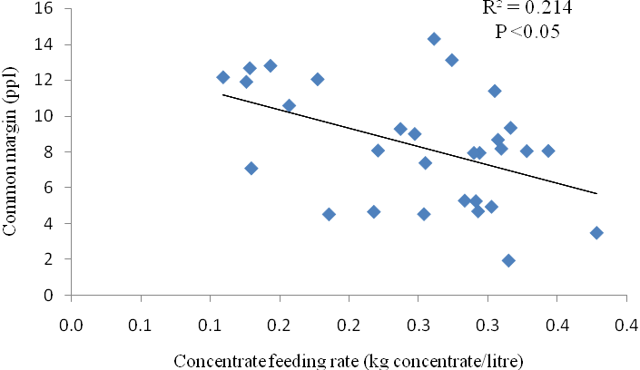

Although there was a trend for the length of time cows spent full-time at grass to be positively related to common margin per cow (Figure 14) and per hectare, it was positively related to common margin per litre. However, the total length of the grazing season was positively related to common margin (ppl, £/cow and £/ha) (Figure 14).

Figure 14. Relationship between a) days full-time grazing and common margin (£/cow) and b) total number of days grazing and common margin (£/cow) on the ten farms over the three years of the study

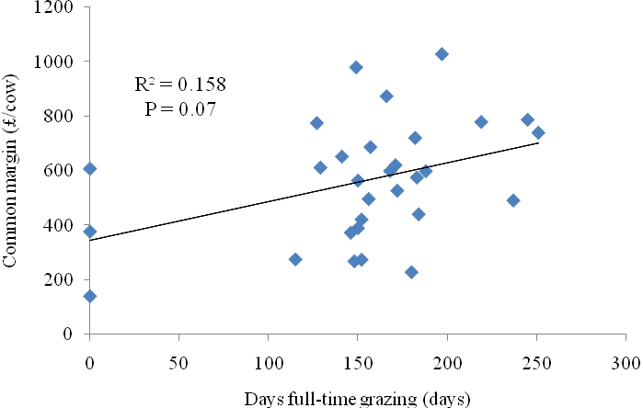
a)

b)

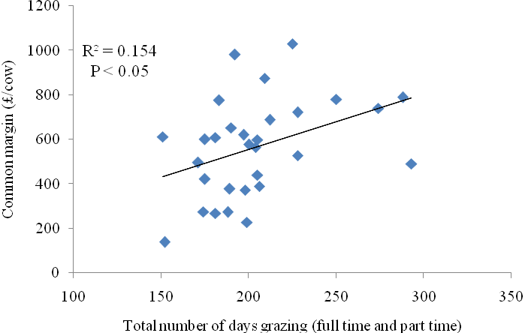

These data show that as the number of days at grass increases, common margin increases. Although the partial confinement system adopted by Farm 8 has an impact on the spread of the data in terms of number of days full-time at grass, this effect is not a factor in the analysis of total grazing days (full-time and part-time). Furthermore, grazing stocking rate in early season was identified as being negatively related to common margin per litre, grazing stocking rate in late season was negatively correlated to common margin per cow (Appendix 30), with the farms operating at higher stocking rates also having higher concentrate inputs. The relationships between days grazing and grazing stocking rates potentially highlights the improved common margin that could be expected from less intensive forage-based production systems.

Milk price, total output/cow (Appendix 31) and total value of milk sold (Figure 15) had a positive influence on common margin (£/cow). The positive effect of milk price is important, and although the majority of the price differences in this study were linked to year effects, the influence of milk quality on milk prices received should be considered.

Figure 15. Relationship between the total value of milk sold and common margin (£/cow) on each of the ten farms over the three years of the study

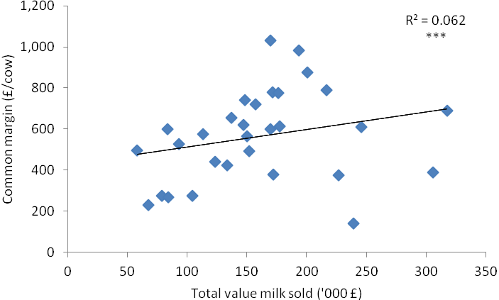

The influence of total concentrate costs on common margin (ppl, £/cow and £/ha) is clearly negative, and the effect remains negative when concentrate costs are expressed on a per cow basis (Appendix 32). Nonetheless, the influence of concentrate costs highlights the opportunity to improve profitability by reducing this cost, and although concentrate prices flutuate with global cereal markets, there are strategies which could be used to reduce this cost. For example, research has shown that concentrates with lower protein contents can be used when supplementing grazing cows (Burke et al., 2008; Dale et al., 2006; Ferris et al., 2002), and the concentrate sparing effect associated with the higher dry matter intake of high quality grass silage compared to medium quality silage (Dewhurst et al., 2009).

Machinery and contractor costs
Other important costs on these farms are the machinery and contractor costs, with contractor costs being negatively correlated to common margin (ppl, £/cow and £/ha) and machinery costs negatively correlated to margin per litre. A significant portion of these annual costs are associated with the production of silage, and within the 10 monitored farms, there were three farms who ensiled their own silage, and these farms are highlighted by the triangles in Figure 16.

It is clear that although their machinery costs were comparable to those on the other monitored farms, their contractor charges were lower. Previous on-farm data (CAFRE, 2007; 2008) have shown that contractor and machinery costs can account for 12 and 15% of the total overhead costs (£/cow), respectively. The average proportion of total overhead costs (£/cow) across the ten farms within the three years was 14 and 16% for contractor and machinery costs, respectively. For the three farms with their own silage machinery, contractor and machinery costs represented 3 and 17% of total overhead costs, with the respective values for the 7 farms without silage making equipment being 19 and 16%. These relationships demonstrate that despite very different machinery and contractor costs between farms, using machinery efficiently is an important factor influencing common margin.

Figure 16. Relationship between a) the machinery cost per cow per year and common margin and b) the contractor costs per cow per year and common margin (£/cow) across the ten farms, over the three years of the study. Farms with their own silage making machinery are highlighted ( )

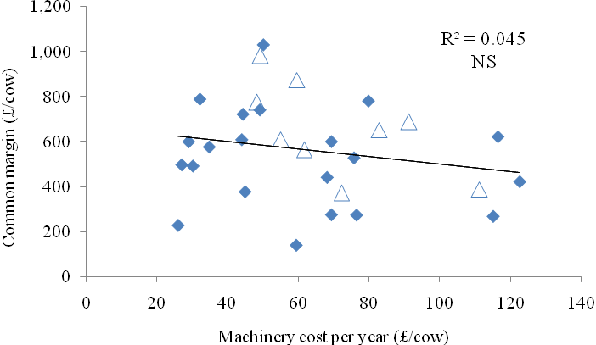
a)

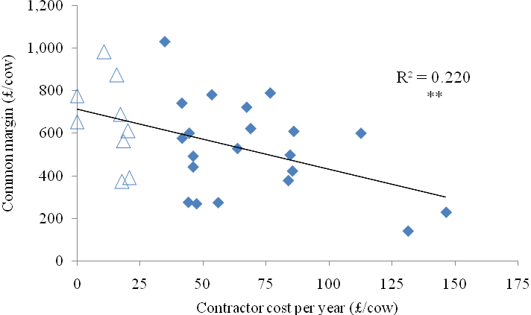
b)

Low input vs high input
Although many of the main variable, common and overhead costs have been discussed individually, the total costs should also be considered, and these costs are negatively related to profitability (ppl, £/cow and £/ha) (Appendix 33). As the total variable, and common costs increased, common margin decreased. However, despite cost control being an obvious driver of profitability, it does not necessarily mean that a low cost, low input system is the most profitbale system. Figure 17 highlights the total annual costs (£/cow) (variable and overhead costs) from four of the farms over the three years of the study. Whilst the two low input farms (clear triangles) have a clear advantage in terms of lower total variable costs, there is no benefit in terms of common margin (£/cow). Despite very different systems, there is considerable overlap in total overhead costs between the low input and higher input farms, and again no association between the systems and common margin (£/cow). Data from these farms prove that both low input and higher input systems can be operated at similar levels of common margin within Northern Ireland.

Figure 17. Relationship between a) total variable costs (£/cow) and common margin (£/cow) and b) total overhead costs (£/cow) and common margin (£/cow) for two low input farms ( ) and two high input farms over the three years of the study

a)

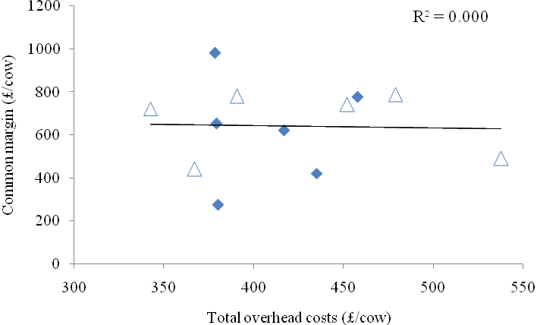

b)

Comparison of top and bottom 20% of farms based on annual common margin
This report has used the information collected from the ten farms to identify the main individual parameters that are driving common margin, particularly common margin per cow. However, what is the exact combination of parameters that are being achieved by the farms with the lowest and highest common margin each year? To identify this all ten farms were ranked by common margin per cow each year, and the bottom two and top two identified, thus representing the top and bottom 20%. The same four farms were identified in Years 1 and 2, with two farms common across all three years (one with the highest margin and one with the lowest). The main physical and financial performance figures for these groups of farms are presented in Tables 23 and 24, with the difference between the groups highlighted for each parameter.

Table 23. The average physical performance achieved by the top 20% and bottom 20% of the 10 farms over the three years of the study

 | Top 20% |  | Bottom 20%
Variable |  | The difference
Herd size (cows) | 95 | + 2 | 93
Milk yield (litres/cow) | 7712 | + 1913 | 5799
Milk butterfat content (%) | 4.25 | + 0.46 | 3.79
Milk protein content (%) | 3.35 | + 0.17 | 3.17
Meal fed (kg/cow) | 2015 | + 640 | 1375
Milk from forage (litres/cow) | 3234 | + 490 | 2744
Concentrate feeding rate  (kg concentrate/litre) | 0.26 | + 0.03 | 0.23
Replacement rate (%) | 21.1 | + 3.4 | 17.7
Days grazing Full time  Full time + part time | 175  211 | + 35  + 19 | 140  192
NB. Farms ranked by common margin (£/cow)

In terms of physical performance (Table 23), the farms with the highest common margin (£/cow) were a similar size to the farms with the lowest margin, but milk composition, milk from forage and days grazing were all higher. In terms of financial performance (Table 24), the farms with the highest common margin (£/cow) achieved a higher milk price and total output per cow, with their overhead, machinery and contractor costs all lower.

Table 24. The average financial performance achieved by the top 20% and bottom 20% of the 10 farms over the three years of the study

 | Top 20% |  | Bottom 20%
Variable |  | The difference
Milk price (ppl) | 21.8 | + 1.6 | 20.2
Total output (£/cow) | 1642 | + 528 | 1113
Variable costs (£/cow) | 544 | + 100 | 444
Gross margin (£/cow) | 1098 | + 428 | 670
Overhead costs (£/cow) | 379 | - 6 | 385
Machinery costs (£/cow) | 52 | - 11 | 64
Contractor costs (£/cow) | 22 | - 71 | 93
Common margin (£/cow) | 793 | + 454 | 339
NB. Farms ranked by common margin (£/cow)

KEY FINDINGS

The information collected within this study has been highlighted and discussed in this report, and the main findings of the report are:
- Wide range in physical and financial performance achieved by the ten farms within this three year period
- The range in average milk price received by the farms over the three years was 3.1 ppl
- Herd size had no effect on forage costs, concentrate costs, variable costs (ppl) or common costs (£/cow) across these farms
- Medium sized (80-120 cows) family run dairy farms can remain competitive within Northern Ireland, provided labour and overhead costs are kept in proportion to the scale of the business
- Total volume of milk sold and average annual milk yield per cow are poor indicators of common margin
- Despite increasing popularity of total mixed ration-based feeding systems, the additional costs involved and the opportunity to adopt higher concentrate inputs need to be monitored, or profit margins could be adversely affected.
- Increasing the total quantity of days grazing was associated with increased common margin, highlighting the potential of maximising the intake of grazed grass in the diet to improve common margin.

ACKNOWLEDGEMENTS

The research team gratefully acknowledge the contribution of the ten participating farmers and their families to the completion of this work, particularly for access to their farms and their benchmarking figures. The assistance of the CAFRE technical team during the collection of the grassland data is also acknowledged, as is the input from the regional dairy advisors during the collection of the benchmarking data and Alan Hopps and Michael Verner for collating the benchmarking data.

REFERENCES

Binnie, R.C., Kilpatrick, D.J. and Chestnutt, D.M.B. (1997). Effect of altering the length of the regrowth interval in early, mid and late season on the productivity of grass swards. Journal of Dairy Science (Cambridge), 128, 303-309.
Burke, F., O’Donovan, M.A., Murphy, J.J., O’Mara, F.P. and Mulligan, F.J. (2008). Effect of pasture allowance and supplementation with maize silage and concentrates differing in crude protein concentration on milk production and nitrogen excretion by dairy cows. Livestock Science 114, 325-335.
College of Agriculture Food and Rural Enterprise (CAFRE) (2006). Greenmount Dairy Benchmarking Report, 2004/2005. Report prepared by James Morrison.
College of Agriculture Food and Rural Enterprise (CAFRE) (2007). Greenmount Dairy Benchmarking Report, 2006/2007. Report prepared by Michael Verner.
College of Agriculture Food and Rural Enterprise (CAFRE) (2008). Greenmount Dairy Benchmarking Report, 2007/2008. Report prepared by Michael Verner.
Dale, A.J., Barrett, P.D. and Mayne, C.S. (2005). Assessment of grass production and efficiency of utilisation on three Northern Ireland dairy farms. Proceedings of a satellite workshop of the XX International Grassland Congress, Cork, Ireland. pp. 238.
Dale, A.J., Ferris, C.P. and Mayne, C.S. (2006). The effect of reducing fertiliser nitrogen inputs and crude protein content of grazing supplements, on the performance of grazing dairy cows. In: Proceedings of the British Grassland Society Eighth Research Conference, Cirencester, 4 – 6 September 2006. Pages 93-94.
Dale, A.J., Mayne, C.S. and Hopps, A. (2009). Current grassland management on ten Northern Ireland dairy farms. Proceedings of the 9th British Grassland Society Research Conference, Harper Adams University, Shropshire, September 8th and 9th 2009.
Department of Agriculture and Rural Development (DARD) (2009). Agriculture statistics. http://www.dardni.gov.uk/index/dard-statistics/agricultural-statistics.htm.
Department of Agriculture and Rural Development (DARD) (2010). Agriculture statistics. http://www.dardni.gov.uk/index/publications/pubs-dard-statistics/pubs-dard-statistics-statsrev-table-2.7
Department of Agriculture and Rural Development (DARD) (2011). Agriculture statistics. http://www.dardni.gov.uk/index/publications/pubs-dard-statistics/pubs-dard-statistics-milkprice-2007.htm
Dewhurst, R.J., Davies, D.W.R. and Fisher, W.J. (2009). Effects of silage digestibility on intake and body reserves of dry cows and performance in the first part of the next lactation. Animal, 3, 12, 1721-1727.
Dillon, P., Shalloo, L. and Horan, B. (2003). Pathways to increase profit. In: Proceedings of the Teagasc National Dairy Conference, Rochestown Park Hotel, Cork
Ferris, C.P., Patterson, D.C., Gordon, F.J. and Kilpatrick, D.J. (2002). Response of grazing dairy cows to level of concentrate supplementation and concentrate protein content. In: Proceedings of British Society of Animal Science, 2002, page 112.
Ferris, C.P. (2007). Sustainable pasture-based dairy systems - meeting the challenges. Canadian Journal of Plant Science, 87, 723-738.
French, P., Horan, B., Donworth, J. and Shalloo, L. (2007). A roadmap for high profit dairy systems for the future. In: Moorepark 07, Irish Dairying – Winning on a World Stage. Moorepark Research Centre, Open Day Booklet, 21 June 2007. Pp. 5-13.
Horan, B and Kelly, F. (2006). Review of commercial on-farm research. In technical booklet: Moorepark Dairy Levy Update, Series No. 2. Regional milk production. 6th April 2006, Ballyhaise. Pp. 10-12
Keady T.W.J. and Anderson D. (2000). The cost of producing and feeding grazed grass and grass silage. Proceedings of British Grassland Society Research Conference, Aberdeen September, 2000. Reading, UK: British Grassland Society.
Kennedy, E., O’Donovan, M., Murphy, J.P., Delaby, L. and O’Mara, F.P. (2007). Effect of spring grazing date and stocking rate on sward characteristics and dairy cow production during mid-lactation. Journal of Dairy Science, 90, 2035-2046.
Kilpatrick C., Keady T.W.J., Cushnahan A. and Murphy J. (2002). Costs of forage on the Northern Ireland dairy Farms. Antrim, Northern Ireland, UK: Greenmount College of Agriculture and Horticulture.
Lee, J.M., Donaghy, D.J. and Roche, J.R. (2008). Short communication: Effect of post-grazing residual pasture height on milk production. Journal of Dairy Science, 91, 4307-4311.
McEvoy, M., Kennedy, E., Murphy, J.P., Boland, T.M., Delaby, L. and O’Donovan, M. (2007). The effect of herbage allowance and concentrate supplementation on milk production performance and dry matter intake of spring-calving dairy cows in early lactation. Journal of Dairy Science, 91, 1258-1269.
McEvoy, M., O’Donovan, M., Kennedy, E., Murphy, J.P., Delaby, L. and Boland, T.M. (2008). Effect of pre-grazing herbage mass and pasture allowance on the lactation performance of Holstein-Friesian dairy cows. Journal of Dairy Science, 92, 414-422.
Mayne, C.S., Patterson, D.C. and Rankin, W.S.A. (2002). On-farm monitoring of grass growth, grass quality and herbage intake of dairy cows in Northern Ireland. End of Project Technical Report presented to AgriSearch, July 2002.
O’Donovan, M., Lewis, E., Boland, T. and O’Kiely, P. (2010). Requirements of future grass based ruminant production systems in Ireland. In: O’Donovan, M. and Hennessy, D. (eds.). Proceedings of the Grasses for the Future. Perennial ryegrass: current and future genetic potential. Cork, Ireland, 14 and 15 October 2010, pp 11-41.
Peel, S. and Matkin, E.A. (1984). Herbage yield and animal production from grassland on three commercial dairy farms in South-East England. Grass and Forage Science 39, 177-185.
Peel, S., Matkin, E.A. and Huckle, C.A. (1986). Utilised output from grazed grassland; Case studies of commercial dairy farms, 1981-1985. In: Frame, J. (Ed.) Grazing. Occasional Symposium No. 19, British Grassland Society, pp. 147-152.

KEY PRESENTATIONS

Conferences
Dale, A.J., Mayne, C.S. and Hopps, A. (2009). Current grassland management on ten Northern Ireland dairy farms. Proceedings of the 9th British Grassland Society Research Conference, Harper Adams University, Shropshire, September 8th and 9th 2009.

Meetings
25th October 2006. Presentation given on project progress to staff from AFBI, CAFRE and Teagasc. Meeting held at Ballyhaise, Co. Cavan
9th November 2006. Presentation given on project results from year 1 to staff from AFBI and CAFRE. Meeting held at Hillsborough.
6th December 2006. Presentation given on project results from year 1 to staff from AFBI, CAFRE and the participating farmers. Meeting held at Greenmount Campus.
13th June 2007. Presentation given on results to date to all DARD dairy advisors and CAFRE staff. Meeting held at Hillsborough.
26th September 2007. Presentation given on results from years 1 and 2 to staff from AFBI and CAFRE. Meeting held at Hillsborough.
5th October 2007. Presentation given on results from years 1 and 2 to AgriSearch Dairy Committee. Meeting held at Hillsborough.

14th November 2007. Presentation given on results from years 1 and 2 to staff from AFBI and CAFRE and the participating farmers. Meeting included an afternoon visit to the farm of Glen Faulkner (participating farmer). Meeting held at Loughry Campus, Cookstown.
18th December 2007. Presentation given on project results to the regional meeting of the UFU Dairy Committee. Meeting held at Hillsborough.
4th December 2008. Presentation given on project status to staff from AFBI and Teagasc. Meeting held at Ballyhaise College, Cavan.
19th May 2009. Presentation given on project status to staff from AFBI, CAFRE and Brendan Horan (Teagasc). Meeting held at Hillsborough.
18th November 2009. Presentation given to summarise project status and close the data collection phase of the project, with staff from AFBI, CAFRE and the participating farmers present at the meeting. Meeting held at Hillsborough.
27th June 2012. Presentation given to finalise the project and summarise the main findings and highlight the key messages from the project, with staff from AFBI, CAFRE and the participating farmers present at the meeting. Meeting held at Hillsborough.
Appendix 1. Details of the parameters from CAFRE Benchmarking programme
Parameter | How calculated
Total area farmed | Broken down into grassland, maize and other
Total beef CE | Numbers of beef animals on the farm in terms of cow equivalents
Heifer 0-1 number
Heifer 1 - 2 number
Heifer over 2 number
Total heifer number
Total heifer CE | Heifer numbers expressed as cow equivalents
Dairy cows CE
Dairy bull CE
Family labour units
Paid labour units
Total labour units
Cows yr start
Cows yr end
Cows average number
Number calved April/May/June | number of calvings in each 3 month period
Number calved July/Aug/Sept | number of calvings in each 3 month period
Number calved Oct/Nov/Dec | number of calvings in each 3 month period
Number calved Jan/Feb/Mar | number of calvings in each 3 month period
Proportion calved April/May/June | calving per 3 month period expressed as a proportion of total calvings
Proportion calved July/Aug/Sept
Proportion calved Oct/Nov/Dec
Proportion calved Jan/Feb/Mar
Total cows calved
Total heifers calved
% herd spring calving (Jan – June)
% herd autumn calving (July - Dec)
Milk sold (litres)
Milk sold ppl (net)
Milk sold value (£)
Milk to calves & house | estimated value of milk used by calves and in farm house
Value milk to calves & house
Total forage costs
Concentrates fed (tonnes)
Concentrate cost (£/tonne)
Total concentrate cost
Total cost other feed
Veterinary & medicine costs
AI costs
Miscellaneous dairy costs
Average milk butterfat %
Average milk protein %
Average milk bacterial count
Average milk somatic cell count
Appendix 2. Details of the parameters from CAFRE Benchmarking programme
Parameter | How calculated
Value milk produced/cow | Milk output/average cow numbers (value milk sold+milk to house and calves)
Calf output/cow
Replacement cost/cow
Total output/cow | (milk output +calf output - replacement cost)
Forage cost/cow | (vc total forage costs/average cow numbers)
Concentrate cost/cow
AI cost/cow
Total variable cost/cow | (Total forage costs + total concentrate costs + total costs other feed + vet & med + AI costs + miscellaneous dairy costs)
Gross margin/cow
Machinery cost/cow
Contractor cost/cow
Total common cost/cow
Labour cost/cow
Total overhead cost/cow
Net profit/cow | (GM- overhead costs)
Annual yield/cow | (includes milk to house and calves)
Stocking rate | (CE cows, heifers, bulls, beef / grass area)
MFF/cow | (milk sold+fed to calves/total meal/0.45)
MFF/hectare | (hectares adjusted to reflect area used by cows)
Meal fed/cow
Replacement rate % | (number heifers calved/average number cows)
Concentrate feeding rate (kg conc/litre milk
Litres/labour unit | (total labour based on proportion of CE that are the cows)
% overheads to cows | (based on CE, cows + bull/ total of cows, bull, heifers and beef)
Total profit from dairying
Milk output ppl
Total output ppl
Forage cost ppl
Concentrate cost ppl
AI cost ppl
Total variable costs ppl
Gross Margin ppl
Machinery cost ppl
Contractor cost ppl
Total common costs ppl
Labour cost ppl
Total overhead cost ppl
Net profit ppl | (total output - total variable costs - total overhead costs)

Appendix 3. Total area farmed, average number of cows in the herd and family and total labour units on each of the ten farms during each of the three years of the study
Farm | Total area farmed (ha) |  |  | Average number of cows in the herd |  |  | Family labour units |  |  | Total labour units
Farm | Year 1 | Year 2 | Year 3 | Year 1 | Year 2 | Year 3 | Year 1 | Year 2 | Year 3 | Year 1 | Year 2 | Year 3
1 | 75.3 | 49.3 | 61.5 | 137 | 140 | 106 | 1.0 | 1.0 | 1.0 | 2.0 | 1.3 | 2.0
2 | 70.6 | 76.6 | 76.6 | 92 | 90 | 95 | 2.0 | 2.0 | 2.0 | 2.0 | 2.0 | 2.0
3 | 131.8 | 128.8 | 136.5 | 176 | 187 | 199 | 2.0 | 2.0 | 2.0 | 2.0 | 2.0 | 2.4
4 | 41.0 | 54.0 | 54.0 | 91 | 94 | 100 | 1.3 | 1.3 | 1.0 | 1.4 | 1.3 | 1.5
5 | 64.0 | 64.0 | 64.0 | 119 | 116 | 115 | 1.5 | 1.5 | 1.5 | 1.5 | 1.5 | 1.5
6 | 40.8 | 40.8 | 43.6 | 78 | 75 | 69 | 1.5 | 1.5 | 1.5 | 1.5 | 1.5 | 1.5
7 | 85.8 | 85.8 | 85.8 | 124 | 124 | 123 | 1.0 | 1.0 | 1.0 | 2.3 | 2.0 | 2.0
8 | 78.2 | 78.2 | 92.8 | 127 | 135 | 155 | 2.0 | 1.5 | 2.0 | 3.0 | 2.5 | 3.3
9 | 37.0 | 37.0 | 37.0 | 81 | 82 | 81 | 1.5 | 1.5 | 1.0 | 1.5 | 1.5 | 1.0
10 | 52.0 | 52.0 | 52.0 | 91 | 75 | 64 | 1.0 | 1.0 | 1.0 | 1.0 | 1.0 | 1.0
Average | 67.7 | 66.7 | 70.4 | 112 | 112 | 111 | 1.5 | 1.4 | 1.4 | 1.8 | 1.7 | 1.8

Appendix 4. Milk produced per cow per year, milk composition, milk somatic cell count and milk price on each of the ten farms during each of the three years of the study

Farm | Milk produced per cow per year (litres)# |  |  | Milk butterfat content (%) |  |  | Milk protein content (%) |  |  | Somatic cell count (‘000/ml) |  |  | Milk price (ppl)
Farm | Year 1 | Year 2 | Year 3 | Year 1 | Year 2 | Year 3 | Year 1 | Year 2 | Year 3 | Year 1 | Year 2 | Year 3 | Year 1 | Year 2 | Year 3
1 | 6094 | 6227 | 5788 | 4.59 | 4.46 | 4.51 | 3.49 | 3.50 | 3.72 | 185 | 194 | 190 | 18.5 | 25.0 | 24.3
2 | 8860 | 8615 | 8637 | 4.21 | 4.12 | 4.20 | 3.24 | 3.25 | 3.26 | 188 | 213 | 178 | 17.0 | 25.1 | 21.6
3 | 7569 | 7372 | 7396 | 4.09 | 4.06 | 4.08 | 3.19 | 3.24 | 3.28 | 149 | 215 | 166 | 17.3 | 23.3 | 21.0
4 | 7169 | 7204 | 7564 | 4.26 | 4.21 | 4.39 | 3.27 | 3.33 | 3.45 | 237 | 221 | 202 | 17.6 | 25.3 | 22.6
5 | 6234 | 6558 | 5937 | 4.09 | 4.08 | 4.21 | 3.30 | 3.35 | 3.38 | 109 | 138 | 107 | 16.9 | 22.8 | 23.4
6 | 6056 | 5692 | 5765 | 3.90 | 3.91 | 3.91 | 3.28 | 3.36 | 3.23 | 170 | 165 | 171 | 16.8 | 22.7 | 21.9
7 | 6914 | 6673 | 7070 | 4.33 | 4.31 | 4.37 | 3.36 | 3.43 | 3.45 | 147 | 263 | 185 | 18.0 | 24.9 | 21.0
8 | 8071 | 7562 | 7249 | 4.02 | 3.99 | 3.90 | 3.16 | 3.21 | 3.13 | 297 | 284 | 259 | 17.1 | 24.4 | 21.3
9 | 7922 | 7833 | 8046 | 4.00 | 3.88 | 4.07 | 3.29 | 3.29 | 3.38 | 226 | 229 | 248 | 16.5 | 23.4 | 20.9
10 | 5058 | 4976 | 4701 | 3.61 | 3.53 | 3.51 | 2.98 | 3.06 | 2.93 | 254 | 244 | 292 | 15.3 | 23.2 | 19.9
Average | 6995 | 6871 | 6815 | 4.11 | 4.06 | 4.12 | 3.26 | 3.30 | 3.32 | 196 | 217 | 200 | 17.1 | 24.0 | 21.8
# includes milk used in the house and fed to calves

Appendix 5. Proportion of animals calving during each three month period, replacement rate and the percentage of animals calving in the spring and the autumn on each of the ten farms during each of the three years of the study

 | Proportion of animals calving during each three month period |  |  |  |  |  |  |  |  |  |  |  |  | Replacement rate (%) |  |  | Animals calving in spring (%)¹ |  |  | Animals calving in autumn (%)²
Farm | April, May, June |  |  | July, August, September |  |  | October, November, December |  |  | January, February, March
Farm | Year 1 | Year 2 | Year 3 | Year 1 | Year 2 | Year 3 | Year 1 | Year 2 | Year 3 | Year 1 | Year 2 | Year 3 |  | Year 1 | Year 2 | Year 3 | Year 1 | Year 2 | Year 3 | Year 1 | Year 2 | Year 3
1 | 0.04 | 0.04 | 0.00 | 0.00 | 0.00 | 0.00 | 0.00 | 0.00 | 0.00 | 0.96 | 0.96 | 1.00 |  | 30 | 14 | 15 | 100 | 100 | 100 | 0 | 0 | 0
2 | 0.09 | 0.00 | 0.03 | 0.31 | 0.26 | 0.19 | 0.40 | 0.41 | 0.39 | 0.21 | 0.33 | 0.40 |  | 18 | 24 | 25 | 30 | 33 | 43 | 70 | 67 | 57
3 | 0.12 | 0.20 | 0.28 | 0.07 | 0.06 | 0.07 | 0.31 | 0.31 | 0.26 | 0.50 | 0.42 | 0.40 |  | 19 | 27 | 24 | 63 | 63 | 67 | 37 | 37 | 32
4 | 0.05 | 0.04 | 0.03 | 0.43 | 0.45 | 0.43 | 0.29 | 0.30 | 0.34 | 0.23 | 0.21 | 0.20 |  | 20 | 23 | 19 | 28 | 27 | 25 | 72 | 73 | 75
5 | 0.21 | 0.21 | 0.20 | 0.00 | 0.00 | 0.00 | 0.01 | 0.00 | 0.00 | 0.78 | 0.79 | 0.80 |  | 16 | 22 | 24 | 99 | 100 | 100 | 1 | 0 | 0
6 | 0.26 | 0.27 | 0.23 | 0.00 | 0.00 | 0.00 | 0.05 | 0.10 | 0.10 | 0.69 | 0.63 | 0.67 |  | 22 | 19 | 38 | 95 | 90 | 90 | 5 | 10 | 10
7 | 0.00 | 0.00 | 0.00 | 0.67 | 0.61 | 0.62 | 0.33 | 0.39 | 0.38 | 0.00 | 0.00 | 0.00 |  | 24 | 21 | 28 | 0 | 0 | 0 | 100 | 100 | 100
8 | 0.06 | 0.07 | 0.13 | 0.17 | 0.18 | 0.12 | 0.67 | 0.52 | 0.47 | 0.10 | 0.23 | 0.27 |  | 39 | 35 | 28 | 16 | 30 | 40 | 84 | 70 | 60
9 | 0.18 | 0.09 | 0.09 | 0.08 | 0.24 | 0.27 | 0.42 | 0.36 | 0.35 | 0.32 | 0.32 | 0.29 |  | 26 | 17 | 43 | 50 | 41 | 38 | 50 | 59 | 62
10 | 0.30 | 0.28 | 0.24 | 0.09 | 0.02 | 0.04 | 0.38 | 0.42 | 0.40 | 0.23 | 0.29 | 0.33 |  | 0 | 0 | 0 | 54 | 57 | 56 | 46 | 43 | 44
Average | 0.13 | 0.12 | 0.12 | 0.18 | 0.18 | 0.17 | 0.29 | 0.28 | 0.27 | 0.40 | 0.42 | 0.44 |  | 21 | 20 | 24 | 53 | 54 | 56 | 47 | 46 | 44
¹ January – June
² July - December

Appendix 6. The main costs of production, gross margin and common margin (£/cow, ppl, £/ha) achieved on each of the ten farms during each of the three years of the study

Farm | Forage costs (ppl) |  |  | Concentrate costs (ppl) |  |  | Total variable costs (ppl) |  |  | Common costs (ppl) |  |  | Gross margin (ppl) |  |  | Common margin (£/cow) |  |  | Common margin (ppl) |  |  | Common margin (£/ha)
Farm | Year 1 | Year 2 | Year 3 | Year 1 | Year 2 | Year 3 | Year 1 | Year 2 | Year 3 | Year  1 | Year 2 | Year 3 | Year 1 | Year 2 | Year 3 | Year 1 | Year  2 | Year  3 | Year 1 | Year 2 | Year 3 | Year  1 | Year  2 | Year  3
1 | 1.1 | 1.5 | 1.8 | 2.5 | 1.9 | 2.6 | 4.8 | 4.6 | 6.0 | 9.0 | 9.4 | 10.7 | 12.3 | 17.5 | 17.5 | 492 | 788 | 741 | 8.1 | 12.7 | 12.8 | 1097 | 2831 | 1766
2 | 1.1 | 1.1 | 1.5 | 3.8 | 6.2 | 5.3 | 6.0 | 8.5 | 8.1 | 9.9 | 12.3 | 12.5 | 11.2 | 15.2 | 13.4 | 653 | 981 | 777 | 7.4 | 11.4 | 9.0 | 1471 | 2126 | 1625
3 | 1.5 | 0.8 | 1.3 | 4.4 | 5.4 | 5.7 | 7.5 | 7.9 | 8.9 | 11.7 | 12.5 | 14.3 | 9.2 | 13.9 | 10.6 | 373 | 688 | 390 | 4.9 | 9.3 | 5.3 | 765 | 1681 | 902
4 | 1.0 | 1.0 | 1.8 | 4.5 | 4.5 | 7.3 | 6.5 | 6.6 | 10.3 | 10.0 | 10.3 | 14.1 | 11.5 | 17.9 | 11.8 | 576 | 1030 | 600 | 8.0 | 14.3 | 7.9 | 1588 | 2251 | 1400
5 | 1.4 | 1.5 | 1.5 | 1.7 | 2.0 | 2.1 | 5.0 | 5.0 | 5.5 | 9.8 | 9.7 | 10.1 | 11.8 | 16.6 | 16.7 | 441 | 780 | 722 | 7.1 | 11.9 | 12.2 | 1027 | 1775 | 1721
6 | 1.8 | 1.6 | 1.8 | 3.3 | 3.8 | 4.5 | 7.2 | 7.2 | 8.6 | 11.9 | 13.2 | 15.1 | 9.2 | 15.3 | 11.2 | 274 | 528 | 268 | 4.5 | 9.3 | 4.6 | 657 | 1252 | 586
7 | 1.3 | 1.2 | 1.1 | 3.8 | 4.4 | 5.6 | 6.5 | 6.7 | 7.9 | 9.1 | 10.1 | 12.5 | 10.7 | 16.6 | 13.2 | 565 | 875 | 613 | 8.2 | 13.1 | 8.7 | 1297 | 1909 | 1334
8 | 0.9 | 1.0 | 1.7 | 4.5 | 6.3 | 7.0 | 6.8 | 8.6 | 10.4 | 10.9 | 13.9 | 17.2 | 8.8 | 13.4 | 8.7 | 377 | 608 | 140 | 4.7 | 8.0 | 1.9 | 852 | 1472 | 304
9 | 0.6 | 2.6 | 1.3 | 5.2 | 4.7 | 5.5 | 7.7 | 9.6 | 8.8 | 12.5 | 14.8 | 13.8 | 8.3 | 13.1 | 10.2 | 275 | 521 | 422 | 3.5 | 7.9 | 5.2 | 840 | 2025 | 1498
10 | 1.9 | 1.3 | 1.2 | 3.1 | 3.5 | 3.4 | 5.8 | 5.5 | 5.2 | 11.0 | 10.1 | 9.3 | 9.7 | 16.6 | 14.6 | 228 | 599 | 497 | 4.5 | 12.0 | 10.6 | 401 | 876 | 751
Average | 1.3 | 1.4 | 1.5 | 3.7 | 4.3 | 4.9 | 6.4 | 7.0 | 8.0 | 10.6 | 11.6 | 12.9 | 10.3 | 15.6 | 12.8 | 425 | 750 | 517 | 6.1 | 11.0 | 7.8 | 999 | 1820 | 1189

Appendix 7. Concentrates fed per cow, stocking rate, milk from forage, milk output per labour unit and concentrate feeding rate on each of the ten farms during each of the three years of the study

Farm | Concentrates fed (kg/cow/year) |  |  | Stocking rate (CE/ha) |  |  | Milk from forage (litres/cow) |  |  | Milk from forage (litres/ha) |  |  | Milk output/labour unit ('000's) |  |  | Concentrate feeding rate (kg concentrate/litre)
Farm | Year 1 | Year 2 | Year 3 | Year 1 | Year 2 | Year 3 | Year  1 | Year  2 | Year  3 | Year  1 | Year  2 | Year  3 | Year 1 | Year 2 | Year 3 | Year  1 | Year  2 | Year  3
1 | 1347 | 801 | 831 | 2.2 | 3.6 | 2.4 | 3102 | 4446 | 3942 | 6921 | 15967 | 9399 | 512 | 848 | 416 | 0.22 | 0.13 | 0.14
2 | 2260 | 2628 | 2137 | 2.3 | 2.2 | 2.1 | 3838 | 2776 | 3888 | 8643 | 6013 | 8138 | 705 | 715 | 693 | 0.26 | 0.31 | 0.25
3 | 2291 | 2333 | 2096 | 2.1 | 2.4 | 2.3 | 2478 | 2189 | 2738 | 5081 | 5346 | 6331 | 1011 | 1165 | 983 | 0.30 | 0.32 | 0.28
4 | 2352 | 1883 | 2193 | 2.8 | 2.2 | 2.3 | 1943 | 3020 | 2690 | 5354 | 6600 | 6276 | 600 | 654 | 635 | 0.33 | 0.26 | 0.29
5 | 809 | 828 | 650 | 2.3 | 2.3 | 2.4 | 4437 | 4719 | 4492 | 10329 | 10737 | 10711 | 609 | 626 | 599 | 0.13 | 0.13 | 0.11
6 | 1538 | 1350 | 1257 | 2.4 | 2.4 | 2.2 | 2637 | 2692 | 2973 | 6333 | 6387 | 6505 | 396 | 367 | 367 | 0.25 | 0.24 | 0.22
7 | 2141 | 1829 | 2173 | 2.3 | 2.2 | 2.2 | 2156 | 2608 | 2241 | 4951 | 5688 | 4881 | 606 | 625 | 661 | 0.31 | 0.27 | 0.31
8 | 2365 | 2598 | 2283 | 2.3 | 2.4 | 2.2 | 2815 | 1788 | 2175 | 6363 | 4325 | 4744 | 468 | 564 | 442 | 0.29 | 0.34 | 0.31
9 | 2998 | 2304 | 2344 | 3.1 | 3.3 | 3.6 | 1261 | 2714 | 2836 | 3851 | 8845 | 10072 | 597 | 630 | 1057 | 0.38 | 0.29 | 0.29
10 | 939 | 883 | 738 | 1.8 | 1.5 | 1.5 | 2971 | 3014 | 3061 | 5232 | 4404 | 4626 | 458 | 373 | 364 | 0.19 | 0.18 | 0.16
Average | 1904 | 1744 | 1670 | 2.3 | 2.4 | 2.3 | 2764 | 2997 | 3104 | 6306 | 7431 | 7168 | 596 | 657 | 622 | 0.27 | 0.25 | 0.24

Appendix 8. Pre-grazing herbage mass (kg DM/ha, above ground level) as measured each month on each of the ten farms during each of the three years of the study

 | Year 1 |  |  |  |  |  |  |  | Year 2 |  |  |  |  |  |  |  | Year 3
Farm | May | June | July | early Aug | late Aug | Sept | late Oct/Nov |  | late Apr | May | June | July | Aug | Sept | Oct |  | late Apr | May | June | July | Aug | Sept | Oct
1 | 4500 | 3400 | 4000 | 2800 | 2900 | 4600 | 3900 |  | 3800 | 3200 | 3400 | 3800 | 3300 | 3300 | 3000 |  | 2400 | 3100 | 3100 | 2800 | 2600 | 3700 | 3700
2 | 5200 | 6500 | 4700 | 4200 | 4000 | 4600 | 3600 |  | 4900 | 5400 | 4800 | 3900 | 4000 | 5800 | 4000 |  | 4300 | 5700 | 5000 | 5300 | 5000 | 4200 | 4800
3 | 4300 | 4600 | 4200 | 4100 | 4800 | 4300 | 3800 |  | 4000 | 5000 | 4700 | 4800 | 3800 | 4300 | 4000 |  | 3700 | 5500 | 3600 | 4600 | 4400 | 4000 | 3900
4 | 5000 | 7300 | 4400 | 3200 | 4200 | 4400 | 3200 |  | 4000 | 5300 | 3800 | 4300 | 4000 | 4600 | 4000 |  | 3500 | 5200 | 3400 | 4600 | 3800 | 3800 | 3500
5 | 4100 | 4400 | 4100 | 3700 | 4400 | 4300 | 3000 |  | 3000 | 4000 | 4400 | 4500 | 3600 | 4500 | 3900 |  | 2900 | 4300 | 3700 | 4300 | 3900 | 3800 | 4200
6 | 5100 | 5900 | 4700 | 4500 | 4000 | 2300 | N/A |  | 4700 | 4700 | 4600 | 4600 | 3400 | 3600 | 3500 |  | 3500 | 6400 | 3200 | 4600 | 3700 | 4100 | 5100
7 | 4700 | 4200 | 4000 | 3400 | 3300 | 3900 | N/A |  | 4500 | 4400 | 4300 | 3900 | 5300 | 3900 | 3300 |  | N/A | 7300 | 5600 | 4400 | 6200 | 3600 | N/A
8 | 4800 | 4200 | 3300 | 4100 | 4800 | 3500 | N/A |  | 5200 | 5400 | 4900 | 4800 | 3600 | 4600 | 3700 |  | 4100 | 6500 | 4500 | 4200 | 5000 | 4600 | N/A
9 | 4600 | 3700 | 3800 | 4000 | 4800 | 4200 | 4300 |  | 5800 | 4100 | 4100 | 2900 | 3700 | 4400 | 4600 |  | 4600 | 6800 | 4100 | 5400 | 3900 | 4200 | N/A
10 | 4800 | 7500 | 5000 | 4500 | 5000 | 4700 | 3300 |  | 3400 | 5800 | 5600 | 6100 | 5500 | 4600 | 3800 |  | N/A | 7300 | 7500 | 4000 | 5000 | 4500 | 3100
Average | 4710 | 5170 | 4220 | 3850 | 4220 | 4080 | 3586 |  | 4330 | 4730 | 4460 | 4360 | 4020 | 4360 | 3780 |  | 3625 | 5810 | 4370 | 4420 | 4350 | 4050 | 4043

Appendix 9. Post-grazing herbage mass (kg DM/ha, above ground level) as measured each month on each of the ten farms during each of the three years of the study

Farm | Year 1 |  |  |  |  |  |  |  | Year 2 |  |  |  |  |  |  |  | Year 3
Farm | May | June | July | early Aug | late Aug | Sept | late Oct/Nov |  | late Apr | May | June | July | Aug | Sept | Oct |  | late Apr | May | June | July | Aug | Sept | Oct
1 | 1907 | 2100 | 2000 | 2000 | 2000 | 1700 | 1700 |  | 1500 | 1900 | 1900 | 2000 | 1800 | 1800 | 1700 |  | 1400 | 1800 | 1600 | 1500 | 1600 | 1600 | 1700
2 | 2400 | 2500 | 2800 | 2400 | 2200 | 2400 | 2300 |  | 2300 | 2500 | 2600 | 2400 | 2300 | 2500 | 2100 |  | 2200 | 2800 | 2500 | 2400 | 2300 | 2200 | 2400
3 | 2400 | 2400 | 2700 | 2400 | 2200 | 2400 | 2500 |  | 2200 | 2200 | 2300 | 2500 | 2100 | 2000 | 2100 |  | 1600 | 2600 | 2200 | 2100 | 2200 | 2300 | 2000
4 | 2500 | 2100 | 1700 | 2300 | 2200 | 2300 | 2200 |  | 2000 | 2200 | 2200 | 2400 | 2400 | 2200 | 2000 |  | 1800 | 2100 | 2200 | 1800 | 2400 | 2000 | 2000
5 | 2000 | 2300 | 2600 | 2200 | 2400 | 2400 | 2000 |  | 2500 | 2400 | 2400 | 2700 | 2600 | 2300 | 2500 |  | 1900 | 2300 | 2200 | 2200 | 2100 | 2200 | 2000
6 | 2300 | 2100 | 2000 | 2400 | 2100 | 2000 | N/A |  | 2500 | 2300 | 2000 | 2000 | 2400 | 1800 | 2000 |  | 1600 | 2100 | 2100 | 2400 | 1800 | 2300 | 2400
7 | 2500 | 2300 | 2200 | 2200 | 2300 | 2300 | N/A |  | 2200 | 2600 | 2400 | 2800 | 2600 | 2500 | 2300 |  | N/A | 2900 | 2600 | 2500 | 2700 | 2400 | N/A
8 | 2500 | 2600 | 2200 | 2500 | 2400 | 2600 | N/A |  | 2600 | 2600 | 2500 | 2800 | 2200 | 2600 | 2400 |  | 2000 | 2800 | 2400 | 2600 | 2600 | 2100 | N/A
9 | 2200 | 2200 | 2400 | 2100 | 2900 | 2500 | 2400 |  | 2400 | 2400 | 2400 | 2000 | 2500 | 1900 | 2500 |  | 2300 | 2300 | 2000 | 2600 | 2100 | 2400 | N/A
10 | 2400 | 2300 | 2500 | 2700 | 2600 | 2000 | 1900 |  | 1800 | 2100 | 2600 | 2700 | 2400 | 2700 | 2400 |  | N/A | 2600 | 2700 | 2400 | 2600 | 2200 | 2000
Average | 2311 | 2290 | 2310 | 2320 | 2330 | 2260 | 2143 |  | 2200 | 2320 | 2330 | 2430 | 2330 | 2230 | 2200 |  | 1850 | 2430 | 2250 | 2250 | 2240 | 2170 | 2071

Appendix 10. Average farm cover (kg DM/ha, above ground level) as measured each month on each of the ten farms during each of the three years of the study

Farm | Year 1 |  |  |  |  |  |  |  | Year 2 |  |  |  |  |  |  |  | Year 3
Farm | May | June | July | early Aug | late Aug | Sept | late Oct/Nov |  | late Apr | May | June | July | Aug | Sept | Oct |  | late Apr | May | June | July | Aug | Sept | Oct
1 | 3300 | 2700 | 2600 | 2200 | 2500 | 3200 | 2800 |  | 2400 | 2600 | 2800 | 2800 | 2500 | 2500 | 2300 |  | 1700 | 2400 | 2200 | 2200 | 2300 | 2400 | 2100
2 | 4600 | 4500 | 3900 | 3600 | 3800 | 3900 | 3400 |  | 3800 | 4300 | 4100 | 3400 | 3600 | 4100 | 3200 |  | 3500 | 4400 | 3800 | 4400 | 3900 | 3400 | 3700
3 | 3700 | 3400 | 3400 | 3300 | 3700 | 3400 | 2900 |  | 3900 | 3600 | 3000 | 3600 | 3200 | 3300 | 2800 |  | 2800 | 3600 | 2800 | 3100 | 3300 | 3100 | 2800
4 | 3600 | 4000 | 3100 | 3600 | 3300 | 3400 | 2700 |  | 3100 | 3400 | 2800 | 3400 | 3300 | 3400 | 2800 |  | 2600 | 3300 | 2900 | 2800 | 3200 | 3400 | 2800
5 | 3259 | 3000 | 3300 | 2800 | 3500 | 3600 | 2800 |  | 2600 | 3300 | 3200 | 3300 | 3600 | 3500 | 3100 |  | 2600 | 3400 | 3000 | 3300 | 3400 | 3000 | 2900
6 | 4200 | 4100 | 3200 | 3800 | 3200 | 3000 | 2700 |  | 3300 | 3100 | 3000 | 3000 | 2900 | 3000 | 2500 |  | 2900 | 3900 | 2500 | 3200 | 3000 | 3200 | 3300
7 | 4300 | 3700 | 3400 | 3200 | 3000 | 3400 | 3100 |  | 3600 | 3100 | 3500 | 3600 | 4200 | 4800 | 2700 |  | 2500 | 4400 | 3600 | 3700 | 4600 | 3400 | N/A
8 | 3700 | 4000 | 2900 | 3100 | 3300 | 3500 | 2900 |  | 3800 | 4400 | 3600 | 3700 | 3300 | 3400 | 3000 |  | 3700 | 4100 | 3600 | 3500 | 3700 | 3300 | 2900
9 | 3600 | 2700 | 3200 | 2900 | 4100 | 3900 | 3200 |  | 3400 | 3200 | 3100 | 3400 | 3100 | 3300 | 3000 |  | 4200 | 3700 | 3100 | 3800 | 3200 | 3300 | 3000
10 | 3200 | 4900 | 3200 | 3400 | 3900 | 3700 | 2800 |  | 2700 | 3800 | 3700 | 4200 | 3900 | 3700 | 2900 |  | 2200 | 4400 | 4000 | 3800 | 3900 | 3500 | 2700
Average | 3746 | 3700 | 3220 | 3190 | 3430 | 3500 | 2930 |  | 3260 | 3480 | 3280 | 3440 | 3360 | 3500 | 2830 |  | 2870 | 3760 | 3150 | 3380 | 3450 | 3200 | 2911

Appendix 11. Grazing stocking rate (cows/ha) each month on each of the ten farms during each of the three years of the study
Farm | Year 1 |  |  |  |  |  |  |  | Year 2 |  |  |  |  |  |  |  | Year 3
Farm | May | June | July | early Aug | late Aug | Sept | late Oct/Nov |  | late Apr | May | June | July | Aug | Sept | Oct |  | late Apr | May | June | July | Aug | Sept | Oct
1 | 3.2 | 3.6 | 2.9 | 3.0 | 2.7 | 3.1 | 2.9 |  | 4.0 | 4.0 | 3.9 | 4.0 | 4.0 | 3.8 | 2.5 |  | 2.6 | 3.3 | 2.7 | 3.0 | 2.6 | 2.6 | 2.5
2 | 5.2 | 5.4 | 4.0 | 2.7 | 3.3 | 2.7 | 2.6 |  | 3.3 | 3.2 | 2.9 | 3.7 | 3.7 | 3.5 | 4.0 |  | 4.3 | 5.2 | 4.5 | 4.3 | 3.9 | 3.8 | 3.8
3 | 4.8 | 5.5 | 5.8 | 3.9 | 3.8 | 3.5 | 3.9 |  | 5.1 | 5.6 | 5.5 | 6.0 | 4.0 | 2.7 | 3.5 |  | 4.9 | 5.8 | 6.0 | 5.8 | 5.4 | 5.1 | 4.3
4 | 4.8 | 3.6 | 3.3 | 2.8 | 1.8 | 2.5 | 2.8 |  | 3.7 | 5.0 | 3.5 | 2.7 | 2.5 | 2.7 | 2.5 |  | 2.7 | 4.6 | 3.4 | 2.6 | 2.0 | 3.1 | 2.6
5 | 4.8 | 4.1 | 4.0 | 3.9 | 3.9 | 4.2 | 3.7 |  | 3.3 | 3.7 | 3.9 | 3.9 | 3.7 | 3.6 | 3.5 |  | 3.6 | 3.7 | 3.7 | 3.6 | 3.6 | 4.1 | 4.1
6 | 4.7 | 4.1 | 3.6 | 3.8 | 2.6 | 2.4 | N/A |  | 3.6 | 3.7 | 4.4 | 3.6 | 2.6 | 2.7 | 2.7 |  | 2.6 | 3.9 | 2.9 | 2.9 | 2.8 | 2.9 | 2.7
7 | 4.9 | 4.9 | 4.9 | 2.4 | 1.2 | 3.7 | N/A |  | 5.0 | 5.0 | 5.0 | 4.6 | 3.0 | 2.7 | 2.7 |  | N/A | 4.9 | 4.9 | 4.0 | 3.1 | 2.1 | N/A
8 | 6.2 | 5.9 | 5.9 | 5.7 | 5.2 | 4.1 | N/A |  | 5.9 | 6.1 | 6.0 | 6.3 | 5.5 | 4.9 | 4.7 |  | 6.7 | 7.5 | 7.3 | 6.5 | 5.4 | 6.1 | N/A
9 | 6.4 | 4.5 | 2.9 | 3.1 | 3.4 | 4.1 | 3.1 |  | 5.7 | 5.2 | 3.5 | 3.6 | 4.1 | 3.2 | 4.2 |  | 5.0 | 3.5 | 3.3 | 4.4 | 3.3 | 3.9 | N/A
10 | 3.3 | 3.7 | 4.1 | 4.3 | 4.0 | 3.1 | 2.4 |  | 2.6 | 3.2 | 3.3 | 3.2 | 3.0 | 2.9 | 2.5 |  | N/A | 3.0 | 2.9 | 2.9 | 2.6 | 2.1 | 1.6
Average | 4.8 | 4.5 | 4.1 | 3.6 | 3.2 | 3.3 | 3.1 |  | 4.2 | 4.5 | 4.2 | 4.2 | 3.6 | 3.3 | 3.3 |  | 4.1 | 4.5 | 4.2 | 4.0 | 3.5 | 3.6 | 3.1

Appendix 12. Grass utilisation (% utilised >1600 kg DM/ha) each month on each of the ten farms during each of the three years of the study

Farm | Year 1 |  |  |  |  |  |  |  | Year 2 |  |  |  |  |  |  |  | Year 3
Farm | May | June | July | early Aug | late Aug | Sept | late Oct/Nov |  | late Apr | May | June | July | Aug | Sept | Oct |  | late Apr | May | June | July | Aug | Sept | Oct
1 | 0.89 | 0.72 | 0.83 | 0.67 | 0.69 | 0.97 | 0.96 |  | 1.00 | 0.81 | 0.83 | 0.82 | 0.88 | 0.88 | 0.93 |  | 1.00 | 0.87 | 1.00 | 1.00 | 1.00 | 1.00 | 0.95
2 | 0.78 | 0.82 | 0.61 | 0.69 | 0.75 | 0.73 | 0.65 |  | 0.79 | 0.76 | 0.69 | 0.65 | 0.71 | 0.79 | 0.79 |  | 0.78 | 0.71 | 0.74 | 0.78 | 0.79 | 0.77 | 0.75
3 | 0.70 | 0.73 | 0.58 | 0.68 | 0.81 | 0.70 | 0.59 |  | 0.75 | 0.82 | 0.77 | 0.72 | 0.77 | 0.85 | 0.79 |  | 1.00 | 0.74 | 0.70 | 0.83 | 0.79 | 0.71 | 0.83
4 | 0.74 | 0.91 | 0.96 | 0.56 | 0.77 | 0.75 | 0.63 |  | 0.83 | 0.84 | 0.73 | 0.70 | 0.67 | 0.80 | 0.83 |  | 0.89 | 0.86 | 0.67 | 0.93 | 0.64 | 0.82 | 0.79
5 | 0.84 | 0.75 | 0.60 | 0.71 | 0.71 | 0.70 | 0.71 |  | 0.36 | 0.67 | 0.71 | 0.62 | 0.50 | 0.76 | 0.61 |  | 0.77 | 0.74 | 0.71 | 0.78 | 0.78 | 0.73 | 0.85
6 | 0.80 | 0.88 | 0.87 | 0.72 | 0.79 | 0.43 | N/A |  | 0.71 | 0.77 | 0.87 | 0.87 | 0.56 | 0.90 | 0.79 |  | 1.00 | 0.90 | 0.69 | 0.73 | 0.90 | 0.72 | 0.77
7 | 0.71 | 0.73 | 0.75 | 0.67 | 0.59 | 0.70 | N/A |  | 0.79 | 0.64 | 0.70 | 0.48 | 0.73 | 0.61 | 0.59 |  | N/A | 0.77 | 0.75 | 0.68 | 0.76 | 0.60 | N/A
8 | 0.72 | 0.62 | 0.65 | 0.64 | 0.75 | 0.47 | N/A |  | 0.72 | 0.74 | 0.73 | 0.63 | 0.70 | 0.67 | 0.62 |  | 0.84 | 0.76 | 0.72 | 0.62 | 0.71 | 0.83 | N/A
9 | 0.80 | 0.71 | 0.64 | 0.79 | 0.59 | 0.65 | 0.70 |  | 0.81 | 0.68 | 0.68 | 0.69 | 0.57 | 0.89 | 0.70 |  | 0.77 | 0.87 | 0.84 | 0.74 | 0.78 | 0.69 | N/A
10 | 0.75 | 0.88 | 0.74 | 0.62 | 0.71 | 0.87 | 0.82 |  | 0.89 | 0.88 | 0.75 | 0.76 | 0.79 | 0.63 | 0.64 |  | N/A | 0.82 | 0.81 | 0.67 | 0.71 | 0.79 | 0.73
Average | 0.77 | 0.78 | 0.72 | 0.68 | 0.72 | 0.70 | 0.72 |  | 0.77 | 0.76 | 0.75 | 0.69 | 0.69 | 0.78 | 0.73 |  | 0.88 | 0.80 | 0.76 | 0.78 | 0.79 | 0.77 | 0.81

Appendix 13. Metabolisable energy and crude protein content of grazed grass being offered each month on each of the ten farms during each of the three years of the study

Farm | Year 1 |  |  |  |  |  |  |  | Year 2 |  |  |  |  |  |  |  | Year 3
Farm | May | June | July | early Aug | late Aug | Sept | late Oct/Nov |  | late Apr | May | June | July | Aug | Sept | Oct |  | late Apr | May | June | July | Aug | Sept | Oct
Farm | Metabolisable energy (MJ/kg DM)
1 | 11.3 | 11.6 | 11.0 | 10.6 | 10.6 | 10.8 | 11.3 |  | 10.4 | 11.2 | 11.2 | 10.6 | 11.8 | 10.3 | 12.0 |  | 12.4 | 11.5 | 12.1 | 11.7 | 11.6 | 11.2 | 11.2
2 | 11.6 | 10.9 | 11.2 | 11.5 | 10.4 | 9.9 | 11.9 |  | 10.4 | 11.5 | 11.4 | 10.2 | 12.2 | 11.1 | 11.7 |  | 12.8 | 12.6 | 12.0 | 12.3 | 11.1 | 11.1 | 11.8
3 | 11.6 | 10.6 | 11.6 | 11.6 | 11.4 | 10.0 | 11.5 |  | 10.5 | 11.7 | 11.3 | 11.0 | 12.2 | 10.4 | 11.8 |  | 12.3 | 11.7 | 12.3 | 11.8 | 11.7 | 11.0 | 12.2
4 | 10.7 | 10.9 | 11.0 | 10.9 | 10.4 | 9.7 | 10.8 |  | 10.9 | 11.2 | 11.3 | 10.6 | 10.9 | 11.6 | 11.6 |  | 12.4 | 10.6 | 12.1 | 11.0 | 11.1 | N/A | N/A
5 | 11.9 | 11.2 | 11.5 | 11.9 | 11.6 | 10.1 | 11.2 |  | 10.9 | 12.1 | 11.7 | 10.7 | 11.4 | 11.2 | 12.4 |  | 13.0 | 11.4 | 12.4 | 11.2 | 11.9 | 11.8 | 12.3
6 | 10.6 | 10.7 | 11.0 | 11.3 | 9.8 | 10.4 | N/A |  | 10.9 | 10.7 | 10.8 | 10.8 | 10.9 | 11.5 | 11.4 |  | 12.5 | 10.2 | 11.6 | 10.6 | 10.9 | 10.9 | 10.5
7 | 11.6 | 11.0 | 11.6 | 10.6 | 11.7 | 9.4 | N/A |  | 10.9 | 12.1 | 11.8 | 11.3 | 11.8 | 10.4 | 11.3 |  | N/A | 10.8 | 11.9 | 12.0 | 11.2 | 12.1 | N/A
8 | 11.5 | 11.3 | 10.8 | 11.4 | 10.6 | 10.4 | N/A |  | 11.1 | 11.4 | 11.8 | 11.3 | 11.3 | 11.9 | 11.9 |  | 11.9 | 10.8 | 11.3 | 11.9 | 11.4 | N/A | N/A
9 | 11.6 | 10.7 | 11.4 | 11.1 | 11.6 | 10.0 | 11.7 |  | 10.6 | 11.7 | 11.5 | 11.1 | 11.2 | 10.9 | 12.1 |  | 12.7 | 12.5 | 11.9 | 12.6 | 12.1 | 10.9 | N/A
10 | 10.1 | 10.6 | 10.0 | 10.6 | 9.7 | 10.9 | 9.4 |  | 10.4 | 10.6 | 11.2 | 10.5 | 10.7 | 11.4 | 11.2 |  | N/A | 11.8 | 10.3 | 10.9 | 10.8 | 10.6 | N/A
 | Crude protein (% DM)
1 | 15.0 | 15.9 | 17.1 | 14.3 | 17.6 | 15.7 | 17.8 |  | 18.6 | 22.4 | 18.3 | 14.6 | 13.6 | 20.2 | 18.9 |  | 24.4 | 14.6 | 21.2 | 16.7 | 20.7 | 21.5 | 17.0
2 | 22.3 | 15.9 | 24.2 | 24.3 | 20.0 | 20.4 | 23.1 |  | 24.7 | 20.9 | 20.4 | 18.2 | 20.0 | 20.2 | 20.3 |  | 19.1 | 21.2 | 17.0 | 23.8 | 16.8 | 15.8 | 20.8
3 | 17.5 | 20.2 | 21.2 | 24.8 | 20.5 | 20.8 | 21.5 |  | 21.4 | 21.3 | 23.0 | 21.4 | 20.7 | 17.8 | 24.1 |  | 21.1 | 16.7 | 21.2 | 22.6 | 23.6 | 17.4 | 22.8
4 | 17.7 | 12.6 | 17.0 | 16.2 | 17.6 | 10.9 | 18.0 |  | 21.7 | 17.6 | 17.8 | 10.0 | 13.0 | 12.3 | 12.4 |  | 14.1 | 19.5 | 23.7 | 14.8 | 15.8 | N/A | N/A
5 | 18.6 | 16.3 | 21.1 | 21.5 | 21.1 | 20.5 | 20.8 |  | 23.0 | 23.2 | 19.8 | 15.6 | 15.4 | 21.5 | 26.5 |  | 22.0 | 20.3 | 19.8 | 21.9 | 24.1 | 19.4 | 24.3
6 | 17.8 | 9.6 | 22.8 | 20.3 | 13.9 | 21.8 | N/A |  | 24.4 | 18.4 | 18.9 | 14.2 | 15.1 | 13.8 | 14.1 |  | 14.4 | 9.4 | 16.1 | 13.4 | 23.1 | 13.4 | 11.9
7 | 17.5 | 25.0 | 21.2 | 18.6 | 21.4 | 15.7 | N/A |  | 22.6 | 22.3 | 24.6 | 18.5 | 18.2 | 16.3 | 18.9 |  | N/A | 14.1 | 21.8 | 22.6 | 17.6 | 19.9 | N/A
8 | 21.5 | 21.3 | 21.0 | 23.2 | 19.6 | 18.8 | N/A |  | 18.4 | 18.7 | 25.5 | 18.6 | 17.0 | 18.1 | 18.6 |  | 21.0 | 14.4 | 15.9 | 22.7 | 20.7 | N/A | N/A
9 | 17.5 | 19.5 | 22.6 | 21.0 | 19.8 | 17.8 | 20.8 |  | 18.2 | 24.6 | 18.8 | 22.5 | 22.7 | 16.8 | 24.5 |  | 21.6 | 15.2 | 18.2 | 24.9 | 24.7 | 19.0 | N/A
10 | 18.0 | 10.6 | 15.1 | 18.4 | 13.5 | 17.6 | 16.8 |  | 24.2 | 15.6 | 18.9 | 10.0 | 12.7 | 12.3 | 15.8 |  | N/A | 12.2 | 5.8 | 13.8 | 12.0 | 10.3 | N/A

Appendix 14. Water soluble carbohydrate and acid detergent fibre content of grazed grass being offered each month on each of the ten farms during each of the three years of the study

Farm | Year 1 |  |  |  |  |  |  |  | Year 2 |  |  |  |  |  |  |  | Year 3
Farm | May | June | July | early Aug | late Aug | Sept | late Oct/Nov |  | late Apr | May | June | July | Aug | Sept | Oct |  | late Apr | May | June | July | Aug | Sept | Oct
Farm | Water soluble carbohydrates (% DM)
1 | 14.5 | 25.7 | 16.4 | 21.0 | 14.6 | 8.0 | 6.0 |  | 9.3 | 18.4 | 15.7 | 13.2 | 17.4 | 8.9 | 9.6 |  | 14.9 | 23.2 | 15.2 | 9.6 | 5.7 | 8.9 | 9.5
2 | 17.3 | 22.3 | 11.0 | 11.8 | 12.8 | 8.0 | 4.3 |  | 8.9 | 9.8 | 13.2 | 12.7 | 12.2 | 9.4 | 8.8 |  | 24.7 | 17.1 | 24.2 | 14.3 | 8.8 | 9.1 | 11.6
3 | 22.2 | 15.1 | 16.3 | 9.5 | 6.9 | 7.0 | 3.7 |  | 8.3 | 10.6 | 9.7 | 14.0 | 11.6 | 4.7 | 7.9 |  | 23.1 | 21.8 | 17.3 | 8.8 | 8.9 | 5.4 | 7.0
4 | 13.9 | 19.0 | 17.5 | 15.2 | 15.1 | 16.5 | 11.5 |  | 8.3 | 28.3 | 12.8 | 20.3 | 19.1 | 10.8 | 18.6 |  | 28.8 | 13.6 | 13.6 | 8.5 | 11.5 | N/A | N/A
5 | 21.9 | 22.0 | 16.1 | 14.6 | 10.8 | 11.3 | 4.8 |  | 12.1 | 10.6 | 16.0 | 17.2 | 18.9 | 9.4 | 8.7 |  | 22.0 | 15.1 | 22.1 | 2.5 | 9.4 | 11.4 | 10.5
6 | 14.5 | 18.4 | 6.4 | 9.8 | 7.4 | 7.5 | N/A |  | 7.5 | 8.4 | 10.4 | 6.2 | 8.4 | 6.6 | 9.3 |  | 26.8 | 20.7 | 15.3 | 9.6 | 4.6 | 14.7 | 11.1
7 | 22.2 | 10.5 | 15.8 | 8.3 | 8.9 | 9.5 | N/A |  | 11.5 | 13.1 | 13.2 | 20.2 | 12.0 | 10.0 | 9.2 |  | N/A | 21.1 | 16.1 | 9.4 | 11.0 | 10.1 | N/A
8 | 15.0 | 15.7 | 13.5 | 9.5 | 13.3 | 11.8 | N/A |  | 16.4 | 12.8 | 11.4 | 11.5 | 5.5 | 10.7 | 13.3 |  | 19.3 | * | 20.1 | 13.5 | 11.4 | N/A | N/A
9 | 22.2 | 19.0 | 13.6 | 15.1 | 11.7 | 8.5 | 6.1 |  | 12.1 | 9.8 | 18.4 | 15.0 | 8.7 | 10.7 | 10.2 |  | 22.4 | 20.3 | 18.6 | 14.3 | 10.9 | 6.6 | N/A
10 | 10.0 | 19.2 | 10.3 | 6.8 | 11.4 | 7.1 | 9.0 |  | 3.5 | 10.7 | 9.0 | 22.0 | 16.6 | 12.8 | 9.1 |  | N/A | 17.9 | 24.7 | 10.0 | 11.8 | 9.4 | N/A
 | Acid detergent fibre (% DM)
1 | 26.3 | 25.1 | 27.9 | 30.4 | 30.3 | 29.1 | 26.6 |  | 31.3 | 28.5 | 29.6 | 32.7 | 26.3 | 34.6 | 25.1 |  | 22.6 | 27.7 | 24.3 | 26.7 | 27.6 | 29.8 | 29.8
2 | 24.9 | 28.7 | 27.3 | 25.6 | 31.2 | 34.2 | 23.5 |  | 31.2 | 26.5 | 28.5 | 35.1 | 23.7 | 30.2 | 26.8 |  | 20.7 | 22.0 | 25.3 | 23.6 | 30.1 | 30.3 | 26.3
3 | 25.1 | 30.5 | 25.0 | 25.1 | 26.0 | 33.4 | 25.5 |  | 30.6 | 25.8 | 29.0 | 30.7 | 24.2 | 34.0 | 25.9 |  | 23.4 | 26.5 | 23.3 | 26.0 | 26.9 | 30.9 | 23.9
4 | 29.8 | 28.6 | 28.1 | 28.5 | 31.5 | 35.0 | 29.0 |  | 28.6 | 16.9 | 29.0 | 33.2 | 31.0 | 27.6 | 27.4 |  | 22.6 | 33.2 | 24.7 | 30.8 | 29.9 | N/A | N/A
5 | 23.2 | 26.9 | 25.2 | 23.2 | 25.1 | 33.1 | 27.2 |  | 28.6 | 23.3 | 26.7 | 32.1 | 28.5 | 29.4 | 23.0 |  | 19.5 | 28.3 | 22.8 | 29.3 | 25.8 | 26.3 | 23.2
6 | 30.5 | 29.6 | 28.1 | 26.7 | 34.7 | 31.2 | N/A |  | 28.8 | 31.0 | 32.1 | 31.7 | 31.1 | 27.7 | 28.2 |  | 22.5 | 35.0 | 27.5 | 32.9 | 31.3 | 31.0 | 33.3
7 | 25.1 | 28.0 | 25.0 | 30.3 | 24.2 | 36.6 | N/A |  | 28.8 | 23.7 | 26.4 | 29.2 | 26.1 | 33.9 | 29.2 |  | N/A | 31.9 | 25.6 | 25.3 | 29.6 | 24.5 | N/A
8 | 25.3 | 26.7 | 29.5 | 26.0 | 30.5 | 31.2 | N/A |  | 29.0 | 27.3 | 26.0 | 29.1 | 29.1 | 25.5 | 25.8 |  | 25.6 | * | 29.2 | 25.6 | 28.6 | N/A | N/A
9 | 25.1 | 29.6 | 26.0 | 25.4 | 25.1 | 33.7 | 24.6 |  | 30.5 | 25.8 | 27.8 | 30.3 | 29.8 | 31.2 | 24.3 |  | 21.1 | 22.2 | 25.4 | 21.9 | 24.7 | 31.2 | N/A
10 | 33.0 | 30.3 | 33.5 | 30.2 | 35.0 | 28.5 | 36.6 |  | 31.2 | 31.6 | 29.7 | 33.4 | 32.6 | 28.5 | 29.6 |  | N/A | 26.1 | 34.9 | 31.3 | 31.9 | 33.0 | N/A

Appendix 15. Dry matter content of grazed grass being offered each month on each of the ten farms during each of the three years of the study

Farm | Year 1 |  |  |  |  |  |  |  | Year 2 |  |  |  |  |  |  |  | Year 3
Farm | May | June | July | early Aug | late Aug | Sept | late Oct/Nov |  | late Apr | May | June | July | Aug | Sept | Oct |  | late Apr | May | June | July | Aug | Sept | Oct
Farm | Dry matter (%)
1 | 17.5 | 19.8 | 23.0 | 21.9 | 17.5 | 15.2 | 15.0 |  | 14.4 | 18.0 | 15.2 | 12.6 | 18.1 | 17.2 | 17.3 |  | 17.9 | 18.7 | 18.9 | 15.3 | 12.4 | 12.6 | 14.8
2 | 18.9 | 20.3 | 19.0 | 16.6 | 12.8 | 11.9 | 16.0 |  | 15.4 | 17.3 | 15.2 | 11.5 | 17.0 | 16.9 | 14.3 |  | 24.4 | 18.6 | 20.3 | 18.0 | 13.0 | 14.3 | 14.4
3 | 19.8 | 18.7 | 18.8 | 18.3 | 14.9 | 11.4 | 15.5 |  | 15.1 | 19.8 | 14.7 | 15.1 | 14.4 | 10.0 | 13.4 |  | 22.0 | 19.8 | 19.0 | 13.2 | 14.4 | 12.3 | 13.9
4 | 15.6 | 22.0 | 18.5 | 19.0 | 13.2 | 11.7 | 18.1 |  | 15.6 | 15.9 | 14.6 | 16.0 | 19.0 | 14.9 | 16.7 |  | 23.1 | 17.1 | 16.2 | 13 | 12.9 | N/A | N/A
5 | 21.9 | 19.3 | 21.6 | 22.3 | 16.5 | 12.5 | 16.1 |  | 16.1 | 17.4 | 17.8 | 13.4 | 19.2 | 17.8 | 16.7 |  | 21.3 | 18.9 | 21.8 | 12.2 | 15.5 | 17.0 | 17.0
6 | 17.4 | 21.5 | 14.3 | 15.9 | 9.1 | 11.8 | N/A |  | 15.6 | 14.5 | 14.5 | 12.4 | 14.7 | 14.8 | 13.0 |  | 19.9 | 16.9 | 15.0 | 12.9 | 10.7 | 13.7 | 17.4
7 | 19.8 | 17.5 | 19.7 | 20.5 | 15.1 | 10.0 | N/A |  | 17.0 | 19.6 | 16.6 | 15.6 | 15.7 | 17.4 | 11.9 |  | N/A | 20.1 | 16.9 | 13.6 | 14.8 | 17.4 | N/A
8 | 17.5 | 19.9 | 21.6 | 18.9 | 15.0 | 16.2 | N/A |  | 16.7 | 20.0 | 16.9 | 16.0 | 16.2 | 16.8 | 18.5 |  | 18.0 | * | 23.2 | 18.5 | 14.8 | N/A | N/A
9 | 19.8 | 20.5 | 19.2 | 19.4 | 15.8 | 10.5 | 16.5 |  | 15.9 | 16.5 | 16.1 | 15.0 | 14.4 | 15.9 | 15.6 |  | 24.8 | 22.1 | 19.6 | 18.2 | 16.1 | 11.4 | N/A
10 | 12.2 | 22.1 | 15.1 | 17.0 | 11.4 | 11.6 | 16.6 |  | 12.1 | 15.2 | 14.4 | 16.2 | 14.3 | 17.9 | 13.8 |  | N/A | 18.9 | 24.9 | 14.3 | 14.4 | 13.1 | N/A

Appendix 16. Quality of first and second cut grass, wholecrop and maize silages produced on each of the ten farms during years 1 and 2 of the study

 | Year 1
 | Average quality 1st cut |  |  |  |  |  |  | Average quality 2nd cut |  |  |  |  |  | Average quality wholecrop silage |  |  |  |  |  |  |  | Average quality maize silage
Farm | DM (%) |  | ME (MJ/kg DM) |  | Silage intake (g/kg W0.75) | CP (% DM) |  | DM (%) | ME (MJ/kg DM) | Silage intake (g/kg W0.75) |  | CP (%DM) |  | DM (%) | Starch (% DM) |  | ME (MJ/kg DM) |  | CP  (% DM) |  |  | DM (%) |  | Starch (% DM) |  | ME (MJ/kg DM) |  | CP  (% DM)
1
2 | 21.5 |  | 11.7 |  | 100 | 16.6 |  | 23.4 | 11.3 | 101 |  | 15.4
3 | 28.2 |  | 11.6 |  | 101 | 13.1 |  | 44.5 | 11.0 | 115 |  | 14.3 |  | 35.9 | 26.4 |  | 9.3 |  | 9.5 |  |  | 25.7 |  | 21.8 |  | 10.1 |  | 7.5
4 | 29.6 |  | 10.8 |  | 103 | 13.1 |  | 19.3 | 10.4 | 96 |  | 19.6
5 | 25.4 |  | 10.7 |  | 93 | 11.7 |  | 31.4 | 11.4 | 111 |  | 13.7 |  | 43.0 | 26.7 |  | 9.0 |  | 9.3
6 | 31.5 |  | 11.2 |  | 103 | 13.9 |  | 17.2 | 10.6 | 89 |  | 18.7
7 | 28.1 |  | 11.2 |  | 95 | 12.3 |  | 22.6 | 10.5 | 88 |  | 13.2
8 | 27.5 |  | 11.8 |  | 97 | 13.2 |  | 26.3 | 11.2 | 106 |  | 15.2 |  |  |  |  |  |  |  |  |  | 29.7 |  | 38.1 |  | 11.2 |  | 7.2
9 | 34.1 |  | 10.8 |  | 110 | 13.5 |  | 35.9 | 10.8 | 106 |  | 13.1 |  |  |  |  |  |  |  |  |  | 33.8 |  | 32.2 |  | 10.9 |  | 7.2
10 | 24.1 |  | 10.8 |  | 92 | 13.2 |  | 18.7 | 10.3 | 86 |  | 14.4
Average | 27.8 |  | 11.2 |  | 99 | 13.4 |  | 26.6 | 10.8 | 100 |  | 15.3 |  | 39.5 | 26.6 |  | 9.2 |  | 9.4 |  |  | 29.7 |  | 30.7 |  | 10.7 |  | 7.3
 | Year 2
1 | 28.5 | 10.7 |  | 91 |  | 11.4
2 | 25.2 | 12.3 |  | 108 |  | 14.9 |  |  |  |  |  |  |  | 37.7 |  | 26.7 |  | 9.1 |  | 8.2
3 | 25.4 | 11.9 |  | 102 |  | 14.0 |  | 30.4 | 9.9 | 88 | 12.0 |  |  | 42.9 |  | 33.2 |  | 9.6 |  | 9.1
4 | 24.0 | 12.0 |  | 97 |  | 13.8 |  | 27.4 | 10.5 | 97 | 13.5
5 | 34.6 | 11.7 |  | 107 |  | 12.3 |  | 28.6 | 10.8 | 88 | 11.7 |  |  | 40.5 |  | 22.7 |  | 9.4 |  | 9.4
6 | 20.5 | 11.4 |  | 91 |  | 15.0 |  | 29.8 | 10.3 | 92 | 12.2
7 |  |  |  |  |  |  |  | 23.2 | 10.8 | 82 | 10.3 |  |  | 27.0 |  | 13.9 |  | 8.9 |  | 8.0
8 | 27.2 | 10.5 |  | 102 |  | 14.2 |  | 22.3 | 9.6 | 76 | 9.0 |  |  |  |  |  |  |  |  |  |  |  |  | 29.6 | 24.2 |  | 11.3 |  | 8.5
9 | 41.4 | 12.3 |  | 115 |  | 16.3 |  |  |  |  |  |  |  | 33.2 |  | 18.2 |  | 9.3 |  | 10.8 |  |  |  | 22.2 | 26.5 |  | 10.9 |  | 7.3
10 | 28.8 | 10.7 |  | 100 |  | 13.0 |  | 34.2 | 10.9 | 101 | 13.3
Average | 28.4 | 11.5 |  | 101 |  | 13.9 |  | 28.0 | 10.4 | 89 | 11.7 |  |  | 36.3 |  | 22.9 |  | 9.3 |  | 9.1 |  |  |  | 25.9 | 25.4 |  | 11.1 |  | 7.9
Appendix 17. Quality of first and second cut grass, wholecrop and maize silages produced on each of the ten farms during the third year of the study

 | Year 3
 | Average quality 1st cut |  |  |  |  | Average quality 2nd cut |  |  |  |  |  |  | Average quality wholecrop silage |  |  |  |  |  |  | Average quality maize silage
Farm | DM (%) | ME (MJ/kg DM) | Silage intake (g/kg W0.75) | CP (% DM) |  | DM (%) | ME (MJ/kg DM) | Silage intake (g/kg W0.75) | CP (%DM) |  |  | DM (%) |  | Starch (% DM) | ME (MJ/kg DM) | CP  (% DM) |  |  | DM (%) |  | Starch (% DM) | ME (MJ/kg DM) | CP  (% DM)
1
2 | 29.3 | 11.8 | 107 | 15.3 |  | 19.5 | 11.2 | 83 | 13.5
3 | 31.6 | 12.3 | 115 | 16.2 |  | 29.1 | 10.4 | 93 | 13.3 |  |  | 44.5 |  | 33.6 | 9.6 | 8.3
4 | 39.3 | 10.1 | 103 | 12.2 |  | 25.3 | 11.4 | 99 | 17.0
5 | 31.4 | 11.9 | 109 | 14.5 |  | 38.8 | 10.6 | 95 | 13.9 |  |  | 47.3 |  | 26.8 | 9.8 | 8.0
6 |  |  |  |  |  | 26.6 | 11.3 | 98 | 14.1
7 | 20.9 | 11.4 | 87 | 11.6 |  | 19.0 | 9.4 | 67 | 12.1
8 |  |  |  |  |  | 35.1 | 10.2 | 102 | 14.9 |  |  |  |  |  |  |  |  |  | 24.6 |  | 18.2 | 10.4 | 10.0
9 | 56.1 | 10.1 | 106 | 10.7 |  | 36.6 | 11.3 | 105 | 15.0
10 | 25.2 | 11.6 | 97 | 13.6
Average | 33.4 | 11.3 | 103 | 13.4 |  | 28.8 | 10.7 | 93 | 14.2 |  |  | 45.9 |  | 30.2 | 9.7 | 8.2 |  |  | 24.6 |  | 18.2 | 10.4 | 10.0

Appendix 18. Boxplots showing distribution of average common margin (£/cow) over the three years on each farm (Graph 1) and the distribution of margin within each year (Graph 2)
Net annual profit (£/cow)
Graph 1
Graph 2
Graph 1

Appendix 19. Boxplots showing distribution of average common margin (ppl) over the three years on each farm (Graph 1) and the distribution of margin within each year (Graph 2)
Graph 1
Graph 2

Appendix 20. Boxplots showing distribution of average common margin (£/ha) over the three years on each farm (Graph 1) and the distribution of margin within each year (Graph 2)
Graph 1
Graph 2
Net annual profit (£/ha)
Appendix 21. Relationship between a range of physical and financial performance parameters measured on the ten farms over the three years of the study and common margin (£/cow, ppl and £/ha)

 | Common margin (ppl) |  |  | Common margin (£/ha) |  |  | Common margin (£/cow)
 | Slope | s.e. | P-value | Slope | s.e. | P-value | Slope | s.e. | P-value
Total area farmed | -.003 | .019 | .867 | -8.542 | 3.393 | .024 | -.200 | 1.307 | .881
Total beef CE | .020 | .020 | .362 | 5.114 | 3.953 | .223 | 2.363 | 1.105 | .070
Heifer 0-1 number | .004 | .026 | .880 | -1.545 | 4.800 | .753 | -.452 | 1.476 | .771
Heifer 1 - 2 number | .010 | .032 | .750 | 1.206 | 6.148 | .847 | .366 | 1.951 | .858
Heifer over 2 number | .102 | .140 | .485 | 11.114 | 22.761 | .633 | 2.543 | 7.448 | .750
Total heifer number | .005 | .015 | .762 | -.138 | 2.846 | .962 | -.063 | .900 | .947
Total heifer CE | .011 | .030 | .720 | .244 | 5.652 | .966 | .019 | 1.797 | .992
Dairy cows CE | -.005 | .020 | .806 | -4.106 | 3.157 | .214 | -1.505 | 1.488 | .333
Dairy bull CE | .033 | .604 | .957 | -94.068 | 104.773 | .383 | 18.331 | 42.007 | .668
Family labour units | -1.716 | 1.243 | .190 | -217.851 | 223.080 | .342 | -19.740 | 84.104 | .818
Paid labour units | 1.100 | .886 | .245 | -322.021 | 189.266 | .107 | 61.720 | 57.761 | .316
Total labour units | .199 | .859 | .823 | -344.138 | 143.088 | .028 | 69.494 | 45.559 | .180
Cows yr start | -.008 | .021 | .704 | -4.313 | 3.203 | .199 | -2.863 | 1.547 | .083
Cows yr end | .004 | .018 | .831 | -5.756 | 3.252 | .100 | .030 | 1.289 | .982
Cows average number | -.005 | .020 | .806 | -4.106 | 3.157 | .214 | -1.505 | 1.488 | .333
Total cows calved | -.005 | .016 | .741 | -2.444 | 2.864 | .408 | -.623 | 1.159 | .599
Total heifers calved | .077 | .032 | .032 | 13.437 | 6.314 | .046 | 5.241 | 2.487 | .049

Appendix 22. Relationship between a range of physical and financial performance parameters measured on the ten farms over the three years of the study and common margin (£/cow, ppl and £/ha)

 | Common margin (ppl) |  |  | Common margin (£/ha) |  |  | Common margin (£/cow)
 | Slope | s.e. | P-value | Slope | s.e. | P-value | Slope | s.e. | P-value
Number calved April/May/June | -.107 | .039 | .015 | -24.383 | 6.192 | .001 | -8.854 | 2.660 | .005
Number calved July/Aug/Sept | .028 | .020 | .193 | 8.444 | 3.156 | .025 | 2.805 | 1.467 | .086
Number calved Oct/Nov/Dec | -.040 | .022 | .104 | -4.428 | 4.333 | .326 | -1.853 | 1.804 | .327
Number calved Jan/Feb/Mar | .003 | .014 | .803 | -1.163 | 2.657 | .670 | -.263 | 1.070 | .810
Proportion calved April/May/June | -13.597 | 4.030 | .008 | -2781.625 | 704.602 | .002 | -1025.269 | 284.771 | .004
Proportion calved July/Aug/Sept | 3.615 | 2.317 | .154 | 1246.932 | 359.395 | .006 | 310.439 | 157.523 | .079
Proportion calved Oct/Nov/Dec | -3.789 | 2.642 | .184 | -111.042 | 542.363 | .841 | -88.556 | 194.466 | .660
Proportion calved Jan/Feb/Mar | 1.562 | 1.886 | .428 | -395.282 | 338.540 | .267 | 15.910 | 133.011 | .907
% herd spring calving (Jan – June) | -.001 | .017 | .976 | -5.220 | 2.910 | .102 | -.915 | 1.177 | .456
% herd autumn calving (July-Dec) | .001 | .017 | .974 | 5.228 | 2.909 | .101 | .918 | 1.176 | .454
Milk sold (litres) | .000 | .000 | .585 | .000 | .000 | .470 | .000 | .000 | .691
Milk sold ppl (net) | .755 | .048 | .000 | 114.446 | 18.480 | .000 | 47.892 | 2.583 | .000
Milk sold value (£) | .000 | .000 | .002 | .002 | .002 | .467 | .004 | .001 | .000
Milk to calves & house | .000 | .000 | .329 | .019 | .014 | .188 | .006 | .004 | .207
Value milk to calves & house | .001 | .001 | .329 | .186 | .135 | .188 | .060 | .044 | .207
Total forage costs | .000 | .000 | .136 | -.031 | .015 | .058 | -.009 | .006 | .121
Concentrates fed (tonnes) | -.009 | .006 | .180 | -1.316 | 1.088 | .250 | -.575 | .479 | .253
Concentrate cost (£/tonne) | -.067 | .013 | .000 | -5.011 | 1.942 | .023 | -3.818 | .740 | .000
Total concentrate cost | -.000 | .000 | .009 | -.010 | .005 | .060 | -.009 | .002 | .000
Total cost other feed | .001 | .000 | .163 | .112 | .081 | .223 | .033 | .021 | .290
Veterinary & medicine costs | .000 | .000 | .079 | -.045 | .028 | .128 | -.016 | .012 | .198
AI costs | .000 | .000 | .180 | .081 | .065 | .230 | .031 | .019 | .169
Miscellaneous dairy costs | .000 | .000 | .067 | -.096 | .036 | .019 | -.035 | .016 | .038
Appendix 23. Relationship between a range of physical and financial performance parameters measured on the ten farms over the three years of the study and common margin (£/cow, ppl and £/ha)

 | Common margin (ppl) |  |  | Common margin (£/ha) |  |  | Common margin (£/cow)
 | Slope | s.e. | P-value | Slope | s.e. | P-value | Slope | s.e. | P-value
Butterfat % | 5.742 | 1.246 | 0.001 | 1219.939 | 226.881 | 0.000 | 375.011 | 107.441 | 0.005
Protein % | 9.305 | 2.822 | 0.005 | 1643.570 | 457.272 | 0.003 | 534.636 | 197.559 | 0.015
Average milk TBC | -0.021 | 0.014 | 0.162 | -1.423 | 2.850 | 0.628 | -1.249 | 1.027 | 0.259
Average milk SCC | -0.011 | 0.009 | 0.263 | -1.472 | 1.843 | 0.439 | -0.780 | 0.695 | 0.284
Value milk produced/cow | 0.010 | 0.001 | 0.000 | 1.490 | 0.246 | 0.000 | 0.714 | 0.049 | 0.000
Calf output/cow | 0.037 | 0.014 | 0.016 | 9.319 | 1.685 | 0.000 | 2.731 | 0.765 | 0.003
Replacement cost/cow | -0.028 | 0.007 | 0.010 | -0.572 | 1.293 | 0.665 | -2.578 | 0.371 | 0.000
Total output/cow | 0.012 | 0.001 | 0.000 | 1.573 | 0.262 | 0.000 | 0.829 | 0.053 | 0.000
Forage cost/cow | -0.007 | 0.014 | 0.652 | -1.997 | 2.352 | 0.419 | -0.039 | 0.645 | 0.956
Concentrate cost/cow | -0.011 | 0.004 | 0.023 | -0.522 | 0.744 | 0.493 | -0.656 | 0.258 | 0.023
AI cost/cow | 0.032 | 0.038 | 0.433 | 8.414 | 7.157 | 0.257 | 2.568 | 2.194 | 0.290
Total variable cost/cow | -0.011 | 0.003 | 0.005 | -0.837 | 0.614 | 0.193 | -0.731 | 0.226 | 0.006
Gross margin/cow | 0.014 | 0.001 | 0.000 | 2.412 | 0.234 | 0.000 | 0.965 | 0.027 | 0.000
Machinery cost/cow | -0.046 | 0.020 | 0.034 | -3.147 | 3.337 | 0.359 | 1.815 | 0.944 | 0.109
Contractor cost/cow | -0.031 | 0.009 | 0.008 | -5.592 | 1.940 | 0.012 | -2.177 | 0.666 | 0.008
Total common cost/cow | -0.011 | 0.002 | 0.000 | -0.978 | 0.415 | 0.034 | -0.856 | 0.131 | 0.000
Labour cost/cow | 0.010 | 0.008 | 0.237 | -2.228 | 1.805 | 0.245 | 0.403 | 0.556 | 0.500
Total overhead cost/cow | 0.000 | 0.006 | 0.979 | -1.773 | 0.840 | 0.049 | 0.090 | 0.345 | 0.798
Net profit/cow | 0.015 | 0.001 | 0.000 | 2.378 | 0.207 | 0.000 | 1.007 | 0.027 | 0.000
Annual yield/cow | 0.000 | 0.001 | 0.695 | 0.109 | 0.084 | 0.217 | 0.029 | 0.033 | 0.391
Stocking rate | -0.519 | 1.199 | 0.675 | 456.887 | 185.633 | 0.032 | -30.587 | 64.304 | 0.661

Appendix 24. Relationship between a range of physical and financial performance parameters measured on the ten farms over the three years of the study and common margin (£/cow, ppl and £/ha)

 | Common margin (ppl) |  |  | Common margin (£/ha) |  |  | Common margin (£/cow)
 | Slope | s.e. | P-value | Slope | s.e. | P-value | Slope | s.e. | P-value
MFF/cow | .001 | .001 | .079 | .146 | .102 | .174 | .049 | .031 | .194
MFF/hectare | .000 | .000 | .120 | .108 | .035 | .012 | .022 | .014 | .176
Meal fed/cow | -.001 | .001 | .140 | .011 | .146 | .942 | -.045 | .054 | .423
Replacement rate % | -.009 | .045 | .852 | -1.319 | 7.709 | .866 | .994 | 2.569 | .708
Concentrate feeding rate  (kg conc/litre milk) | -16.706 | 7.503 | .043 | -911.268 | 1359.027 | .512 | -564.566 | 458.065 | .254
Litres/labour unit | .000 | .000 | .849 | .001 | .000 | .128 | .000 | .000 | .985
% overheads to cows | -.154 | .047 | .008 | -20.023 | 8.832 | .047 | -10.612 | 2.681 | .002
Total profit from dairying | .000 | .000 | .000 | .021 | .002 | .000 | .008 | .001 | .000
Milk output ppl | .768 | .052 | .000 | 118.030 | 18.563 | .000 | 48.769 | 2.612 | .000
Total output ppl | .875 | .061 | .000 | 123.189 | 20.393 | .000 | 53.743 | 3.381 | .000
Forage cost ppl | -.473 | .873 | .623 | -326.923 | 167.184 | .078 | -26.081 | 46.726 | .620
Concentrate cost ppl | -1.108 | .343 | .005 | -93.274 | 59.570 | .137 | -60.342 | 19.895 | .010
AI cost ppl | 2.040 | 2.544 | .448 | 373.389 | 467.350 | .437 | 137.011 | 141.844 | .374
Total variable costs ppl | -1.218 | .267 | .000 | -150.093 | 44.907 | .005 | -69.436 | 17.107 | .001
Gross Margin ppl | .992 | .034 | .000 | 138.190 | 20.953 | .000 | 61.528 | 3.524 | .000
Machinery cost ppl | -2.442 | 1.474 | .115 | -370.172 | 223.864 | .119 | -25.349 | 93.871 | .790
Contractor cost ppl | -1.686 | .457 | .007 | -298.181 | 107.267 | .017 | -102.454 | 35.514 | .019
Total common costs ppl | -1.259 | .132 | .000 | -156.349 | 26.193 | .000 | -79.233 | 9.381 | .000
Labour cost ppl | .737 | .465 | .156 | -116.075 | 108.123 | .307 | 29.520 | 33.380 | .410
Total overhead cost ppl | .134 | .343 | .704 | -146.245 | 52.125 | .012 | -2.490 | 21.338 | .910

Appendix 25. Relationship between a range of physical performance parameters measured on the ten farms over the three years of the study and common margin (£/cow, ppl and £/ha)

 | Common margin (£/cow) |  |  |  | Common margin (ppl) |  |  | Common margin (£/ha)
Variable | Slope | s.e. | P-value | Slope |  | s.e. | P-value |  | Slope | s.e. | P-value
Days full-time grazing | 1.491 | .735 | .068 | .026 |  | .008 | .012 |  | 3.415 | 1.706 | .067
Days full-time and part-time grazing | 2.524 | .895 | .014 | .050 |  | .013 | .002 |  | 5.518 | 2.560 | .044
Average pre grazing cover^{1 #} | -.013 | .025 | .616 | .000 |  | .000 | .563 |  | .037 | .073 | .625
Average pre grazing cover^{2 #} | -.142 | .062 | .041 | -.003 |  | .001 | .008 |  | -.194 | .199 | .341
Average post grazing cover^{1 #} | .051 | .130 | .700 | .000 |  | .002 | .838 |  | .200 | .343 | .568
Average post grazing cover^{2 #} | -.236 | .125 | .086 | -.005 |  | .002 | .013 |  | -.419 | .381 | .285
Average farm cover^{1 #} | -.028 | .055 | .618 | -.001 |  | .001 | .213 |  | .152 | .152 | .331
Average farm cover^{2 #} | -.073 | .083 | .410 | -.002 |  | .001 | .158 |  | .080 | .262 | .765
Average grazing stocking rate (CE/ha)¹ | -30.097 | 31.444 | .357 | -1.285 |  | .478 | .015 |  | -71.308 | 81.981 | .396
Average grazing stocking rate (CE/ha)² | -79.826 | 32.344 | .027 | -1.332 |  | .514 | .020 |  | -174.469 | 89.438 | .067
Average grass utilisation^{1 } | -83.107 | 391.202 | .842 | 1.845 |  | 7.098 | .802 |  | -36.138 | 1,280.427 | .978
Average grass utilisation^{2 } | 849.232 | 411.252 | .057 | 17.429 |  | 6.599 | .017 |  | 1,766.120 | 1,129.765 | .137
¹ Average of April, May and June each year
² Average of July, August and September each year
# kg DM/ha (>ground level)
 % (>1,600 kg DM/ha)

Appendix 26. The relationship between common margin per cow and common margin per hectare (Graph 1) and common margin per hectare and common margin per litre (Graph 2) for the ten farms over the three years of the study.
Graph 1
Graph 2
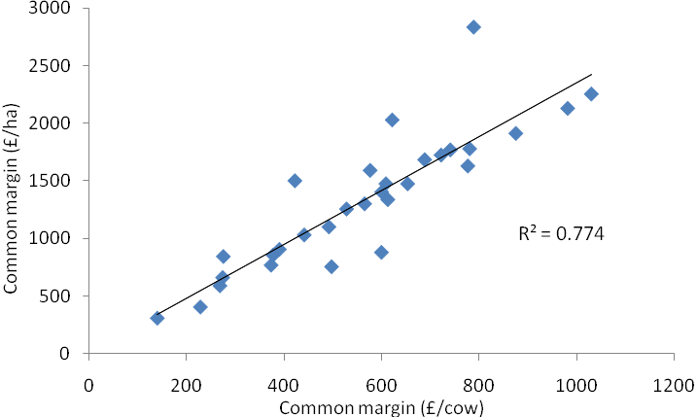
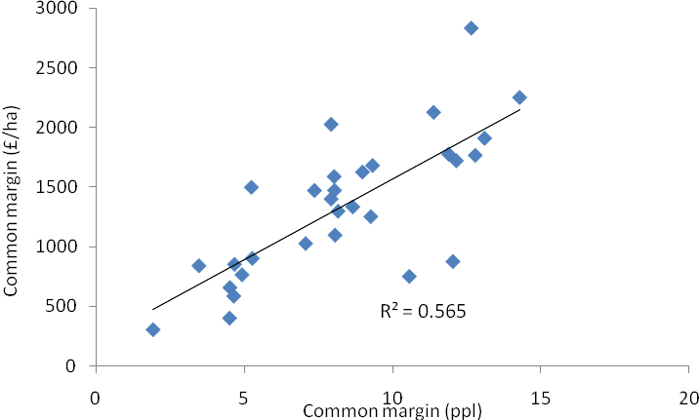

Appendix 27. The relationship between the number of cows at the end of each year of the study and common margin (£/cow) across the ten farms
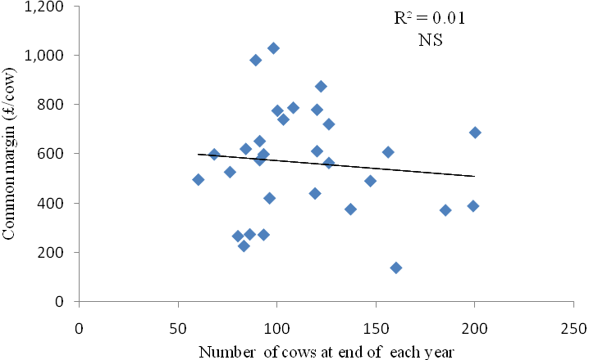

Appendix 28. The relationship between concentrate feeding rate (kg concentrate/litre) and concentrates fed (kg/cow/year) and common margin (£/cow) over the ten farms for the three years of the study.

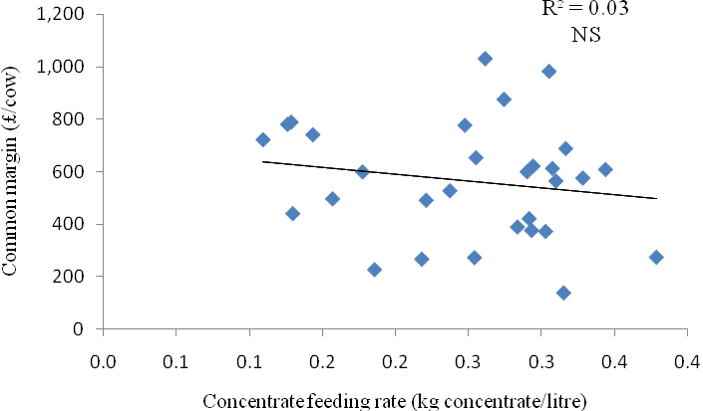
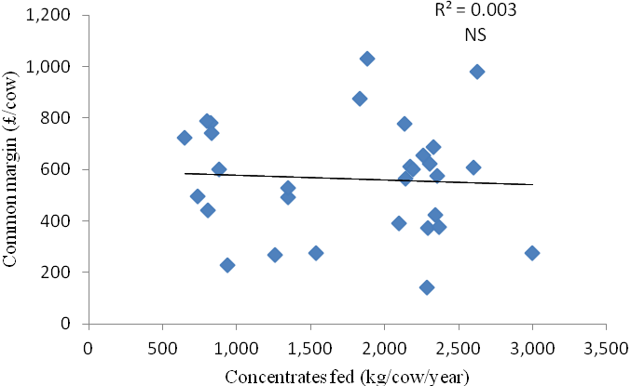

Appendix 29. The relationship between concentrate feeding rate (kg concentrate/litre) and milk from forage (litres/cow/year) and common margin (ppl) over the ten farms for the three years of the study.

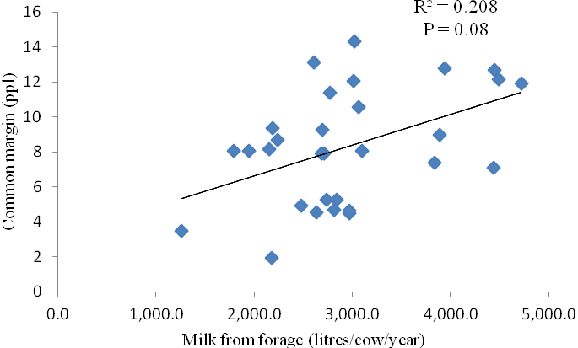

Appendix 30. Relationship between average grazing stocking rate in early (April, May, June) and late (July, August, September) season and common margin (£/cow) over the ten farms during the three years of the study.

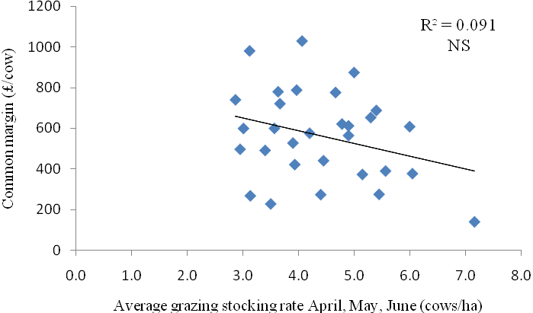
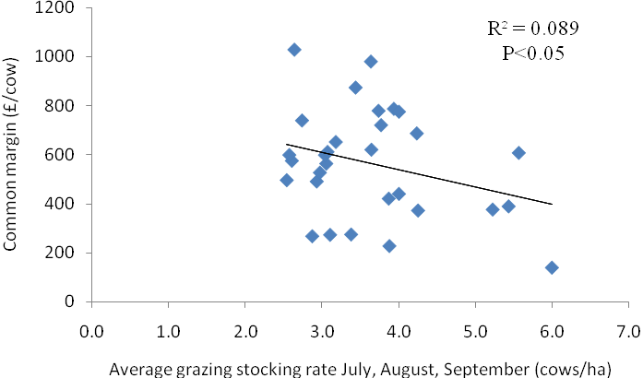

Appendix 31. Relationship between milk price (ppl) and total output per cow per year (£) and common margin (£/cow) over the ten farms during the three years of the study.
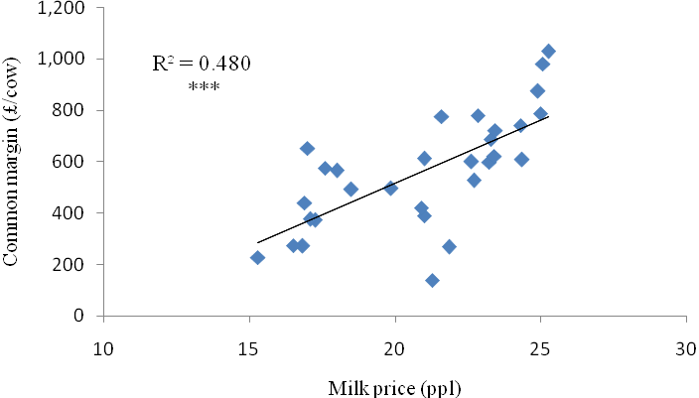
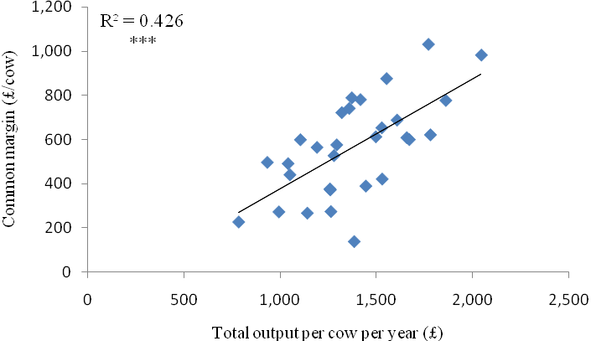

Appendix 32. Relationship between total concentrate cost (£/year) and concentrate cost per cow per year (£) and common margin (£/cow) over the ten farms during the three years of the study.

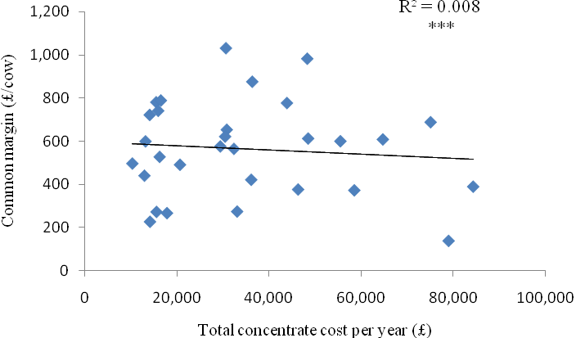
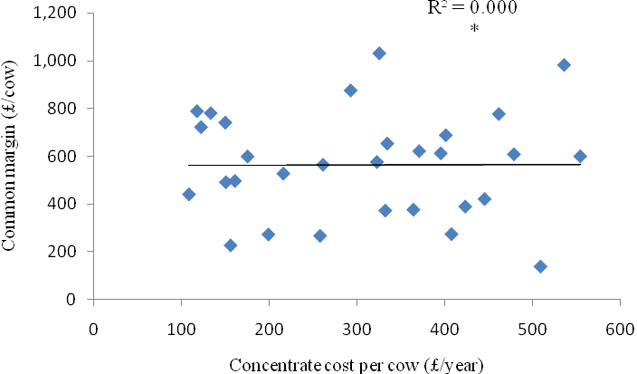

Appendix 33. Relationship between total variable costs (£/cow), total common costs (£/cow) and total overhead costs (£/cow) and common margin (£/cow) over the ten farms during the three years of the study.
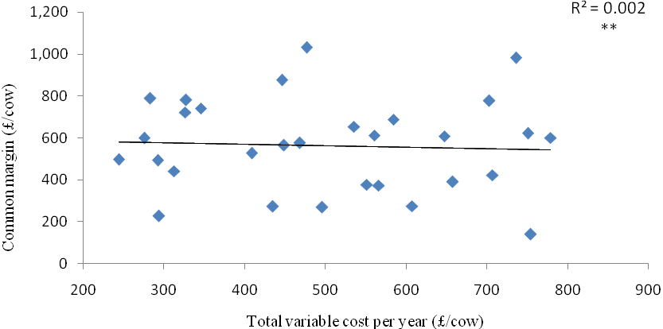
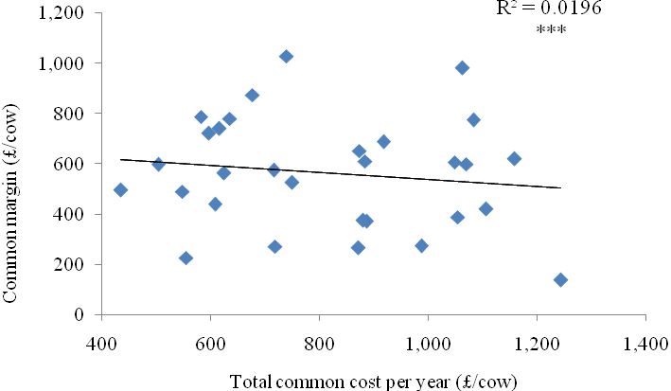

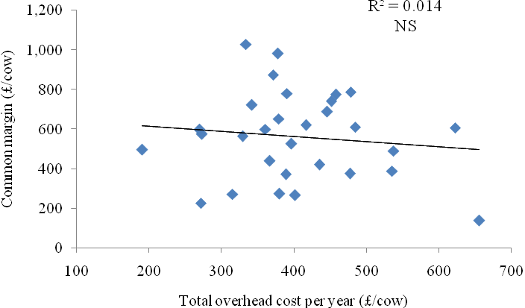

Appendix 34. Analysis of the common data from Northern Ireland and the Republic of Ireland.

The ten farms monitored in Northern Ireland were part of a larger study involving 16 dairy farms being monitored in the Republic of Ireland by TEAGASC. These 16 dairy farms were located in the North west and North east counties of the Republic of Ireland and they were also monitored for three years, commencing a year earlier than the Northern Ireland farms. The work was completed by TEAGASC staff based at sites in Ballyhaise and Moorepark.

Similar to the Northern Ireland farms, these farms were visited monthly during the grazing season to collect grassland data, with financial data collected annually through PROFIT monitor. To allow comparison with the grassland data collected in Northern Ireland, 1,500 kg DM/ha was added to the grass covers recorded on the Republic of Ireland farms, as their grassland measurements were established by eyeballing herbage mass above 3.5 cm. Furthermore, due to the differences in currency, the costs of production are not presented here, with common margin calculated in both currencies and converted to common units for analysis. This was achieved by identifying the average common margin each year across the farms in both countries and determining the proportion of that average achieved by each farm. For example, farms achieving a higher common margin than the group average were allocated a number greater than 1.0, with those achieving a lower common margin allocated a number less than 1.0. This new ranking was used for all analysis.

The key herd performance data for the 16 farms in the Republic of Ireland are presented in Table 34A. Herd size within the 16 farms ranged from 34 up to 167 cows, with milk yield per cow ranging from 4,800 to over 7,500 litres/year. Milk production from forage also varied widely between the farms monitored, ranging from 1,720 up to 4,230 litres/cow/year. In comparison to the 10 farms monitored in NI, the NI herds were larger, had higher milk yields per cow and produced milk of higher quality. However, average milk produced from forage was over 300 litres/cow/year higher for the farms in the Republic of Ireland.

Table 34A. Key herd performance data collected from the sixteen farms in the Republic of Ireland.

 |  | Herd size | Total milk sold per year | Annual milk yield |  | Milk composition |  | Milk solids produced | Concentrates fed |  | Milk produced from forage
 |  | (cows) | (litres) | (litres/cow) | (litres/ha) | Fat (%) | Protein (%) | (kg/cow/year) | (kg/cow/year) | (kg/litre) | (litres/cow/year)
Farm | 1 | 120 | 764917 | 6381 | 20786 | 3.69 | 3.18 | 438 | 1258 | 0.20 | 3584
 | 2 | 167 | 1117001 | 6667 | 26716 | 3.74 | 3.22 | 467 | 2025 | 0.31 | 2168
 | 3 | 62 | 315119 | 5089 | 13284 | 3.69 | 3.19 | 351 | 1042 | 0.20 | 2773
 | 4 | 56 | 300259 | 5393 | 13790 | 3.77 | 3.24 | 378 | 1652 | 0.31 | 1721
 | 5 | 51 | 299590 | 5905 | 14113 | 3.84 | 3.33 | 424 | 866 | 0.15 | 3981
 | 6 | 75 | 416516 | 5561 | 11533 | 3.88 | 3.47 | 408 | 647 | 0.12 | 4124
 | 7 | 68 | 374754 | 5557 | 11925 | 3.87 | 3.48 | 408 | 828 | 0.15 | 3717
 | 8 | 41 | 284446 | 7011 | 15458 | 3.70 | 3.14 | 479 | 1742 | 0.25 | 3141
 | 9 | 82 | 428808 | 5261 | 13687 | 3.99 | 3.51 | 395 | 464 | 0.09 | 4231
 | 10 | 68 | 373802 | 5525 | 10938 | 3.94 | 3.46 | 409 | 594 | 0.11 | 4205
 | 11 | 34 | 257240 | 7539 | 14702 | 3.73 | 3.21 | 523 | 2541 | 0.34 | 1893
 | 12 | 55 | 311620 | 5662 | 13377 | 3.77 | 3.27 | 398 | 927 | 0.16 | 3602
 | 13 | 47 | 321912 | 7510 | 19864 | 3.89 | 3.32 | 542 | 1616 | 0.21 | 3920
 | 14 | 58 | 277845 | 4809 | 8495 | 3.85 | 3.35 | 346 | 761 | 0.16 | 3118
 | 15 | 53 | 264426 | 4955 | 11189 | 3.83 | 3.36 | 357 | 816 | 0.16 | 3142
 | 16 | 71 | 498562 | 6994 | 12767 | 3.77 | 3.29 | 494 | 1800 | 0.26 | 2994
Overall average |  | 69 | 412926 | 5989 | 14539 | 3.81 | 3.31 | 426 | 1224 | 0.20 | 3270
Year | 1 | 68 | 393828 | 5827 | 13577 | 3.76 | 3.27 | 409 | 1158 | 0.19 | 3253
 | 2 | 68 | 418763 | 6148 | 14818 | 3.82 | 3.32 | 438 | 1248 | 0.20 | 3375
 | 3 | 72 | 426188 | 5990 | 15222 | 3.85 | 3.36 | 431 | 1264 | 0.20 | 3181

Table 34B. Key grassland performance data collected from the sixteen farms in the Republic of Ireland.

 |  | Average pre-grazing herbage mass |  | Average post-grazing herbage mass |  | Average farm cover |  |  | Average grazing stocking rate |  |  | Average grass utilisation
 |  | April, May, June | July, August, September | April, May, June | July, August, September | April, May, June | July, August, September |  | April, May, June | July, August, September |  | April, May, June | July, August, September
 |  | kg DM/ha |  |  |  |  |  |  | cows/ha |  |  | %
Farm | 1 | 3244 | 3217 | 1717 | 1684 | 2281 | 2212 |  | 3.71 | 3.71 |  | 0.87 | 0.89
 | 2 | 2978 | 3275 | 1711 | 1725 | 2132 | 2261 |  | 4.22 | 4.29 |  | 0.85 | 0.87
 | 3 | 2756 | 3183 | 1695 | 1700 | 1999 | 2120 |  | 2.79 | 2.51 |  | 0.84 | 0.88
 | 4 | 3244 | 3292 | 1783 | 1742 | 2242 | 2223 |  | 3.63 | 2.67 |  | 0.83 | 0.86
 | 5 | 2689 | 2958 | 1733 | 1758 | 2085 | 2209 |  | 3.23 | 2.58 |  | 0.80 | 0.82
 | 6 | 3261 | 2767 | 1750 | 1717 | 2200 | 2318 |  | 3.26 | 2.35 |  | 0.85 | 0.83
 | 7 | 3122 | 2933 | 1708 | 1696 | 2131 | 2093 |  | 2.98 | 2.20 |  | 0.85 | 0.85
 | 8 | 2900 | 3167 | 1725 | 1700 | 2232 | 2200 |  | 3.66 | 2.35 |  | 0.82 | 0.87
 | 9 | 3161 | 3133 | 1725 | 1708 | 2255 | 2317 |  | 3.68 | 2.76 |  | 0.86 | 0.87
 | 10 | 2942 | 2992 | 1711 | 1704 | 2115 | 2373 |  | 3.38 | 2.87 |  | 0.85 | 0.86
 | 11 | 2650 | 3033 | 1708 | 1683 | 2044 | 2166 |  | 2.41 | 2.24 |  | 0.80 | 0.88
 | 12 | 2967 | 3117 | 1692 | 1750 | 2190 | 2191 |  | 3.84 | 2.78 |  | 0.87 | 0.84
 | 13 | 3300 | 3200 | 1867 | 1758 | 2331 | 2250 |  | 3.51 | 2.97 |  | 0.80 | 0.84
 | 14 | 2855 | 2850 | 1692 | 1708 | 2104 | 2133 |  | 2.77 | 2.19 |  | 0.85 | 0.84
 | 15 | 3067 | 2883 | 1803 | 1750 | 2178 | 2146 |  | 2.31 | 2.21 |  | 0.81 | 0.80
 | 16 | 3034 | 2783 | 1756 | 1759 | 2148 | 2118 |  | 2.55 | 2.38 |  | 0.82 | 0.79
Overall average |  | 3012 | 3049 | 1737 | 1721 | 2166 | 2208 |  | 3.23 | 2.69 |  | 0.84 | 0.85
Year | 1 | 3084 | 3111 | 1783 | 1744 | 2173 | 2169 |  | 3.08 | 2.53 |  | 0.81 | 0.84
 | 2 | 2890 | 3063 | 1732 | 1722 | 2138 | 2243 |  | 3.20 | 2.76 |  | 0.83 | 0.85
 | 3 | 3066 | 2973 | 1699 | 1699 | 2188 | 2213 |  | 3.41 | 2.79 |  | 0.87 | 0.86

The key grassland performance information collected from the 16 farms in the Republic of Ireland is shown in Table 34B. The overall average pre- and post-grazing herbage mass being grazed on these farms was within industry targets, as was average farm cover. On average the 16 farms in the Republic of Ireland utilised approximately 85% of the grass offered to their grazing herds. In comparison to the farms in NI, the farms in the Republic of Ireland were grazing lower grass covers, achieving a tighter post-grazing herbage mass and achieving a higher overall grass utilisation efficiency.

Table 34C. Milk price (cents/litre) and common margin (cents/litre and Euro/cow) on the 16 farms in the Republic of Ireland
 |  |  | Milk price |  | Common margin
 |  |  | (per litre) | (per litre) |  | (per cow)
Farm | 1 |  | 26.9 | 15.0 |  | 950
 | 2 |  | 31.0 | 13.9 |  | 934
 | 3 |  | 29.1 | 6.4 |  | 339
 | 4 |  | 27.0 | 9.3 |  | 504
 | 5 |  | 29.0 | 12.8 |  | 756
 | 6 |  | 28.4 | 15.4 |  | 849
 | 7 |  | 29.0 | 17.0 |  | 939
 | 8 |  | 28.4 | 8.2 |  | 582
 | 9 |  | 27.8 | 18.5 |  | 982
 | 10 |  | 28.2 | 18.0 |  | 993
 | 11 |  | 27.7 | 8.4 |  | 617
 | 12 |  | 27.7 | 13.8 |  | 784
 | 13 |  | 29.6 | 16.2 |  | 1054
 | 14 |  | 28.6 | 12.8 |  | 611
 | 15 |  | 28.3 | 10.9 |  | 539
 | 16 |  | 27.8 | 14.6 |  | 1010
Overall average |  |  | 28.4 | 13.2 |  | 778
Year | 1 |  | 26.8 | 10.9 |  | 642
 | 2 |  | 25.8 | 10.8 |  | 660
 | 3 |  | 32.7 | 18.0 |  | 1031

Although most of the financial information is not presented for the farms in the Republic of Ireland, Table 34C highlights the average milk price and common margin achieved on the farms. Similar to the farms in Northern Ireland, there was a wide range in milk price received across the farms, and also the effect of year on milk price is apparent, with a significant increase in milk price observed in Year 3 compared to Years 1 and 2. The variation in common margin between farms and between years is also apparent, which again is similar to the trends observed in the NI data.
Table 34D. Relationships between the main common parameters measured on the twenty six farms in Northern Ireland and the Republic of Ireland and common margin (£/cow, ppl).
 | Common margin
 | (£/cow) |  | (ppl)
 | P-value | relationship | P-value | relationship
Average pre-grazing cover^{1#} | 0.877 |  | 0.958
Average pre-grazing cover^{2#} | 0.939 |  | 0.610
Average post-grazing cover^{1#} | 0.975 |  | 0.718
Average post-grazing cover^{2#} | 0.940 |  | 0.893
Average farm cover^{1#} | 0.731 |  | 0.941
Average farm cover^{2#} | 0.862 |  | 0.640
Average grazing stocking rate (CE/ha) | 0.918 |  | 0.918
Average grazing stocking rate (CE/ha) | 0.198 |  | 0.230
Average grass utilisation^{1V} | 0.959 |  | 0.630
Average grass utilisation^{2V} | 0.778 |  | 0.395
Stocking rate (cows/ha) | 0.982 |  | 0.779
Number cows (cows) | 0.794 |  | 0.728
Litres milk sold (litres/cow/year) | 0.961 |  | 0.324
Average yield per cow (litres/year) | 0.813 |  | <0.05 | -ve
Milk fat (%) | <0.05 | +ve | 0.058 | +ve
Milk protein (%) | 0.111 | +ve | <0.05 | +ve
Concentrates fed/cow (kg/cow/year) | 0.223 |  | 0.001 | -ve
Milk from forage (litres/cow/year) | 0.110 | +ve | <0.05 | +ve
Concentrate feeding rate  (kg concentrate/litre) | 0.113 | -ve | <0.01 | -ve
¹ Average of April, May and June each year
² Average of July, August and September each year
# kg DM/ha (>ground level)
^{V} % (>1,600 kg DM/ha)

The common data measured on the farms in the Republic of Ireland and Northern Ireland were combined into a dataset to determine if there were any relationships with common margin (Table 34D). Similar to the analysis of the Northern Ireland data on its own, there were no relationships established between common margin and the grassland management measurements taken. However, common margin (£/cow) increased as milk fat content increased (P<0.05), and there were trends for common margin to increase as milk protein and milk from forage increased, and decrease as concentrate feeding rate increased. On a per litre basis, common margin was negatively associated with milk yield per cow and concentrates fed per cow, and positively associated with milk protein content and milk from forage (Figure 34A).

Figure 34A. The relationship between milk produced from forage and common margin (ppl) on the twenty six farms monitored within Northern Ireland and the Republic of Ireland (all common margins converted to ppl).
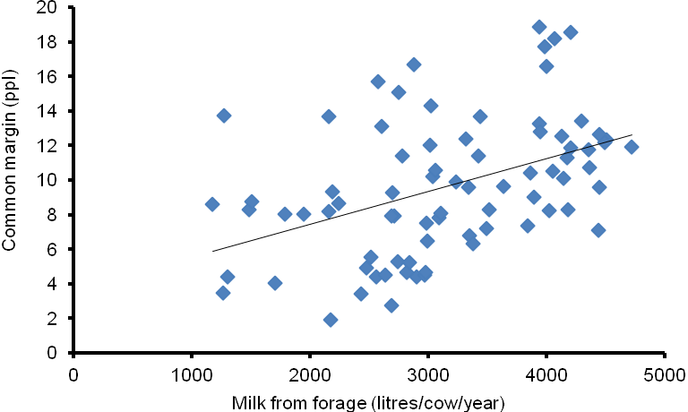

The analysis of the combined dataset of twenty six farms reinforces many of the trends already highlighted by the data from the Northern Ireland farms, namely that milk yield and herd size are not related to common margin, but that increased milk from forage has a positive effect on common margin (ppl).

